Platform | Copy | Creative Asset
Facebook | Primary Text: Get the COVID-19 vaccine and reduce your chances of getting sick. Ask your teacher, doctor, or a close  family member where you can get vaccinated, or visit  www.covid-resources.org.  Headline on visual: The COVID-19 vaccine is good for your health. | 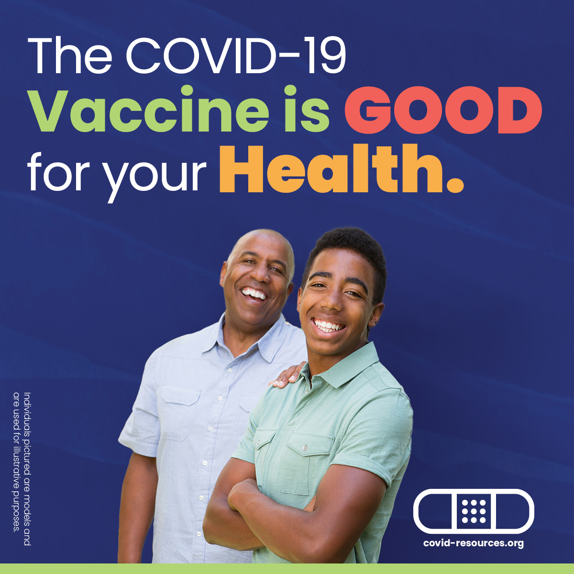
Facebook | Primary Text: Get the COVID-19 vaccine so you can protect your health and the health of those around you. Ask your teacher, doctor, or a close family member where you can get vaccinated, or visit www.covid-resources.org.  Headline on visual: The COVID-19 vaccine is good for your health. | 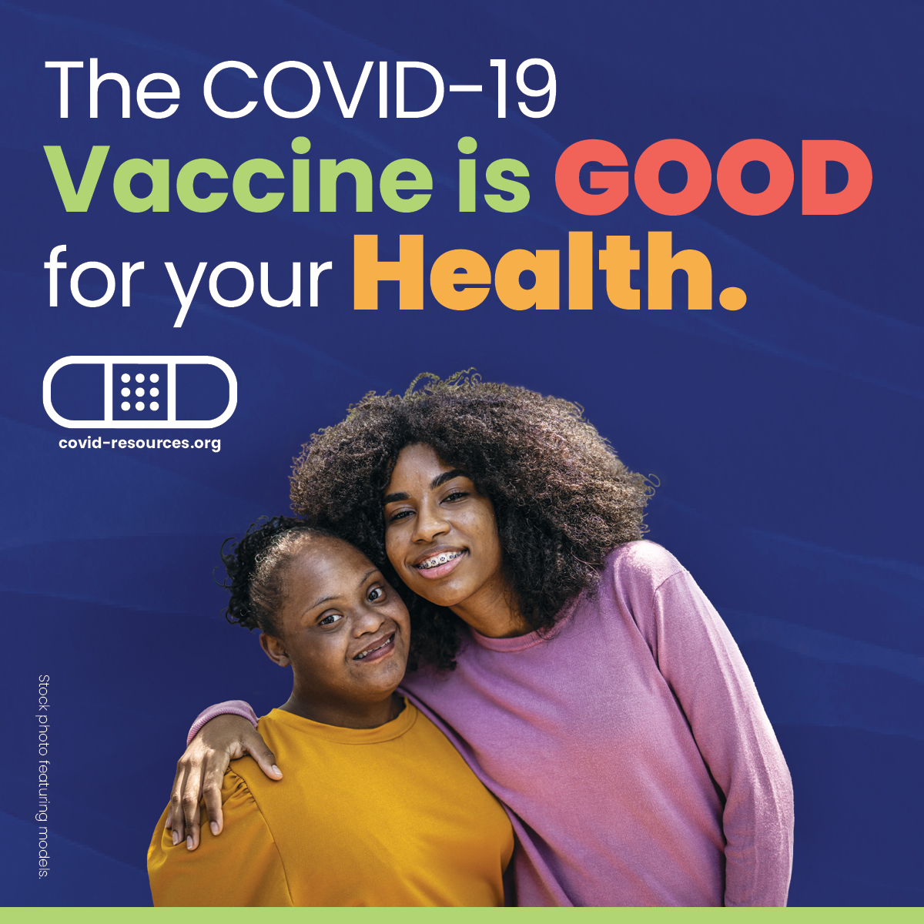
Facebook | Millions of people have received the COVID-19 vaccine. It is safe and will keep you healthy. Ask your teacher, doctor, or a close family member where you can get vaccinated, or visit www.covid-resources.org.  Headline on visual: The COVID-19 vaccine is good for your health. | 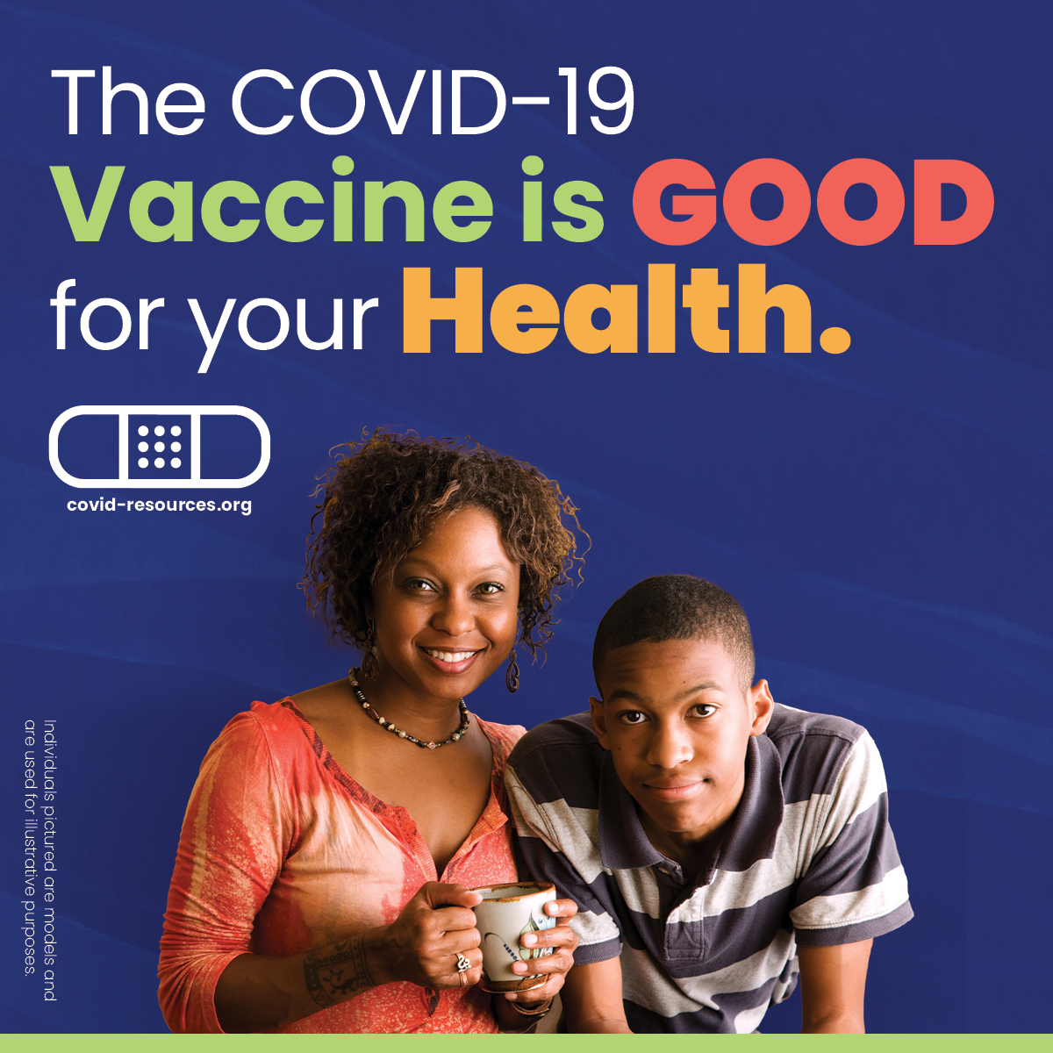
Facebook | Primary Text: The COVID-19 vaccine will keep you and your loved ones in good health. Ask your teacher, doctor, or a close family member where you can get vaccinated, or visit www.covid-resources.org.  Headline on visual: The COVID-19 vaccine is good for your health. | 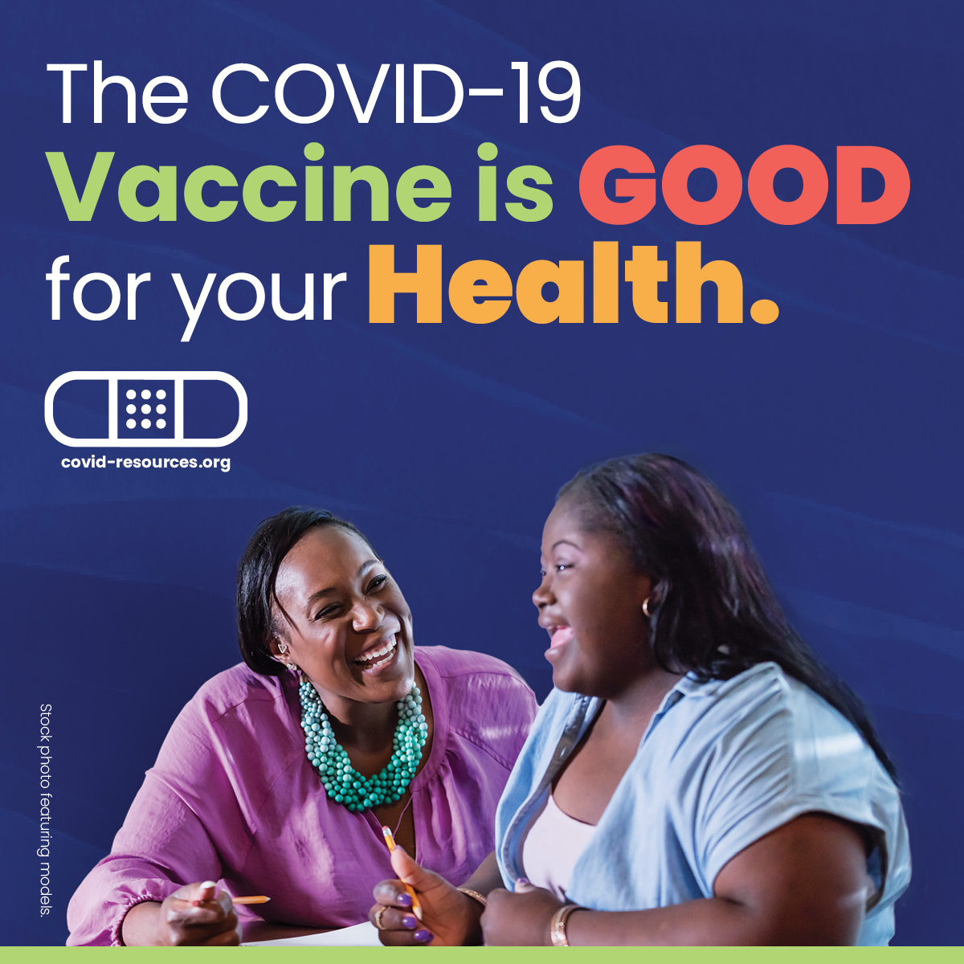
Facebook | Primary Text: When you have a pre-existing condition, getting the COVID-19 vaccine is key to keeping you healthy. Ask your teacher, doctor, or a close family member where you can get vaccinated, or visit www.covid-resources.org.  Headline on visual: The COVID-19 vaccine is good for your health. | 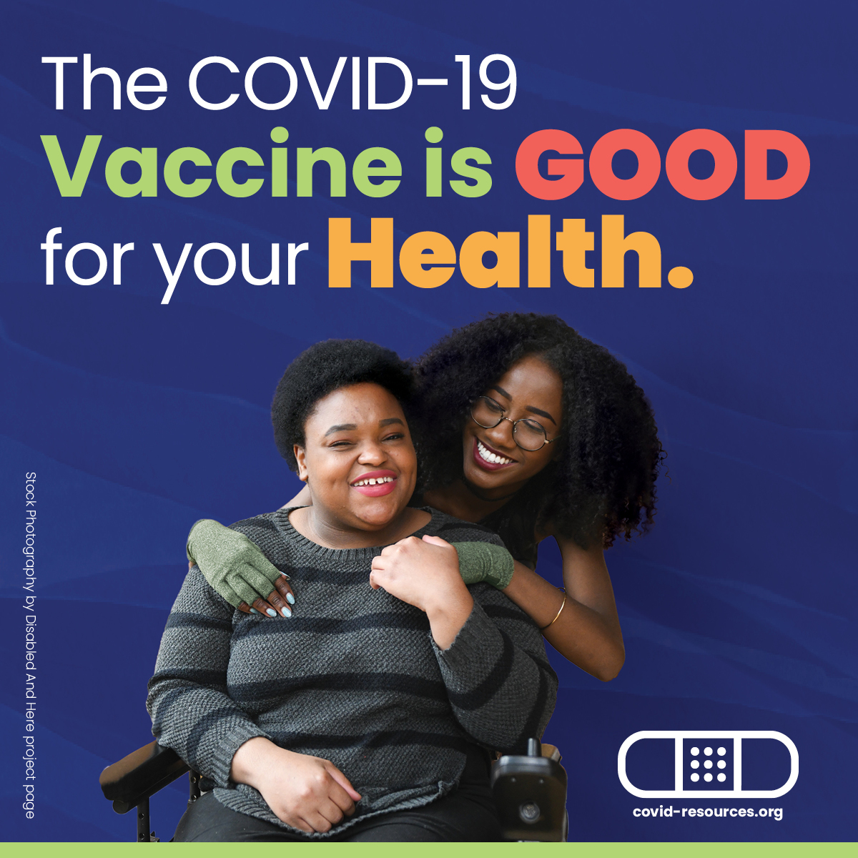
Instagram | Primary Text: Get the COVID-19 vaccine and reduce your chances of getting sick. Ask your teacher, doctor, or a close family member where you can get vaccinated, or visit www.covid-resources.org.
Instagram | Primary Text: Get the COVID-19 vaccine so you can protect your health and the health of those around you. Ask your teacher, doctor, or a close family member where you can get vaccinated, or visit www.covid-resources.org.
Instagram | Primary Text: Millions of people have received the COVID-19 vaccine. It is safe and will keep you healthy. Ask your teacher, doctor, or a close family member where you can get vaccinated, or visit www.covid-resources.org.
Instagram | Primary Text: The COVID-19 vaccine will keep you and your loved ones in good health. Ask your teacher, doctor, or a close family member where you can get vaccinated, or visit www.covid-resources.org.
Instagram | Primary Text: When you have a pre-existing condition, getting the COVID-19 vaccine is key to keeping you healthy. Ask your teacher, doctor, or a close family member where you can get vaccinated, or visit www.covid-resources.org.

