FY21 Updates

New LEND questions under Activities dataset
Is this activity addressing the transitional needs to adult health care for youth with special health care needs?
Sub-question: Through what processes are you promoting or facilitating the transition to adult health care for youth with special health care needs?
Is this activity promoting and/or facilitating developmental screening and follow-up in your program?
Sub-question: Through what processes are you promoting and/or facilitating developmental screening and follow up in your program?

UCEDD 5-year cumulative report
Located under ADMIN>UCEDD Final Progress Report (5-Year Report)

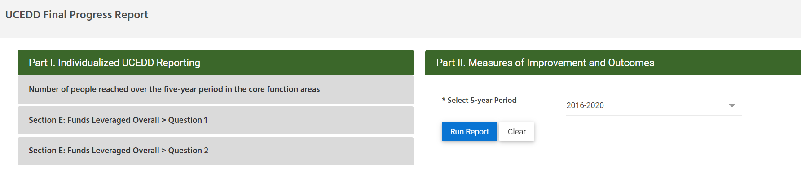
Part I. Individualized UCEDD reporting
- Number of people reached over the five-year period in the core functions areas
- Section E: Funds Leveraged Overall > Question 1
- Section E: Funds Leveraged Overall > Question 2
Part II. Measures of Improvement and Outcomes.
-Select 5-year period.

