Flu Vaccine Messaging
A mini-toolkit for social media advocacy
Purpose: To leverage existing community relationships to educate the disability community (e.g. individuals with disabilities, family members, direct support professionals) on the importance of the flu vaccine in protecting the health of everyone in accessible, relevant messaging.
Intended messengers: The social media accounts of UCEDDs, LENDS, and IDDRCs, and individual leaders in the AUCD network
Intended recipients: The state and local disability communities served by the network centers.
Source of information: The Centers for Disease Control and Prevention (CDC) (@CDCGov or @CDCFlu)
Hashtags: #FightFlu #FluFriday #FluFactFriday #SleeveUp
Order | Suggested Date | Messaging | Image
Week 1 | 10/9/2020 | Flu Fact: Getting the flu vaccine is the best way to protect yourself, your loved ones, and your community from developing serious flu-related complications. Find where to get your flu shot today: https://bit.ly/3i9Rb3H  #FightFlu #FluFriday #FluFactFriday #SleeveUp | 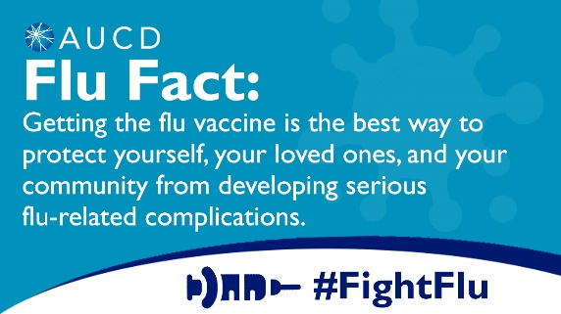
Week 2 | 10/16/2020 | Flu Fact: Flu vaccines are offered in many doctor’s offices, urgent care clinics, pharmacies, health departments, and even in schools and businesses. Find where to get your flu shot today: https://bit.ly/3i9Rb3H  #FightFlu #FluFriday #FluFactFriday #SleeveUp | 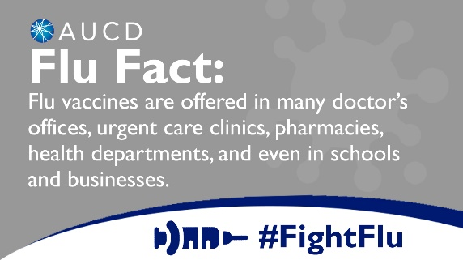
Week 3 | 10/23/2020 | Flu Fact: The same people with disabilities who are at higher risk for flu complications are also at higher risk for COVID-19 complications. Protect yourself and those around you this winter by getting your flu shot: https://bit.ly/3i9Rb3H  #FightFlu #FluFriday #FluFactFriday #SleeveUp | 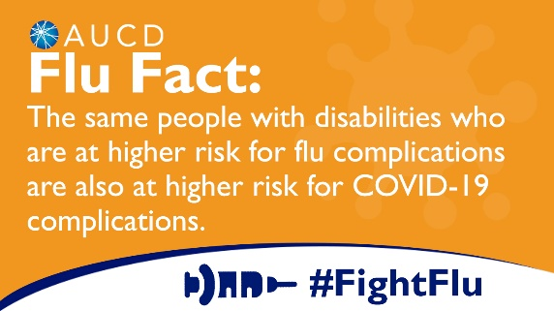
Week 4 | 10/30/2020 | Flu Fact: A flu vaccine will not protect you from COVID-19. But it will decrease your risk of developing serious flu. Protect yourself and those around you this winter by getting your flu shot: https://bit.ly/3i9Rb3H  #FightFlu #FluFriday #FluFactFriday #SleeveUp | 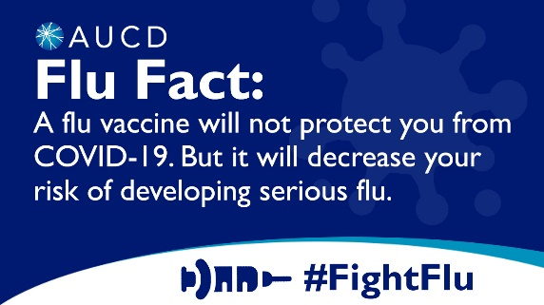
Week 5 | 11/6/2020 | Flu Fact: Everyone who is in frequent contact with individuals with disabilities can plan an important role in reducing risk of serious flu and covid-19 symptoms by getting their flu shot. Get your flu vaccine today: https://bit.ly/3i9Rb3H  #FightFlu #FluFriday #FluFactFriday #SleeveUp | 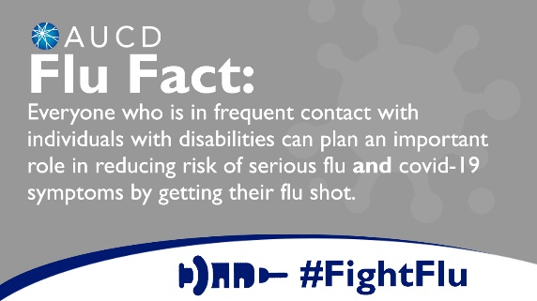
Week 6 | 11/13/2020 | Flu Fact: There is ZERO evidence that vaccines cause or are related to Autism Spectrum Disorders. To learn more about the science, visit @CDCGov https://bit.ly/365YfLt  #FightFlu #FluFriday #FluFactFriday #SleeveUp | 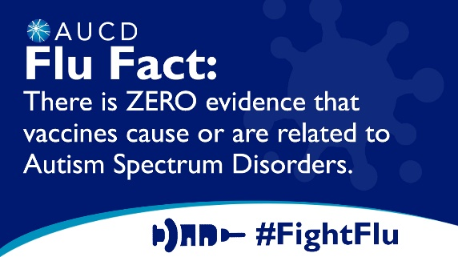
Week 7 | 11/20/2020 | Flu Fact: It is more important than ever to get your flu vaccine to reduce risk of serious flu symptoms and strain on healthcare systems responding to the COVID-19 pandemic. Find where to get your flu shot today: https://bit.ly/3i9Rb3H  #FightFlu #FluFriday #FluFactFriday #SleeveUp | 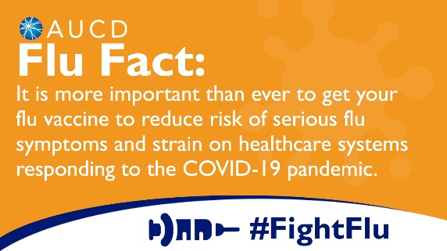
Week 8 | 11/27/2020 | Flu Fact: The flu vaccine is a safe, easy, and affordable way to protect yourself, your loved ones, and your community this holiday season. Find where to get your flu shot today: https://bit.ly/3i9Rb3H  #FightFlu #FluFriday #FluFactFriday #SleeveUp | 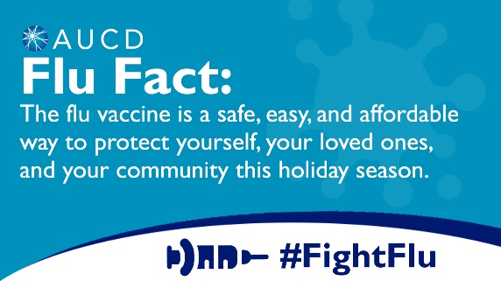
Additional ideas for posts:
- State-based data on flu vaccination rates, number of reported cases of the flu, number of hospitalizations due to flu
- People with certain types of disabilities are at higher risk for developing flu-related complications that could require hospitalization. A full list of people at higher risk for flu-related complications is at https://www.cdc.gov/flu/about/disease/high_risk.htm.
- Educate on everyday actions to protect from the flu and COVID-19. Visit http://www.cdc.gov/flu/protect/habits/index.htm.
- Educate on flu signs and symptoms. People with disabilities may be at risk of getting flu and/or having unrecognized flu symptoms because they,
  - May have limited mobility and cannot avoid coming into contact with others who may be infected, like caretakers and family members;
  - May have trouble understanding or practicing measures to prevent infections like the flu, such as handwashing, or avoiding contact with people who are sick;
  - May not be able to communicate if they are sick; or
  - May not be monitored closely for symptoms of illness.
- Target direct service professionals and other support providers
  - For example: Caregivers in long-term care facilities—in addition to residents—who are in daily close contact with people who are most vulnerable to serious flu and COVID-19 illness and death should be sure to get their flu vaccine.

Additional resources from the CDC:
- #SleeveUp to #FightFlu campaign: https://www.cdc.gov/flu/resource-center/sleeveup/index.htm
- CDC Digital Media Toolkit: 2020-21 Flu Season: https://www.cdc.gov/flu/resource-center/toolkit/index.htm

