
AUCD Publication Order Form

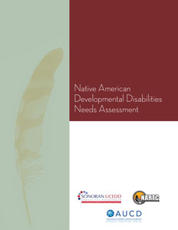
Publication:

Native American Developmental Disabilities Needs Assessment

Item | Rate | # Copies | Cost
This publication | Network Members: $5.00 each  Center: _____________________
This publication | Non-Network Members: $8.00 each
Shipping | +$5.00 first piece  +$2 each additional piece
Total | Return this form to: AUCD, Attn Ryan Jesien,  1100 Wayne Avenue, Suite 1000, Silver Spring MD 20910

Payment Information |  | Shipping Information
Check  Payable to AUCD | Credit card  __Visa __ Mastercard  __American Express | Name:  Address1:  Address2:  City/State:  Zip: Phone:
CC Number:  Card Holder:  Address1:  Address2:  City/State:  Zip: Phone: |  | Name:  Address1:  Address2:  City/State:  Zip: Phone:

AUCD Billing Code  875 | Date Received | Date Paid | Date Shipped

