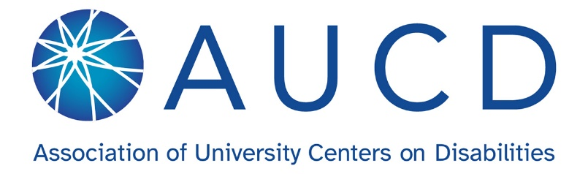
AUCD CEDC Meeting Agenda
May 21st at 12:00 PM Eastern Time
Please register for the meeting to receive the Zoom Link: https://us06web.zoom.us/meeting/register/VB_k_uZZTEaKOTUxAqBa-w#/registration

- Welcome (5 minutes)
  - In the chat, please respond to the icebreaker:
    - Something you are looking forward to this summer?

- Introductions (5 minutes)
  - Chair - Vacant
  - Vice Chair - Miranda Hooper
  - Secretary - Amy Burt
  - AUCD Staff Liaison - Anna Costalas
  - PD Committee Chair - Aimee Deliramich

- New CEDC Business & Announcements (5 minutes)
  - Reminder CEDC chair vacancy
  - Padlet Resources: https://tinyurl.com/padletCEDC
  - Interested in serving? Let us know!
  - Data snapshot for February and March meetings

- CEDC Professional Development Committee Updates (5 minutes)
  - PD Committee recruitment and update - Speaker series

- Shoutout Corner – Any attendee (5 minutes)

- Break (5min)
- Information Sharing & Network Spotlights (25 minutes) Begins at 12:30
  - PowerPoint and Presentation Accessibility: Making Slides Accessible for All - Amy Riser, Senior Program Manager for Community Training and Evaluation and the University of Wyoming - Wyoming Institute for Disabilities (WIND)
- Closing Remarks & Future Meetings (5 minutes)
  - Quarterly meetings occur on the third Thursday at 12:00-1:00 EST
  - Upcoming Meetings: see below

3-Part Series – Access for All: Building Digital and Document Accessibility Skills
PowerPoint and Presentation Accessibility: Making Slides Accessible for All
- June Coffee Chat (6/18/26): 1-hour hands-on workshop applying skills and tools introduced in the May presentation on PowerPoint and Presentation Accessibility Register for June
- July Coffee Chat (7/16/26): 1-hour reflective session to explore what’s working well and where challenges remain in applying these tools related to PowerPoint and Presentation Accessibility Register for July

Digital and Social Media Accessibility: Creating Inclusive Online Content
- August Quarterly Meeting (8/20/26): 20-minute presentation on digital and social media accessibility
- September Coffee Chat (9/17/26): 1-hour hands-on workshop applying skills and tools introduced in the August presentation on Digital and Social Media Accessibility
- October Coffee Chat (10/15/26): 1-hour reflective session to explore what’s working well and where challenges remain in applying these tools related to Digital and Social Media Accessibility

o November 2026 (Date TBD): AUCD Conference - more details to come!

