We’re Here. Then, Now, Always.

The Evolving Role of DD Councils in Employment

Webinar Date: March 10, 2026 | Time: 3:00 pm to 4:30 pm Eastern Time
In recognition of Developmental Disabilities Awareness Month (DDAM), join the Disability Employment Technical Assistance Center (DETAC) for a webinar featuring partners from the National Association of Councils on Developmental Disabilities (NACDD), the Nebraska DD Council, and NACDD self-advocate apprentice, Bryan Dooley. During this session, NACDD will introduce this year’s DDAM theme and explore how DD Councils play a critical role in moving the needle on employment by convening partners, influencing systems, and elevating effective practices through capacity building. The Nebraska DD Council will highlight key state-level initiatives, partnerships, and lessons learned in their work to impact employment outcomes across Nebraska. NACDD apprentice, Bryan Dooley, will also share how councils can meaningfully incorporate lived experience into policy and practice, drawing from his own employment journey.
Learning Objectives
Understand how DD Councils advance employment outcomes by convening partners, influencing systems, and investing for impact.
Identify replicable strategies, partnerships, and lessons learned from state-level initiatives to advance employment.
Consider how DD Councils can meaningfully incorporate lived experience into policy and practice.
Presenters
 |  | 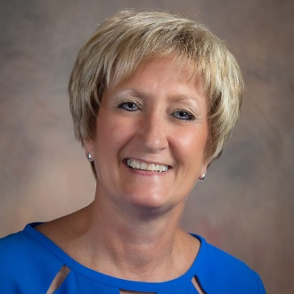 | 
Jill Jacobs  Executive Director  NACDD | Kristen Larsen  Executive Director  Nebraska Council on Developmental Disabilities | Becki Koehler  Independent Consultant  Nebraska | Bryan Dooley  Community Inclusion Specialist  Solutions for Independence

Register Now!
https://us06web.zoom.us/webinar/register/WN_-X2AYdDETh6TZh8avVtZjg

