Title | Autism across the years
Description/ purpose | The custom report looks for all products with the ‘Autism’ word in the title, keywords, and description.  The goal was to pull data for Autism related products to build a multi-year report.
Selected Fields | 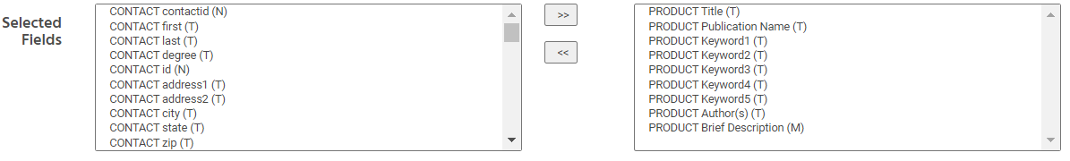
Selected Criteria | 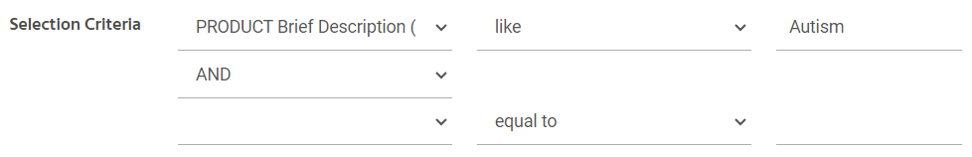
Sort & Group by | 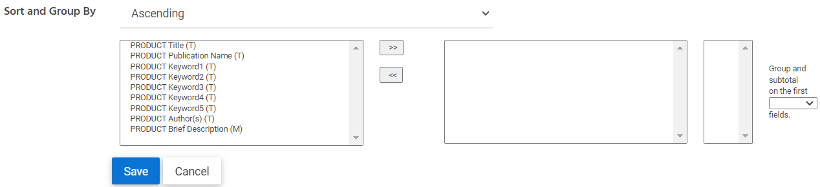
Additional Comments

