Envisioning the Future:
Allies in Self-Advocacy
Final Report

September 2012

by
Joe Caldwell
Katie Keiling Arnold
Mary Kay Rizzolo

Institute on Disability and Human Development
The University of Illinois at Chicago

Self-Advocate Version
Edited by:
Liz Weintraub

This report was funded by the Administration on Intellectual and Developmental Disabilities (AIDD) and does not necessarily represent the views of AIDD or AUCD.

Background

The Administration on Intellectual and Developmental Disabilities (AIDD) is the federal agency that supports the developmental disabilities network. The network includes Developmental Disabilities Councils (DD Councils), University Centers for Excellence in Developmental Disabilities (UCEDDs), and Protection and Advocacy systems (P&As).

AIDD held nine regional summits in 2011 and 2012. The goals of the summits were to:
- Find out what is happening in the states on self-advocacy
- Make state team plans to strengthen self-advocacy
- Make national recommendations to strengthen self-advocacy

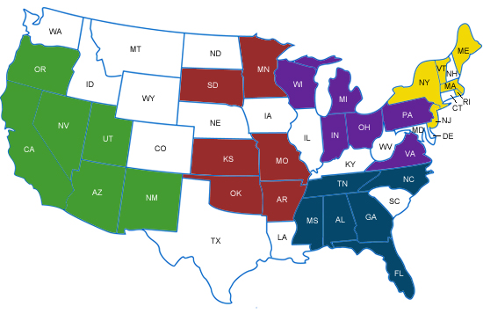
Regional Self-Advocacy Summits
The states that were in the first round of summits were:
- Atlanta, Georgia
(March 10-11, 2011)
        - Including: Alabama, Florida, Georgia, Mississippi, North Carolina, Tennessee
- Los Angeles, California
(March 24-25, 2011)
        - Including: Arizona, California, Nevada, New Mexico, Oregon, Utah
- Kansas City, Missouri (April 11-12, 2011)
        - Including: Arkansas, Kansas, Minnesota, Missouri, Oklahoma, South Dakota
- Columbus, Ohio (April 28-29, 2011)
        - Including: Indiana, Michigan, Ohio, Pennsylvania, Virginia, Wisconsin
- Providence, Rhode Island (May 16-17, 2011)
        - Including: Maine, Massachusetts, New Jersey, New York, Rhode Island, Vermont

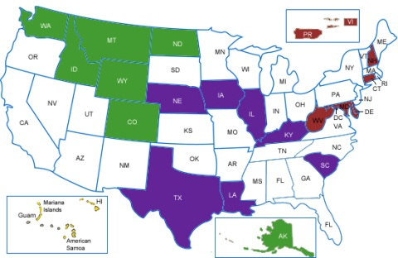
The states and territories that were in the second round of summits were:
- Baltimore, Maryland (March 19-20, 2012)
  - Including: Connecticut, Delaware, District of Columbia, Maryland, New Hampshire, Puerto Rico, Virgin Islands, West Virginia
- Honolulu, Hawaii (March 28-29, 2012)
  - Including: American Samoa, Guam, Hawaii, Commonwealth of the Northern Mariana Islands
- Chicago, Illinois (April 19-20, 2012)
  - Including: Illinois, Iowa, Kentucky, Louisiana, Nebraska, South Carolina, Texas
- Seattle, Washington (May 10-11, 2012)
  - Including: Alaska, Colorado, Idaho, Montana, North Dakota, Washington, Wyoming

Each state and territory developed a team of 9-12 people, with the same amount of self-advocates and professionals. The team included:
- 2 to 3 people from the self-advocacy leadership
- A person from the DD Council
- A person from the P&A
- A person from the UCEDD
- A person from the DD Services Agency

FINDINGS

Self-Advocacy in the States
State teams did presentations on self-advocacy in their state. States were all at different places in their support for self-advocacy. Some states had a lot of support and strong movements. Some states were still trying to form a statewide organization. Some state teams knew each other well. Others were still getting to know each other. Some states and territories had the same or similar goals. On the Allies in Self-Advocacy website, www.alliesinselfadvocacy.org, there is information about similar goals so states and territories can learn from each other.

Plans to Strengthen Self-Advocacy in States
State teams made plans to make the self-advocacy movement in their state stronger. The main goals of their plans were:

- Support peer training, mentoring, and leadership development (like serving on boards and committees)
- Strengthen supports and funding for self-advocacy at the local, regional, and state level
- Strengthen partnerships with other disability organizations and allies
- Reach out and communicate with other self-advocates (like youth, minority, and other populations that are not part of the movement or who may not be represented very often)
- Educate the public about disability and self-advocacy (like getting rid of the “R” word, and educating businesses about employing people with disabilities)
- Improve community services and supports (like education, transition, transportation, housing, community living, and ADA accessibility)

National Recommendations
State teams also came up with recommendations to support self-advocacy at the national level. Some recommendations were for actions that AIDD could take in the short term. Other recommendations were for policy changes. These are the major things that state teams said.

Things that AIDD could consider doing in the short term:

Provide support to strengthen self-advocacy
- Support state self-advocacy information and training centers run by self-advocates
- Start a national resource center run by self-advocates to assist local and state self-advocacy organizations
- Provide support for self-advocacy through national DD network Associations (Association of University Centers on Disabilities, National Association of State Developmental Disabilities Councils, and National Disability Rights Network) and encourage DD network members to include self-advocacy as part of their websites
- Provide support for self-advocacy groups to build partnerships and develop leaders, get rid of the “R” word, and use respectful language
- Develop resources where self-advocacy groups can come together and share ideas and information such as a website, online community, and national newsletter by and for self-advocates

Promote inclusion and self-advocacy at the federal level
- Hire and provide leadership opportunities for people with disabilities at the federal level
- Improve accessibility and use of respectable language, and make all AIDD programs and materials use language that everyone can understand
- Raise expectations for DD network and grantees about including self-advocates
- Encourage and support self-advocate participation on review panels for federal grants

Educate people about disability and self-advocacy
- Help the public understand why it is important to support funding for self-advocacy
- Help public offices in the states to understand why it is important to include self-advocates on advisory boards, councils, and committees
- Start a media campaign to promote people with disabilities as people with value

Work with other federal agencies on issues
- Improve education, employment, transportation especially in rural areas, community services, affordable and accessible housing
- Work with Social Security and Medicaid to improve these benefits to people with disabilities in the US territories

Bigger policy recommendations for the Developmental Disabilities (DD) Act:
- Make state self-advocacy information and training centers as an equal part of the DD Act. Some people call this adding the “fourth leg.” Another way to think about it is that it would support the UCEDDs, P&As, and DD Councils and make the DD Act stronger.
- Require the DD network to work together on a plan to strengthen self-advocacy
- Require the UCEDDs and P&As to support self-advocacy (like the DD Councils)
- Require DD Councils to include a young self-advocate (under 28 years of age) on the council
- Promote inclusion of self-advocates with significant disabilities and self-advocates from underrepresented communities
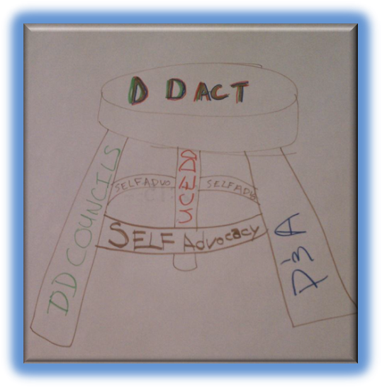
- Write rules in the DD Act to promote self-advocacy

Conclusion

The summits recommended a lot of things for AIDD to consider. However, it is important to know that AIDD has limited funding and cannot do all the things people recommended. Some of the things are more long-term goals.

People said they learned how to work together as a team. The team needs to make sure the voice of self-advocates is the primary voice. The majority of people said the summits “got a lot right” in terms of accessibility for people with intellectual and developmental disabilities. However, there are things that need to be improved on accessibility and inclusion (especially at the state team level).

People who participated in the summits said they were useful. They said they learned about what AIDD does. They said they learned about what other states are doing. They left the summits with energy and excitement. States made plans and are taking actions to support self-advocacy.

For more information check-out the summit website: www.AlliesInSelfAdvocacy.org

