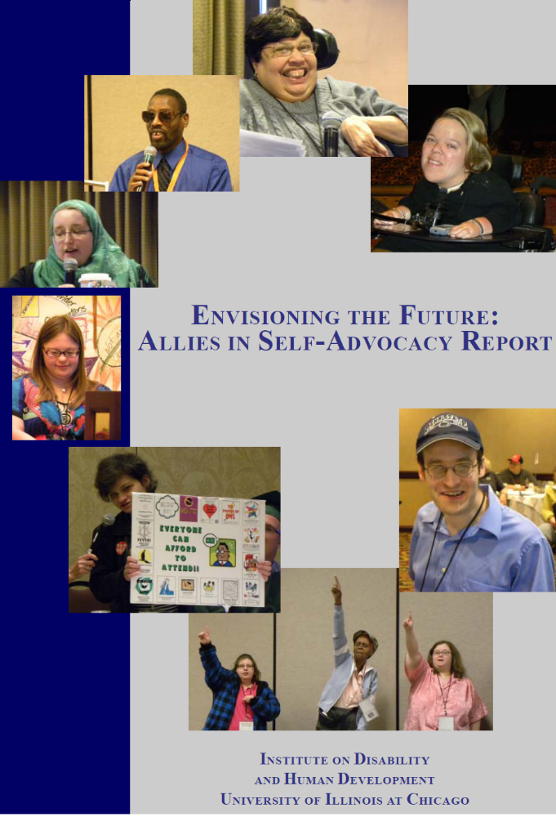
Envisioning the Future:
Allies in Self-Advocacy Report

September 2011

Report Authors:
Joe Caldwell
Katie Keiling Arnold
Mary Kay Rizzolo
Institute on Disability and Human Development
The University of Illinois at Chicago

Self-Advocate Report Editors:
Liz Weintraub, Association of University Centers on Disabilities
Julie Petty, Human Services Research Institute

Publisher:
Association of University Centers on Disabilities

This report was funded by the Administration on Developmental Disabilities through technical assistance contract HHSP23320082917YC. This report was commissioned by the Association of University Centers on Disabilities.
The contents of this document do not necessarily reflect the views or policies of the Administration on Developmental Disabilities, Administration for Children and Families, US Department of Health and Human Services, the US Government, or AUCD.

Background

The Administration on Developmental Disabilities (ADD) is the federal agency that supports the Developmental Disabilities Network. The Network includes Developmental Disabilities Councils (DD Councils), University Centers for Excellence in Developmental Disabilities (UCEDDs), and Protection and Advocacy systems (P&As).

ADD held five regional self-advocacy summits in the spring of 2011. The goals of the summits were to:
- Find out what is happening in the states on self-advocacy
- Make state team plans to strengthen self-advocacy
- Make national recommendations to strengthen self-advocacy

Regional Self-Advocacy Summits
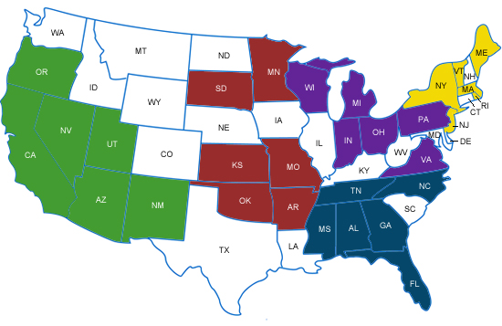
The states that were in the first round of summits were:
- Atlanta, Georgia summit
        - States: Alabama, Florida, Georgia, Mississippi, North Carolina, Tennessee
- Los Angeles, California summit
        - States: Arizona, California, Nevada, New Mexico, Oregon, Utah
- Kansas City, Missouri summit
        - States: Arkansas, Kansas, Minnesota, Missouri, Oklahoma, South Dakota
- Columbus, Ohio summit
        - States: Indiana, Michigan, Ohio, Pennsylvania, Virginia, Wisconsin
- Providence, Rhode Island summit
        - States: Maine, Massachusetts, New Jersey, New York, Rhode Island, Vermont

Because of funding, ADD could not include every state in the first round of summits. However, ADD plans to hold more summits to reach other states and territories.

Each state developed a state team of 9-12 people, with the same amount of self-advocates and professionals. The team included:
- 2 to 3 people from the self-advocacy leadership
- A person from the DD Council
- A person from the P&A
- A person from the UCEDD
- A person from the DD Services Agency

FINDINGS

Self-Advocacy in the States
States teams did presentations on self-advocacy in their state. States were all at different places in their support for self-advocacy. Some states had a lot of support and strong movements. Some states were still trying to form a statewide organization. Some state teams knew each other well. Others were still getting to know each other.

Plans to Strengthen Self-Advocacy in States
State teams made plans to make the self-advocacy movement in their state stronger. The main goals of their plans were:

- Support peer training, mentoring, and leadership development (like serving on boards and committees)
- Strengthen supports and funding for self-advocacy at the local, regional, and state level
- Strengthen partnerships with other disability organizations and allies
- Reach out and communicate with other self-advocates (like youth and other population that are not part of the movement)
- Educate the public about disability and self-advocacy (like getting rid of the “R” word)
- Improve community services and supports (like education, transition, transportation, housing, and community living)

National Recommendations
State teams also came up with recommendations to support self-advocacy at the national level. Some recommendations were for actions that ADD could take in the short term. Other recommendations were for policy changes. These are the major things that state teams said.

Things that ADD could consider doing in the short term:

Provide support to strengthen self-advocacy
- Support state self-advocacy information and training centers run by self-advocates
- Start a national resource center run by self-advocates to assist local and state self-advocacy organizations
- Provide support for self-advocacy through national DD Network associations (Association of University Centers on Disabilities, National Association of State Developmental Disabilities Councils, and National Disability Rights Network)

Promote inclusion and self-advocacy at the federal level:
- Hire and provide leadership opportunities for people with disabilities at the federal level
- Improve accessibility and use of respectable language
- Raise expectations for DD network and grantees about including self-advocates

Educate people about disability and self-advocacy

Work with other federal agencies on issues (like improving education, employment, transportation, and community services)

Bigger policy recommendations for the Developmental Disabilities
(DD) Act:
- Make state self-advocacy information and training centers as an equal part of the DD Act. Some people call this adding the “fourth leg.” Another way to think about it is that it would support the UCEDDs, P&As, and DD Councils and make the DD Act stronger.
- Require the DD network to work together on a plan to strengthen
self-advocacy
- Require the UCEDDs and P&As to support self-advocacy (like the
DD Councils)
- Require DD Councils to include a young self-advocate (under 28 years of age) on the Council
- Promote inclusion of self-advocates with significant disabilities and self-advocates from underrepresented communities
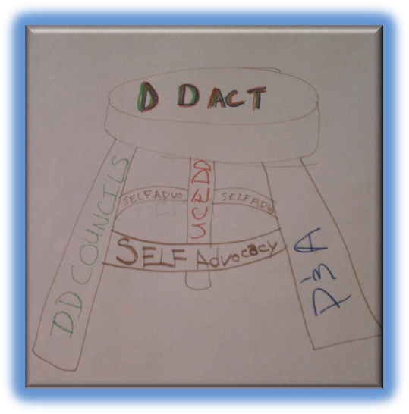
- Write rules (called regulations) in the DD Act to promote
self-advocacy

Conclusion

The summits recommended a lot of things for ADD to consider. However, it is important to know that ADD has limited funding and cannot do all the things people recommended. Some of the things are more long-term goals.

People said they learned how to work together as a team. The team needs to make sure the voice of self-advocates is the primary voice. The majority of people said the summits “got a lot right” in terms of accessibility for people with intellectual and developmental disabilities. However, there are things that need to be improved on accessibility and inclusion (especially at the state team level).

People who participated in the summits said they were useful. They said they learned about what ADD does. They said they learned about what other states are doing. They left the summits with energy and excitement. States made plans and are taking actions to support self-advocacy.

For more information, check out the summit website: www.AlliesInSelfAdvocacy.org

