

Issue
 | Nomination of Judge Brett Kavanaugh
 | to the Supreme Court of the United States.

Background
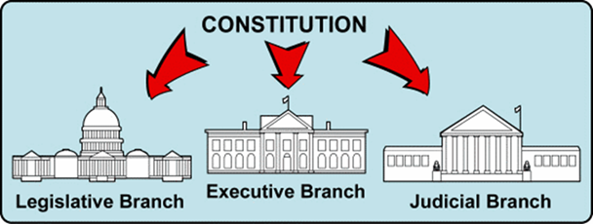 | The Government of the United States has three branches: Legislative, Executive, and Judicial.
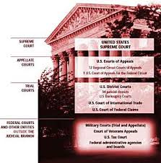 | The Judicial Branch is a system of courts that makes sure our laws follow the Constitution.
 | The Supreme Court is the highest Court.
 | Presidents (Executive Branch) have the power to nominate Supreme Court Justices.
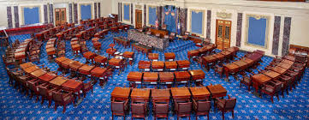 | The Senate (Legislative Branch) has the power to confirm judges.

Disability Rights Concern
 | Disability and civil rights groups
 | believe that Judge Kavanaugh should not be confirmed.
 | His past work shows that he does not understand civil rights for people with disabilities.

Doe ex rel. Tarlow v. D.C.
 | Three women with intellectual disabilities from Washington, DC,
 | had surgeries they didn’t want.
 | The women wanted self-determination.
 | Judge Kavanaugh’s ruling said that people with disabilities don’t have the right to make up their own minds about their bodies.

Action Steps
 | Sample:  I am <Name> from <State>. As a person with a disability, self-determination is important to me. I am worried about Judge Kavanaugh. The way he ruled in the Doe case does not protect my rights. Please learn more about this. Please protect my civil rights.  Thank you
 | Call your Senators at (202) 224-3121
 | Send your Senators an email. Use this link to share your thoughts.
 | Send your comments for us to deliver in person.  Liz Weintraub lweintraub@AUCD.ORG
 | Go to your Senator’s office in your state and share your thoughts.

