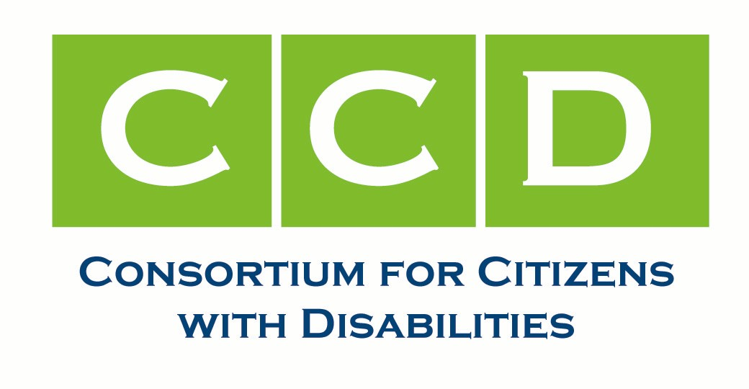
The Honorable Thad Cochran, September 21, 2006
Chairman, Senate Appropriations Committee

The Honorable, Robert Byrd, Ranking Member,
Senate Appropriations Committee

The Honorable Judd Gregg,
Chairman, Subcommittee on Homeland Security

Dear Senators Cochran, Byrd and Gregg:

The Consortium for Citizens with Disabilities’ Emergency Management Task Force, organizations that work with and support people with disabilities across the United States, would like to express our strong support for the disability-specific provisions of the authorizers’ compromise Post Katrina Emergency Management Reform Bill as part of HR 5441, the Department of Homeland Security Appropriations Bill for FY 2007.

We appreciate the Congress working with CCD representatives as these provisions were crafted and believe that, in general, they bring the world of emergency management in the U.S. light years closer to understanding and responding to the issues and functional needs of people with disabilities than ever before. The experiences of last year’s hurricanes were a wake-up call to everyone, and the disability community was particularly affected by the shortcomings of the various systems that did not serve them well. People with disabilities comprised 25-30% of those impacted by Hurricanes Katrina and Rita. We believe that the functional needs of people with disabilities in a disaster, when left un/undermet, provide an unnecessary, costly and dangerous burden on critical infrastructure and limited resources that CAN be minimized, with adequate advance leadership, authority and resources.

Some of the specific provisions in the bill that disability advocates particularly support include:

- The inclusion of people with disabilities in every phase of emergency management activities at all levels of government
- Post-disaster case management services
- Requirements for accessible temporary and replacement housing
- Non-discrimination in services on the basis of disability
- A national Disability Coordinator

We appreciate the fact that the law would incorporate provisions relating to accessibility in shelters, first-aid stations, mass feeding areas, transportation, communications and temporary housing. The bill addresses several housing assistance issues including the expansion of housing options beyond travel trailers or mobile homes. It also addresses disaster rental subsidies and many other types of federal assistance to individuals and households, and speaks to the need to “accommodate the housing needs of people with disabilities.”

We would, however, strongly encourage a specific requirement for fully accessible temporary and long-term relief housing of at least 5% of available or developed housing resources.

Also, we would encourage specific language that would exclude the option of anything but extremely short-term institutionalization as a solution to housing needs for people with disabilities. It is all too easy to fall back on the use of empty institutional beds for people who may have functional needs; but people with disabilities have struggled for too many decades to become free of the stereotype of the helpless institutionalized person with a disability. A disaster should never be the reason for re-institutionalizing an individual who has been or could be living in the community. Institutional settings should be used for no more than temporary shelters, as a last resort.

With regard to medical services and case management services, we would encourage legislative language that would provide specifically for disability-related case management services, as well as specific mental health and substance abuse services. People with cognitive or intellectual disabilities may have a particular need for someone to provide them case management services in order to re-establish their lives. Mental Health and substance abuse services are crucial, not only to people who experience mental health or substance use-related disabilities, but to individuals who might incur a mental condition or substance abuse problem as a result of the disaster.

We also believe that people with disabilities should have access to free legal services provided by legal experts with special training in disability rights and other disability law.

We are pleased with specific provisions of the bill that include standards to accommodate individuals with disabilities in accessibility, communications and programs related to:

- Shelters
- Recovery centers
- Other types of facilities
- First aid stations
- Mass feeding areas
- Portable payphone stations
- Portable toilets
- Temporary housing

We are particularly pleased with the accessible communications provisions. Accessible formats and a wide variety of communications strategies are essential to meet the needs of people with a broad range of sensory, physical and mental disabilities.

We are also very pleased that the bill also mandates nondiscrimination in disaster assistance for people with disabilities by requiring that such things as durable medical equipment and service animals are considered “essential assistance.”

A provision that has long been sought by the disability community is the creation of the position of a National Disability Coordinator. While we fully support this position, we want the Congress to ensure that it is housed in the best possible place within the federal agency structure in order to accomplish expeditious and appropriate actions on behalf of people with disabilities. This means direct access to the highest level of decision-making possible. Delays in getting approvals, in getting policy exceptions based on the needs of individuals, in getting accessible accommodations, in getting exceptional health care needs met were all factors in the barriers encountered by people with disabilities in the relief responses to the 2005 hurricanes. We strongly believe that the National Disability Coordinator must have a great deal of authority to act, and must have access to direct decision-makers, particularly when time is of the essence to someone with a disability. The Coordinator must have adequate knowledge, authority and resources to be effective, and this role must not be subsumed by other responsibilities, even when an emergency or disaster is not known to be imminent.
We also believe that just a single National Disability Coordinator is inadequate. Disaster relief work takes place “on the ground,” and again, the hurricanes of 2005 taught us that often, the intentions of those in Washington, DC were not even known, much less carried out, at the local level. A well-coordinated network of Regional Disability Coordinators would go far in mitigating the information gap, and the communications chasm, that kept appropriate relief and recovery efforts so remote from so many people with disabilities. We strongly encourage the Congress to back up the intention of carrying out solid well-coordinated effort to address the needs of people with disabilities in disasters and emergencies with the national structure and resources to do so.

The disability community also supports the provision calling for Child Locator Centers, family reunification services and a voluntary National Emergency Family Registry and Locator System that would allow a displaced individual to voluntarily register after a disaster, by submitting personal information to be entered into a database that could be used by others seeking to locate that individual.

The bill sets forth standards for state planning efforts, and there is specific language to ensure that “such plans take into account the needs of individuals with special needs and requirements.” While disability advocates would like eliminate the “special needs” terminology, replacing the word “special” with the preferred and far more descriptive term “functional”, we support the intention to address people with disabilities who have medical needs or who utilize care givers or service animals to maintain their independence.

To its credit, the bill would also require training programs for those involved in emergency preparedness and response in “planning for and responding to individuals with special needs,” and it would require accessible transportation assistance.

While not specifically related to disability, people with disabilities, their families and disability organizations are also acutely aware of the lack of coordination among national, state and local government, as well as with non-governmental disaster services such as the American Red Cross. It is critical to the safety of the more than 54 million Americans with disabilities that these significant deficits are resolved and that the rights of people with disabilities are not minimized or abrogated before, during or after an emergency or disaster.

While we do not take a specific position on the authority and placement of FEMA, we would encourage the Congress to retain and adequately resource the federal agency elements that have been of value to people with disabilities – entities that have grown in expertise, and efforts that been inclusive of the disability consumer and advocacy community and have served to bring coordination to current efforts. This would include the Office for Civil Rights and Civil Liberties at the Department of Homeland Security, the Preparedness Directorate, and the Interagency Coordinating Council on Emergency Preparedness and Individuals with Disabilities. Along with complimentary efforts on the part of the US Department of Health and Human Services Office on Disability and Administration on Developmental Disabilities, these entities have been of great benefit to the efforts to meet the needs of people with disabilities in disasters and emergencies. It is critical that these entities work closely with the National Disability Coordinator and be provided with adequate authority and resources, so that there is continuity of leadership as the myriad of issues related to the needs of disaster survivors with disabilities are addressed seamlessly, by experts.
Thank you for the opportunity to support the disability-related provisions of HR 5441, the Department of Homeland Security Appropriations Bill for FY 2007.

Sincerely,

Curt Decker, Co-Chair, Emergency Management Task Force and Chair of the Consortium for Citizens with Disabilities,

Janna Starr, Co-Chair, Emergency Management Task Force

The Consortium for Citizens with Disabilities is a Coalition of more than 100 national consumer, advocacy, provider and professional organizations headquartered in Washington, D.C. (A list of members is available at www.c-c-d.org.) Since 1973, the CCD has advocated on behalf of people of all ages with physical and mental disabilities and their families. CCD has worked to achieve federal legislation and regulations that assure that the 54 million children and adults with disabilities are fully integrated into the mainstream of society. The Emergency Management Task Force was established in 2005 and has more than 25 member organizations.

Encl: CCD’s Principles for Preparedness

