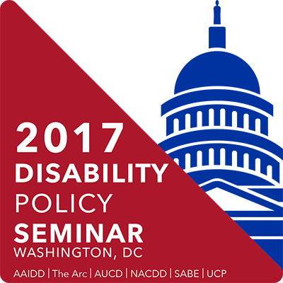
AUCD Trainee Policy Summit
Pre-Work
Before attending the AUCD Trainee Policy Summit and Disability Policy Seminar, there are a couple exercises you should complete as you prepare yourself for visiting Washington, DC and speaking with your legislator and/or their staff. These exercises are designed to help you plan your visit and frame your message for the greatest impact.

Don’t Forget!
- Complete the following homework by March 10!
- Order your 2017 AUCD t-shirt before March 1st and pick it up at the Trainee Policy Summit – then wear it on Monday, March 20th of the Policy Seminar: Order yours here for just $10.07!
- Bring your business cards (you’ll want at least 50 for networking with trainees and professionals from around the country, and for disseminating on your Hill Visits)
- Prepare any promotional material (for an event) or supplementary data (for an issue) from your Center to give to your Legislator/their staffer during your visit
- Bring table décor for your state. On Monday morning of the Policy Seminar, attendees will be sitting at tables designated by state. Bring a few (non-valuable) items that represent your state to display as a fun centerpiece: a blow-up lobster for Maine, a cheesehead for Wisconsin, etc.
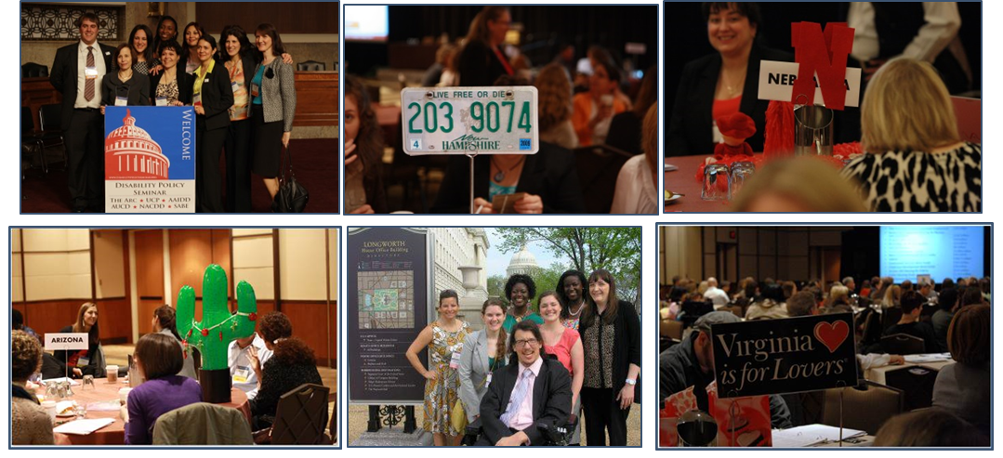
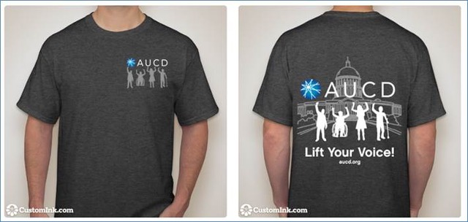

Assignment 1: Plan Your Visit and Speaking Topic
This exercise should be done in conjunction with your faculty/staff mentor and any other trainees or individuals accompanying you on your visit. Ensure you have a consistent message as a team and that individual roles of all making the visit are clear.
Before arriving in Washington, DC, you need to decide what you want to speak to your Legislator(s) about and make one or more appointments. Be sure to discuss the process of making an appointment and persons responsible for making all visits with your faculty mentor, as some programs have specific procedures to follow and goals for your visit. The information and suggestions below should serve to guide your decision making process as you work with your faculty to plan your visit(s).
Task: Using the below outline, determine your “ask” and make your appointment(s). Bring your visit notes and any materials you will be presenting during the visit with you to the Trainee Summit.
- Read this “Quick Start Guide to Educating Policy Makers.”
- Figure out the process for making a Hill visit during DPS.
  - Is your faculty member making the visit for your team?
  - Do you coordinate with attendees from other organizations within your state?
  - Are you responsible? Read “How to Schedule a Hill Visit” for tips.
- Figure out who you’ll be looking to schedule appointments with by using this form to find your legislators.
  - Research their background for information including: What committees are they on?
  - What jurisdiction does that committee have over disability issues or funding?
  - Do they have a personal connection to disability? How have they voted on disability issues in the past?
- Determine if you will be speaking with your Legislator about an experience or an event.
Speaking About an Experience
As a trainee, you have a strong story to tell about your experience and the people you’ve seen during your training year. Legislators may not have not heard of the LEND or UCEDD programs, and you play an important role in informing them of the transformative work happening at these Centers and the lives they touch. By telling that story, you can also inform the Legislators of the importance of funding these programs so future trainees can have the same experiences, and therefore contribute to changing communities for people with disabilities.
You should have a solid level of familiarity and comfort with your talking points to ensure a good visit. Share about your LEND or UCEDD in general, the role of trainees, how trainees help people with disabilities and how they’ll continue to be a change agent for years to come. If possible, bring evidence-based research that supports your experience. Remember that your role is to educate your Legislator or their staff about why that issue is important to you; you should not ask them for anything (support, votes, a commitment) in return as that is considered lobbying.
  - Shape what you talk about with your Legislators: connect your experience to the larger issues. Describe how being trained by the LEND or UCEDD to be a leader in [your] discipline is going to change lives in your community. Use the attached LEND and UCEDD talking points to frame your story and connect it back to legislation or funding that the Member has influence over. (Remember: you can educate them about the importance of funding but not ask them for more funding.)
  - Include a personal story, especially if you have a family member with disabilities. Connecting policies to people not only makes your meeting stand out among the hundreds they have each year, but it reminds everyone that abstract policies have real world effects.
  - Prepare your materials. Bring a branded folder for each person you’ll meet with that contains data, brochures, pictures of individuals, pictures of your Center, etc. that will support your points and make your story memorable. Be prepared to leave a copy of your materials with your Legislator, along with a business card of yourself or your Center so they can follow up with any questions or if they need more information.
  - Draft a thank you. After the visit, you should send a follow up thank you note, simply recapping the visit and providing answers to anything you may have promised to follow up on. Sending a thank you note also serves to strengthen your relationship and establish you/your Center as a reliable point of information. After you return home, complete the thank you note with the specifics and send it off.
An Event
Your LEND or UCEDD is a wealth of information and expertise for Legislators and their staff, but they cannot access it if they don’t know about it. Inviting your Legislator to visit your Center while they are on recess and in their district offices is a great way to build that relationship and help your Legislator understand the work you do and the people you serve.
  - With your faculty mentor, pick an event/program/conference for the Legislator member to attend (or speak at – they love to be invited to speak at events!) in their home district/state, OR invite them to tour your Center.
  - Prepare talking points on what they’ll learn during the event/tour, the people they’ll meet, the work being done, and how it makes a difference in the lives of constituents. You’ll want to be well versed on the event or the breadth of work being done at your Center so you can properly promote it during your visit. Tell your story of how the Center has changed your perspective and impacted your training.
  - Create/bring an invitation with the specifics. Include the Center logo, address, and contact information (likely of your faculty mentor) for more information or a confirmation. If you’re inviting them to an event, include the date and theme.
  - Draft a thank you. After the visit, you should send a follow up thank you note, simply recapping the visit and providing answers to anything you may have promised to follow up on. You may want to re-include a copy of the invitation. After you return home, complete the thank you note with the specifics and send it off.
  - Complete the official invitation. Simply talking to a member of Congress or a staffer and inviting them in person is not enough. After you return home:
    - Contact the staffer that was your point of contact during your Hill visit, or
Contact the official Scheduler in the Member’s state office closest to your Center or event
    - Maintain an open dialogue with your point of contact, regardless of the status of the invitation
    - Follow up as appropriate with reminders about the event
- Think about how you’ll share your visit
  - Plan to email AUCD staff (Kim: kmusheno@aucd.org) about your who you visited and how it went. AUCD will follow up with them to help facilitate a lasting relationship and answer any future questions about our Centers, disability policies, and the people they affect.
  - Contact your Center/university and inquire if they’ll post your story and photos. Your visit is a big deal and you deserve some credit. Members of Congress also enjoy being tagged in positive posts or seeing a photo of them with constituents in a local newsletter.


