**NIRS Boot Camp Day 4 Script**

Table of Contents

1.0 Questions and Answers (Q&A) from Boot Camp Day Three 2

2.0 Autism CARES Module 3

2.1 What is CARES Module 3

2.2. Accessing and managing the Autism CARES Evaluation Module 4

2.3 Starting the Autism CARES Module and using Module data 5

2.4 Overview of LEND Program Quality Improvement (LPQI) 9

3.0 DGIS Export, Data Review 2019+ Export Tool 11

4.0 Export/ Import NIRS Data Tools 15

4.1 Export 15

4.2 Import Tool 21

4.3 Import Exercises 23

4.3.1 Transfering multiple records from the previous year into a new year 23

4.3.2 Importing NEW data 33

Welcome to the fourth and final Bootcamp session! We will start with questions and answers (Q&A) from the homework.

The rest of day four will be dedicated to going through the Autism CARES Module, LPQI, the “DGIS Export, Data Review 2019+” tool, and exporting/importing data in NIRS.

**Learning Objectives for today's session:**

By the end of the boot camp, participants will learn how to:

1. Manage data in the Autism CARES Module
2. Leveragw the LEND Program Quaity Improvement (LPQI) Application
3. Review data in the “DGIS Export, Data Review 2019+” Export Tool
4. Extract data from data in NIRS using the Export function
5. Enter bulk records into NIRS using the Import function

**Helpful Links for Today's Session**

[NIRS Resources Page](https://www.aucd.org/template/page.cfm?id=449)

[NIRS Data Dictionary](https://www.aucd.org/nirs/db/dd.cfm)

[NIRS User's Guide](https://www.aucd.org/nirs/db/help.cfm)

[LPQI Resources](https://www.aucd.org/template/page.cfm?id=993)

[LPQI Recording](https://vimeo.com/712204227/9a35de42a7)

[Discretionary Grants Information System (DGIS)](https://mchb.hrsa.gov/data-research/discretionary-grants-information-system-dgis)

[Tips Sheet – Data Cleaning in the Products Dataset](https://www.aucd.org/docs/nirs/NIRS_training_fy2022/2022%20NIRS%20Tips%20Sheet%20Data%20Cleaning%20in%20the%20Products%20Dataset.pdf)

[2020 Import Tool Webinar](https://aucdnirsrelatedmaterials.s3.amazonaws.com/2020+NIRS+Import-Export+Webinar)

# 1.0 Questions and Answers (Q&A) from Boot Camp Day Three

Questions and answers (Q&A) from the audience on Day Two of the NIRS Boot Camp.

# 2.0 Autism CARES Module

## 2.1 What is CARES Module

The Autism Collaboration, Accountability, Research, Education and Support Act (Autism CARES) is **the primary source of federal funding for autism research, services, training, and monitoring**.

**Examples of Autism CARES grantees:** ITAC, LEND programs, DBP programs

The Autism CARES Act **ensures support for research, services, prevalence tracking, and other government activities**.

AUCD recognizes that as required through the Government Performance and Results Act (GPRA) and specific accountability criteria outlined in the Autism CARES Act, data collection and analysis for the CARES-funded training programs is vitally important to MCHB for monitoring recipients' progress and assessing investments related to training. Furthermore, in order for training recipients to accomplish their program goals, they need to have access to system data and have the ability to analyze and use it for QI efforts.

A specific NIRS module has also been developed for LEND and DBP programs to collect/report on their specific autism specific-related training and clinical activities under the Autism CARES Act (i.e. "CARES module"). The data is collected annually from this module and is sent to MCHB.

LENDs and DBPs submit the Autism CARES Module on an annual basis.

## 2.2. Accessing and managing the Autism CARES Evaluation Module

The Module can be found in the main navigational area, the Admin section, sub-menu "CARES Evaluations."

Only NIRS users with Administrative access can access the CARES Evaluation module.

**Autism CARES Timeline**:

The Autism CARES Module is open in the middle of June, with a deadline in the middle of July. Below is a diagram to visualize the timeframe.

## 2.3 Starting the Autism CARES Module and using Module data

The CARES Module can be accessed in the admin dataset. The page may be empty if your program is new to NIRS and if it is your program’s first year.

The page will include Reports from past years if your program has participated in NIRS for some years. (Example below). NIRS administrators can only VIEW data submitted from previous years.

To view the submitted Report, click VIEW:

An “ADD” button will be displayed for Programs the first time the module is accessed in the current reporting year.

To review the Module during our demonstration, we will use the form from Fiscal Year 2022 because the 2023 CARES module is still closed.

Let's look at the module’s report structure:

The introduction text includes a definition of each trainee category and a link to the Data Dictionary.

There are four Topic areas:

1. Topic Area I: Training Trainees
2. Topic Area II: Other Training Activities
3. Topic Area III: Service Delivery
4. Topic Area IV: Research

Each area has a list of questions:

1. Topic Area I = Questions #1 through 3
2. Topic Area II = Questions #4 through 7
3. Topic Area III = Questions #8 and 9
4. Topic Area IV = Question #10

I want to use the Bootcamp session to update you on recent updates in the Autism CARES Module that were completed last week.   
  
This year, in June 2023, you will see a slightly revised form when you work on completing the Autism CARES Evaluation. MCHB decided to reduce the burden on grantees and eliminated Question #1 in Topic Area I.

Question #1 = Total number of trainees: Short-, Medium-, Long-term.

MCHB felt that data included in Question #1 is duplicated from reporting completed in your performance report in the EHB. So, MCHB will be using data on the number of short, medium, and long term trainees entered in the EHB as opposed to in the Autism CARES module. Question #1 is grayed-out, and the form displays test provided by MCHB to clarify the change. I want to share a screenshot of the form:

Additionally, this year MCHB removed ableist language from the autism CARES module. “ASD/DD” was replaced with “AS/DD”.

**Business Rules of the Form:**

1. All questions are type-in, i.e., you should provide the answer by typing it in.
2. All answers must be only numbers. Text is not allowed. An error message will appear if text is provided.

1. The **SAVE Button** at the top of the form allows you save data that has been entered on the form and allows you to return to completed the module at a later time after it is has been started.
2. The **SUBMIT Button**, at the bottom of the form, will submit the form to AUCD and lock all data. **Note:** You will not be able to edit the data after submitting the form.

How can NIRS help you to answer the questions in the Module? The trainee dataset is the central area where you manage records for trainees. Based on the data that has been entered in NIRS, AUCD developed various reports that assist you in completing the CARES Module questions.

**Topic Areas I - III** have links to relevant reports containing information that will assist with answering the questions in the Module. These reports contain your program’s data that were entered by data coordinators throughout the year.

**For Topic area I**, on Training Trainees, there are three separate standard reports, which pull data for Short-term, medium-term, and long-term trainees that have been entered in the trainee dataset. Simply click on the text, highlighted in blue, to run each report.



**Topic area II**, on Other Training Activities, also has a standard report that will pull data entered by data coordinators from the activities dataset. Simple click on “click here” to run the report.



**In Topic III,** on Service Delivery, click on “click here” to run the standard report that will help in answering questions eight and nine.



**Resources:**

1. [Autism CARES Module Tutorial Video](https://www.loom.com/share/9155808f8e6440d5af90f001ec6eb32e)
2. [Autism CARES Module Script](https://www.aucd.org/docs/nirs/NIRS_training_fy2022/2022%20Autism%20CARES%20Evaluation%20Script%20PDF.pdf)

**Note:** The recording and script are from PY21/FY22 and will be updated.

## 2.4 Overview of LEND Program Quality Improvement (LPQI)

**LPQI = LEND Program Quality Improvement**

The goal of the LEND Program Quality Improvement (LPQI) Network is to help individual programs improve the quality of LEND training in core competencies (e.g. interdisciplinary team building, family-professional partnerships, policy (focus on system change) by:

1. Using standardized measurement tools (i.e. to show that LENDs are effective across state borders)
2. Developing a voluntary inter-institutional database
3. Providing feedback to programs to use for quality improvement
4. Identifying programs that demonstrate changes consistent with "best practices"

There are two helpful Podcasts through the Journal of the American Association for Pediatrics which supplies helpful information on the LPQI Network:

1. [A Quality Improvement Network for Interdisciplinary Training in Developmental Disabilities](https://publications.aap.org/pediatrics/article-abstract/150/6/e2022058236/189925/A-Quality-Improvement-Network-for?redirectedFrom=fulltext)  
   Pediatrics on AAP Podcast (starts at 20:19 min)  
   Jennifer Smith, PsyD, BCBA-D, LEND Director, OH
2. [Reducing Harm from Firearms, Improving Training in Developmental Disabiilities – Episode 139](https://www.aap.org/en/pages/podcast/reducing-harm-from-firearms-improving-training-in-developmental-disabilities/)  
   Pediatrics Article on multidisciplinary training in the field of developmental disabilities   
   Lois K. Lee, MD, MPH, FAAP, FACEP  
   Jennifer Smith, PsyD, BCBA-D, LEND Director, OH

**How to Gain Access to LPQI:**

Send an email to [Nirs@aucd.org](mailto:Nirs@aucd.org) with request to join LPQI. Please include in your email an administrator who will manage LPQI.

**What to do with LPQI:**

1. Set up schedule (T1, T2, and T3).
2. Invite trainees
3. Invite faculty
4. Invite trainees to submit a LPQI survey
   1. This is completed at the beginning and again at end of year
   2. We recommend using the automatically generated email invitation, built into the LPQI application
5. Ask faculty to assess trainees in the middle and at the end of the year.

Please note that there are multiple support available for the LPQI application:

1. A manual detailing LPQI
2. Tutorial Videos
3. TA Support at [nirs@aucd.org](mailto:nirs@aucd.org)

**Helpful LPQI Resources:**

[**LPQI Resources**](https://www.aucd.org/template/page.cfm?id=993)

[**LPQI Recording**](https://vimeo.com/712204227/9a35de42a7)

# 3.0 DGIS Export, Data Review 2019+ Export Tool

**DGIS =** Discretionary Grant Information System **EHB =** Electronic Handbooks

Initially released in October 2004, the Discretionary Grant Information System (DGIS) is a web-based system that allows grantees to report their data online to the Maternal and Child Health Bureau (MCHB) through HRSA's Electronic Handbooks (EHBs) as part of grant application and performance reporting processes.

Below is a diagram that explains how reporting data gets into DGIS/EHB.

MCHB’s DGIS system opens only for reporting system once a year. AUCD developed the NIRS application to assist programs/centers in preparing data systematically throughout the year. [data complete + accurate + tools in NIRS can be used throughout the year]

The NIRS application includes the tool that exports all reportable data at the end of each Program/Fiscal year and imports program data to the MCHB database (EHB.). The tool is available for each center to review reportable data for their center at any time.   
  
The tool's name is "DGIS Export, Data Review 2019+" and can be found under the Admin navigational tab.

**Note:** In 2019, MCHB revamped the data import format, so we have two options,   
1) DGIS Export, Data Review 1998-2018 and   
2) DGIS Export, Data Review 2019+  
  
The DGIS Export tool is accessed in the admin dataset.

The DGIS Export, Data Review tool allows NIRS administrators to select the reportable year and dataset(s).   
  
**Note**: **Only Trainees and Products data are included in the DGIS export.** While the Directory dataset (faculty) is listed as an option, it is **not** a reportable dataset. MCHB stopped requesting faculty data in 2018. Data coordinators requested to keep it as an option for internal purposes.

**Step by Step instructions on using the DGIS Export, Data Review 2018+ tool below:**

1. Select "fiscal year(s)" – as a required single-select field. The default is the current fiscal year.
2. Check the box(es) for datasets – checkboxes allow multiple selections if needed: Trainee, Products, and/or Faculty. By checking the boxes for Trainees and Products, data is included from those datasets into your export files.

1. Click "Export."
2. On the next page, follow the instructions at the top of the page to download files.   
   **Note:** The export results are 15 files for the Products dataset; there is one file for each product material type. There are two files for the Trainee dataset: current and former trainees.

**Best Practices when using the DGIS Export, Data Review Tool:**

**For Current/Long-Term Trainees** (Trainee_Current_LEND in the above example), you could compare the .CSV file with the Trainees' dataset > manage long/med term trainees.

**For Former Trainees** (Trainee_Former_LEND in the above example), you could compare the exported list with two other lists:

1. long term trainees in trainee dataset > standard report > Long term Survey Info (2018+)
2. Trainee dataset > list survey

**For Products:** You could compare the each product .CSV file with products listed in each material type in products dataset > add product > click the number under “total Type Items” next to the appropriate product material type

**Data Cleaning Tips for Reportable Data:**

**TRAINEES**

1. Review the Standard Report: Trainee Data Entry Errors and resolve any error messages.
2. Compare the number of current Trainees exported with the number of Trainees in the NIRS Trainee dataset > **Manage Long/med term trainees**
   * **Example:** for –AAA Test Center, there are 6 exported but 7 trainees listed in NIRS
3. Compare the number of Former Trainees exported with the number of Trainees in the Trainee dataset > Standard Report > under LEND, LEAH, PPC, DBP > **Long Term Survey Info (2018+)**

**PRODUCTS**

1. Review the Standard Report: Product Data Entry Errors and resolve any error messages.
2. [**Tips Sheet – Data Cleaning in the Products Dataset**](https://www.aucd.org/docs/nirs/NIRS_training_fy2022/2022%20NIRS%20Tips%20Sheet%20Data%20Cleaning%20in%20the%20Products%20Dataset.pdf)

# Export/ Import NIRS Data Tools

|  |  |
| --- | --- |
| **Import** | **Export** |

Import and Export of data share a semantic analogy with copying and pasting, in that sets of data are copied from one application and pasted into another.

The concept of those tools (Export and Import) is straightforward: get data in and out of NIRS. Both tools are located under the Admin tab. Only data coordinators with Admin access can use those tools.

## 4.1 Export

Let's start with the Export tool. The Export tool will allow extracting data from the NIRS database. The Export tool will save data from relevant database tables into an Excel spreadsheet.

The Export tool is located in the admin dataset in NIRS. As such, only NIRS administrators at your center/program can view and use the Export tool.

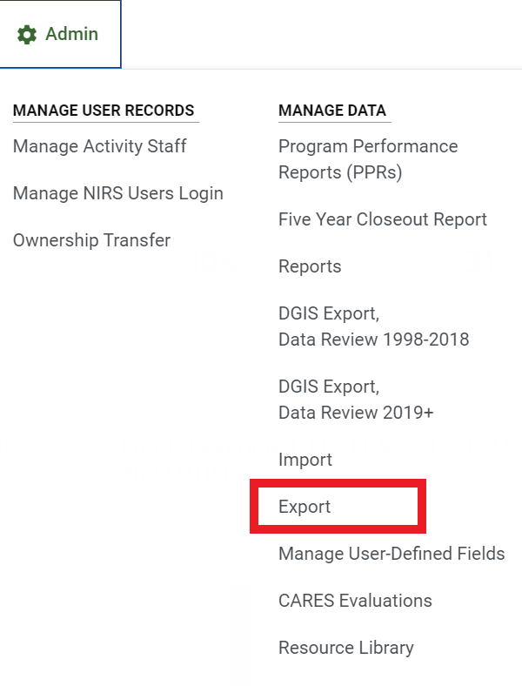

There are two practical uses for the Export tool:

1. NIRS is one of many information systems available online. Using the Export tool, you can extract all the data that has been entered into NIRS over the years and move the data to a different system or application (i.e. excel sheets).
2. The export tool can also be sued to move data in bulk from the past years to the current program/fiscal year. Today we will do an exercise together when we talk about the importing data.

Let's go to the Tool and see it in action.

On the Export Page, there are three columns. From left to right, they are as listed:

1. **Data Dictionary and definitions** of all fields listed in the in the .CSV files.
2. **EXPORT OPTIONS:**   
   Your center is reporting data to MCHB on an annual basis, so you can:
   * select a specific year, OR
   * select multiple years, OR
   * select ALL YEARS.
3. **EXPORT:**  
   You can select one dataset at a time, which will export a .CSV file with your data. **Note:** Trainee profiles consist of a main + annual record(s) pair. You will need to export Trainees + Trainees Years.

Below is a list of steps on how to extract the data using the Export tool. If there are any questions on using the tool, please contact [nirs@aucd.org](mailto:nirs@aucd.org).

**Tips when using the Export Tool**

|  |
| --- |
| 1. Select the appropiate years under EXPORT OPTIONS.   In our example, we will select FY2023. |
|  |
| 1. Select which dataset you wish to download data from under EXPORT.   For our example,we will select Products (for FY2023 data included in the Products dataset) |
|  |
| 1. A popup window will open in your browser, indicating that records were found and processed.   A .CSV file will appear in your DOWNLOADS folder on your device. |
|  |
| 1. Open the .CSV file using excel.   **SUCCESS!**   In our example, the file contains all data that exists in the product dataset from FY2023. |
|  |

|  |
| --- |
| Screen shot with our .CSV file with exported Product data below: |
|  |
|  |
| **Note that all export files match with online NIRS Forms.**   In our example, we selected the Product dataset. Field headers in the .CSV file starting in cell A1 match with fields in the Products dataset in NIRS: |
|  |

For example, in our .CSV file, cell S1 reads “materialType”. In cell S2, materialType = BK (meaning Product Material type book).

You may also note that cell C1 reads “title” which matches with the “Title” field on the Product Material type Book online form in NIRS.

As previously mentioned, we have also a data dictionary and Code Table linked on the Export tool page in NIRS. Let’s have a look at them.

1. The first column in the Export tool includes two essential links:

[**NIRS Table and Field Definitions**](https://www.aucd.org/nirs/db/admin/structures.cfm?): this is the data dictionary of the NIRS database. It includes a list of all tables with listed field datatypes. We are transparent in our approach, so we are giving you all information about database architecture.

[**Code Table Definitions**](https://www.aucd.org/nirs/db/admin_codes.cfm?)**:** that table displays the relationship between the online display value and the value entered in the database.

For example, the list starts with **Activity**.

|  |  |
| --- | --- |
|  |  |
|  |  |

If it is helpful, try searching for various fields (we find pressing CTRL + F together helpful). This will help to familiarize with each field and interpret mapping between NIRS and the .CSV files.

## 4.2 Import Tool

Now that we have reviewed the Export tool and how to extract data from NIRS, let’s go on to the Import tool.

The Import tool allows upload of data in bulk from external sources into NIRS.

You can import data into four datasets:

1. Products
2. Activities
3. Projects
4. Trainees (Main + Annual records).

The Import tool is also located in the admin dataset. As such, only NIRS administators at your program/center will be able to view and use the Import tool.

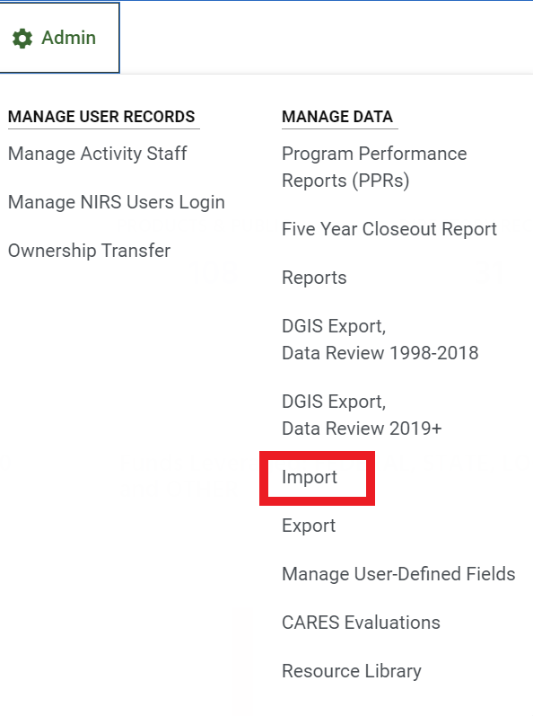

You can read business rules at the top of the page in the Import tool.

**Note: Data imported will always be added to the current program/fiscal year.**

On the Import tool page, you will see that it is split into three columns:

* + - On the left side, you can find references and other helpful materials.
    - In the middle column, you can find links to the templates that can be used with the import tool.
    - On the right side, you can select the file you wish too upload. Files will be selected from your device.

**Note:** The Import button highlighted in blue will read data from the selected file and enter the data into the NIRS database.

When creating the script, I thought about how to present the Import tool to minimize the work of data coordinators in and across the network and to ease up the technological learning curve. I decided that instead of going over each dataset and database fields, I would set up a targeted exercise based on the past data coordinators' requests/questions. Please feel free to provide any feedback on the learning curve, materials, explanation of the import/export tool and whether it will be a comprehensive approach. We can always be reached at [nirs@aucd.org](mailto:nirs@aucd.org).

## 4.3 Import Exercises

As previously mentioned, the import tool has two potential uses which we will cover below:

1. Transfering multiple records from a previous year into a new year
2. Importing new data

## Transfering multiple records from the previous year into a new year

One common question that many data coordinators ask:

**How can I transfer multiple products/projects/activities from the previous year into a new year?**

**Answer:** There is no tool for that, and I will teach you how Export and Import Tools can do the job for you.

**Step A:** export the data from the last year using Export Tool

**Step B:** update records in a Excel file

**Step C:** Import the file using the Import Tool.

There are several steps involved. The next section will be dedicated to providing tips to help guide the import process in the product and activity datasets.

**PRODUCTS**

|  |  |
| --- | --- |
| 1. Before getting started, run the **data entry error standard report** for the **product dataset** to ensure that all required fields are entered. If there are any error messages, resolve them. | |
| 1. **Export** the records from the desired year(s) using the Export tool. | |
| Graphical user interface  Description automatically generated with low confidence  Graphical user interface, text, application, email  Description automatically generated  Graphical user interface, application  Description automatically generated | |
| 1. **Update** the excel files.   Below is a list of potential modifications to prepare the .CSV file for Importing into NIRS. | |
| 3.1 First, update the ProductID. We recommend starting with any number greater than 10. | |
| **Before Updates:**   | **After Updates:**   |
| 3.2 This step is **ONLY** if you are **UCEDD/LEND**:   flip 'LEND,UCEDD' to 'UCEDD,LEND' | |
| **Incorrect Entry**:   | **Correct Entry:**   |
| 3.3 Update the reporting year from whatever is in the file to a current year | |
| **Before Updates:**   | **Updated Entries:**   |
| 3.4 Update the Publication Date | |
| **Before Updates:**   | **Updated Entries:**   |
| 1. Review any other fields in the excel sheet you feel need to be updated (i.e. title, etc.)   Once you feel the .CSV file is ready to import, go to the import tool in the admin dataset. On the left hand side, choose the excel file from your device. Click the import button highlighted in blue.   **Note:** Be sure to import under the correct dataset. | |
| If the import was **not successful**, you will see an Error message: | |
| Table  Description automatically generated  The error message will help to resolve any errors. You will need to return to your excel sheet to make corrects before trying again.   For example, the error report begins with a description of the field that needs to be corrected, which field the error occurred with, which row number the error occurred on in the excel sheet, and the explanation of why the error occured.  Based on the error message in our example above, we know that we should locate the field header “ProductID” in our excel sheet, and on rows five through eight, enter a valid number into those records. | |
| If the import **was successful**, you will see the following message: | |
|  | |
| 1. Once the import has been successful, run the **data entry error standard report** in the **product dataset** again to ensure that all required fields are entered correctly. If any errors are listed, resolve them. | |

**ACTIVITIES**

|  |
| --- |
| 1. Before getting started, run the **data entry error standard report** in the **activity dataset** to ensure that all required fields are entered. If there are any error messages, resolve them. |
| 1. **Export** the records from the desired year(s) using the Export tool. |
| A picture containing table  Description automatically generated  Graphical user interface, text, application, chat or text message, email  Description automatically generated  Graphical user interface, application  Description automatically generated |
| 1. **Update** the excel files.   Below is a list of potential modifications to prepare the .CSV file for Importing into NIRS. |

|  |  |
| --- | --- |
| 3.1 First, update the ActivityID. We recommend starting with any number greater than 10. | |
|  **|  **|
| * 1. This step is **ONLY** if you are **UCEDD/LEND**:   flip 'LEND,UCEDD' to 'UCEDD,LEND' | |
| **Incorrect Entry:**   | **Correct Entry:**   |
| * 1. Update the Activity Date to the current year | |
| **Before Updates:**   | **After Updates:**   |
| * 1. Update the Activity Duration and During_Not_Applicable fields   0= No 1=Yes  If we are following along, we know that the Duration field is required in the activity dataset. We must provide a response for all records in the excel sheet.   For our example, we will change all responses in “ActivityDuration” to zero (0).   We will then indicate yes (1) in the “Duration_Not_Applicable” field in our excel sheet. We can update these responses later once we have successfully imported the data, if applicable. | |
| |  |  |  | | --- | --- | --- | | **Before:**   ActivityDuration | | Duration_Not_Applicable | | 1 | 0 | | | 0 | 1 | | | |  |  | | --- | --- | | **After:**   ActivityDuration | Duration_Not_Applicable | | 0 | 1 | | 0 | 1 | |  |  | |
| * 1. Update the Collaboration Agency field.   For our example, we will list “na” in these fields. We can update the fields later once we have imported the data successfully, if applicable. | |
| 1. Review any other fields in the excel sheet you feel need to be updated (i.e. title, etc.)   Once you feel the .CSV file is ready to import, go to the import tool in the admin dataset. On the left hand side, choose the excel file from your device. Click the import button highlighted in blue.   **Note:** Be sure to import under the correct dataset. | |
| If the import was **not successful**, you will see an Error message: | |
| Graphical user interface, text, application  Description automatically generated  The error message will help to resolve any errors. You will need to return to your excel sheet to make corrects before trying again.  In our example above, the description tells us that we have a user-defined field that could not be read in our excel file.   Simply fix the header in our exel sheet to fix the error message. Remember that user-defined fields are case-sensitive. Once we have fixed the errors, we can attempt to import again. | |
| If the import **was successful**, you will see the following message: | |
|   **SUCCESS!** | |
| 1. Run the **data entry error standard report** in the activity **dataset** again to ensure that all required fields are entered correctly. If any errors are listed, resolve them. | |

We hope that these tips are helpful. If there are any questions, please contact [Nirs@aucd.org](mailto:Nirs@aucd.org).

**TRAINEES Main and Annual record pair**– We could not see a scenario in which data coordinators might want to export and import the same trainee profiles, as doing so would create duplicates.   
  
However, data coordinator’s may wish to enter trainee records in bulk for new trainees. In this case, it is important to prepare two excel files: one for their MAIN record, and another for their ANNUAL record. Both files can be imported one after the other to ensure that all trainees have a complete trainee profile.

We will take a short five minute break before moving on to our last scenario: Adding new data using the Import tool.

## 4.3.2 Importing NEW data

As we mentioned earlier, there are two possible scenarios when importing data into NIRS:

1. Transfering multiple records from a previous year into a new year
2. Importing new data

Since we just covered the first scenario, we now want to cover adding new records to NIRS.

For example, you (the data coordinator) has collected data on trainees at your training program, and compiled them into an excel sheet. There are many trainees, and you ask yourself “Is there an easier way to add all these trainees in bulk into NIRS?”   
  
The answer is YES!

The import process was first created by request from data coordinators to help decrease the amount of time that they were spending on data entry.   
  
Please also note that all data will be imported into the current program/fiscal year.

With more practice importing data, the more comfortable you will become with the import process.

We created a chart to help visualize the steps needed for the import process:

As a helpful resource for importing bulk records into NIRS, AUCD created templates to use with importing records into NIRS. Each template also contains helpful examples on the first few rows to help guide your process.

Where can you find NIRS Templates for the Import process?

NIRS Resource > Templates <https://www.aucd.org/template/page.cfm?id=449>

Let's look at how those templates look. We will start with Products.

* Each Product Material Type has an individual template
* You will need to select the product material type that you need/want. You can then download the template onto your desktop (it may be located in your download folder).
* Review the template.

Each template has some similarities. You will notice:

1. Some fields allow regular text, so you can easily type in those fields in the template:

1. Some fields contain abbreviated values, and may be difficult to decode so that you know which values to enter into them.

For example, **target_audience**. In the online Product form:

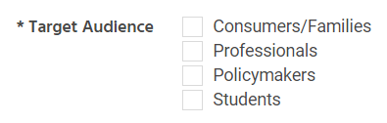

In our scenario: we will answer the following question: **What does “P,M” mean?**

Now we can demonstrate how to find definitions for values in each import template. AUCD created an excel spreadsheet for each dataset, that can be used to show the mapping in each template. Let’s demonstrate how to use them as tip sheets.

The tip sheets are located in the admin dataset > import. Once in Import tool window, review the first column. Templates are linked under "**FIELDS MAPPING and DEFINITIONS**”.   
  
In our example, we will use the template linked under the import for Products by clicking on the text highlighted in blue “**Full list of Product NIRS fields mapping database fields with online form fields”.**

Let's download the tip sheet and review it. In our example, we will use the Product temple for material type “Book”:

Let's find **target_audience:**

|  |  |
| --- | --- |
|  | Professionals  Policymakers |
|  |  |

To answer our original question: we can see that P,M means **Professionals** and **Policymakers**!

Let’s do another example. Let’s find the field “AlternativeFormats” and answer the question, **“What does “V,C,A,L” mean?”**

Another column: **AlternativeFormats**

|  |  |
| --- | --- |
|  | Visual Format or Large Print  Captioned  Audio (cassette, audio file, etc.)  Language other than English |
|  |  |

We can see from the tips sheet that “V,C,A,L”means “Visual Format or Large Print”, “Captioned”, “Audio”, and “Language other than English”.

**Resources:**   
  
There is also a helpful video detailing the use of the mapping spreadsheet:

[2020 Import Webinar](https://aucdnirsrelatedmaterials.s3.amazonaws.com/2020+NIRS+Import-Export+Webinar)

Please see below for a few helpful tips before we wrap up today’s session:

1. When importing in the **product dataset,** import records from only one product material type at a time.
2. When importing in the **activity dataset**, import records from only one activity core function at a time.
3. When importing in the **trainee dataset**, be sure to upload their trainee MAIN + ANNUAL record pair one after the other.

* For example, prepare two excel sheets using the appropiate templates, one for their trainee MAIN record, and the other for their ANNUAL record) .

1. When preparing the import templates, there are examples at the top to help guide you.
2. Do not forget to delete the example rows before you import the templates.
3. Be sure to include correct spacing when entering your own data in the excel templates. For fields that allow multiple choice, each option should be separated by a comma without spacing.
4. Take each column in the excel templates step by step and one at a time.
5. Lastly, we are here to help! Message [nirs@aucd.org](mailto:nirs@aucd.org) with any questions

**Thank you everyone for joining us for the boot camp!**