**NIRS Boot Camp Day 3 Script**

Table of Contents

1.0 Questions and Answers (Q&A) from Boot Camp Day Two 3

2.0 Projects Dataset 3

2.1 Introduction of Projects Dataset 4

2.1.1 Projects and NIRS Public Search 4

2.2 Manage Project Records 5

2.2.1 Create Project record 6

2.2.2 List, View, Delete 8

2.2.3 Searching and Managing Projects records 9

2.2.4 Standard & Custom Reports 11

2.2.4.1 Standard reports 11

2.2.4.2 Custom reports 12

2.2.5 Administrative Tool: Manage User-Defined Fields 14

2.3 Homework for Project Dataset 15

3.0 Activities Dataset 16

3.1 Introduction to Activities Dataset 16

3.2 Manage Activities Records 16

3.2.1 Create Activities Records 16

3.2.2 View, Edit, Delete 23

3.2.3 Search Activities records 23

3.2.4 Standard & Custom Reports 24

3.2.4.1 Standard reports 24

3.2.4.2 Custom Reports 26

3.2.5 Administrative Tool: Manage User-Defined Fields 28

3.3 Homework for Activities Dataset 30

4.0 Products Dataset 31

4.1 General Information about Products 31

4.2 Products and NIRS Public Search 31

4.3 Create Product Record 32

4.4 List, View, and Delete 35

4.5 Managing and Searching Projects records 35

4.6 Product Dissemination Tool 37

4.7 Standard & Custom Reports 38

4.7.1 Standard Reports 38

4.7.2 Custom Reports 38

4.8 Administrative Tool: Manage User-Defined Fields 40

4.9 Homework for Products Dataset 42

5.0 Closing Remarks 43

**Introduction**

**Learning Objectives for today’s Session:**

By the end of today’s session, participants will learn how to:

1. Manage Project Records
2. Manage Activity Records
3. Manage Product records

**Helpful Links for Today's Session:**

[NIRS Resources Page](https://www.aucd.org/template/page.cfm?id=449) – central location for all NIRS related tips sheets and other helpful documents.

[User's Guide](https://www.aucd.org/nirs/db/help.cfm) – provides essential technical assistance to users of the NIRS system

[Data Dictionary](https://www.aucd.org/nirs/db/dd.cfm) – the term Centers is used to refer to ALL organizational units that use NIRS

[Tips Sheet - Data Cleaning in the Products dataset](https://www.aucd.org/docs/nirs/NIRS_training_fy2022/2022%20NIRS%20Tips%20Sheet%20Data%20Cleaning%20in%20the%20Products%20Dataset.pdf) – Helpful best practices and tips in the products dataset

[Discretionary Grants Information System (DGIS)](https://mchb.hrsa.gov/data-research/discretionary-grants-information-system-dgis) – Contains an overview of DGIS and other helpful resources

[DGIS Training form on Continuing Education Activities](https://mchb.hrsa.gov/sites/default/files/mchb/data-research/dgis-training-form-continuing-education_0.pdf) – HRSA/MCHB DGIS form on Continuing Education Activities

[LEND Short, Medium, and Long-term trainees and Continuing Education Participants](https://www.aucd.org/docs/DGIS%20PM%20LEND%20Tip%20Sheet.pdf) – Contains HRSA/MCHB examples for short and medium-term trainees and continuing education participants

Welcome back to the Third Day of Bootcamp! We will start with checking the Homework. We plan to answering your questions.

The rest of Day 3 of Bootcamp will be dedicated to the three new datasets: Projects, Activities, and Products.

# 1.0 Questions and Answers (Q&A) from Boot Camp Day Two

Questions and answers (Q&A) from the audience on Day Two of the NIRS Boot Camp.

# 2.0 Projects Dataset

## 2.1 Introduction of Projects Dataset

The Projects dataset is intended to capture general information each fiscal year on all the major initiatives of the Centers--which may span several years. Centers should record data on all projects, not just those primarily funded by OIDD or MCHB. Those projects will likely prompt multiple activities, which will be reported in the Activities dataset.

For further context, The Activities dataset is intended to record information on individual, time-limited events (often measurable in hours) with a more targeted purpose. NIRS is designed so that projects in the Projects dataset may be linked to several measurable activities in the Activities dataset.

Project-level reporting focuses more on the project's purpose or infrastructure, while activity-level reporting is focused on the impact of activities (e.g., the number of students trained).

**Note:** Project entries are not reported to MCHB. Project data are most likely important to MCHBHB training programs to track financial information on the grant and promote their activities to the public. Projects are included in the AUCD NIRS Public search.

**Who should use Project dataset:**

|  |  |  |  |  |  |  |
| --- | --- | --- | --- | --- | --- | --- |
| Center type | UCEDD | UCEDD/LEND | LEND | DBP | LEAH | PPC |
| Who should Add Project record with Total Funding= Core Funding | **YES**: add one record:  Total Funding= UCEDD Core Funding | **YES**: add two records  Total Funding= UCEDD Core Funciton  Total Funding= MCHB Core Funding | No need to add a project record | No need to add a project record | No need to add a project record | No need to add a project record |

### 2.1.1 Projects and NIRS Public Search

## 2.2 Manage Project Records

### 2.2.1 Create Project record

The online form to Add Project records is the same for LEND, LEAH, DBP, and PPC program/center types. To UCEDD/LEND, there is a checkbox selection.

You can add a Project record:

We want to bring your attention to the fields that usually have TA questions:  
All required fields are noted with an asiterisk (*).

1. **\*Title of Project** (Best practice is always to have a unique Title, even if the project is over several years. You can include the year in the title.)
2. **\*Project Code:** Supply the Center-generated project code (if it has one) OR check No Project Code.
3. **\*Contact:** provide contact information from Program/Center Online Directory (single-select.)
4. **Funding Start/ End**: Supply the dates that funds for the project were originally received/will be terminated, even if that date falls outside the current reporting period/fiscal year.
5. **Total Funding:** Supply the total amount of funding for the project over the entire course of the project's life.  
   Note: Omit dollar symbols and commas (i.e., use 2000, not 2,000). Omit decimal points and round-off figures (i.e., use 24, not 23.99) as necessary.
6. **Current FY Funding Amount(s) & Source(s)**

The database has organized funding sources into four categories: Federal, State, Local, and Other. Definitions for these categories:

* **Federal** Funding Sources list major federal agencies.
* **State** Funding Sources list typical state-level functional units, such as Social Services, Education, and Health. State funding sources of particular relevance to LENDs.
* **Local** Funding Sources
* **Other** Sources

Clicking on any main categories pulls up a menu of specific sub-categories. Provide information on categories of funding for the project.

Note: Omit dollar symbols and commas (i.e., use 2000, not 2,000). Omit decimal points and round-off figures (i.e., use 24, not 23.99) as necessary.

The current FY Funding amount is automatically calculated based on the amount(s) entered in the Funding Sources field(s). To change the figure in the Total Current FY Funding field, change the amount(s) listed in the Funding Sources field(s). Any changes made will cause an automatic recalculation of the amount in the Total Current FY Funding field.

1. **Type of activity:** **Note:** The **Project**dataset allows for the selection of **multiple** activity types because projects typically encompass multiple activities. In contrast, only **one** activity type may be selected for each activity in the **Activities** dataset.
2. **Core function**
3. **Areas of Emphasis**: emphasis where those funding dollars are being used
4. **Target Audience:** The target audience applies to the entire life of the project. Recorded the intended or anticipcated audience. If not applicable, you can select “not applicable”.

**Note:** type and number of participants can be recorded in the activities dataset

1. **Consumer participation role**: Supply information on the roles played by consumers in the**development, implementation, or evaluation**of the project, not in their roles (if any) as the audience of the project.
2. **Key words/description**: think of these fields like your abstract. They can be used to highlight projects to those around the country. Information in these fields are used to facilitate the Public search on the AUCD homepage.

**Guidelines:**

1. Indicate the funding source that directly provided funding to the project, which might or might not be the source of funding (grant funding).
2. Specific to UCEDD-only and UCEDD/LEND programs:   
   Add a Project with Core Funds for each reporting period, from July 1 – June 30.

All NIRS funding reports use the formula:  
  
*Total Funding for the annual reporting period (sum of funding in all Project records) minus the Core Funding amount*

The reporting will be off if the program/center does not enter the project with total funding = Core Funding.

1. Apportioning Funds for Multiyear Projects

Centers may use their own judgment in determining how to apportion total project funding over multiple fiscal years or when the project funding period does not run from July 1 through June 30. For example, if a project is funded over three years with funding disbursed each year on October 1, Centers typically choose one of the following options:

The Center may elect to report the full funding amount in each of the July 1-June 30 reporting periods in which funding is disbursed on October 1, even if the funding actually spills over into additional fiscal years (or reporting periods) or  
  
The Center may pro-rate the figures to reflect the funds captured in each of the July 1-June 30 reporting periods.

**Note: Only For UCEDD/LENDs**: please enter your LEND funding as a separate project. Your UCEDD core funding amount should also be entered as its own project record each year. This is because a UCEDD will sometimes leverage a LEND project as part of the interdisciplinary preservice preparation training program and the interdisciplinary preservice core function.

### 2.2.2 List, View, Delete

Now we have gone through how to add a project, now we want to find it again.

### 2.2.3 Searching and Managing Projects records

The Data dictionary is linked in the top right corner in NIRS.

**Saving Past Project Records into a New Fiscal Year (the Save As Function):**

Many projects span multiple years. However, NIRS requires a separate Project Record for each year. To create a new fiscal year Project record for a multiyear project:

1. Find the project using the Manage or Advanced Search function.
2. Click on the View button to display the Project Record.
3. Click on the Save As button in the upper right corner of the screen. A Project record entry form, pre-filled with the project information, will be displayed. Modify as necessary for the current fiscal year and click Save.

**Search Project records:**

1. Search by Fiscal/Program year

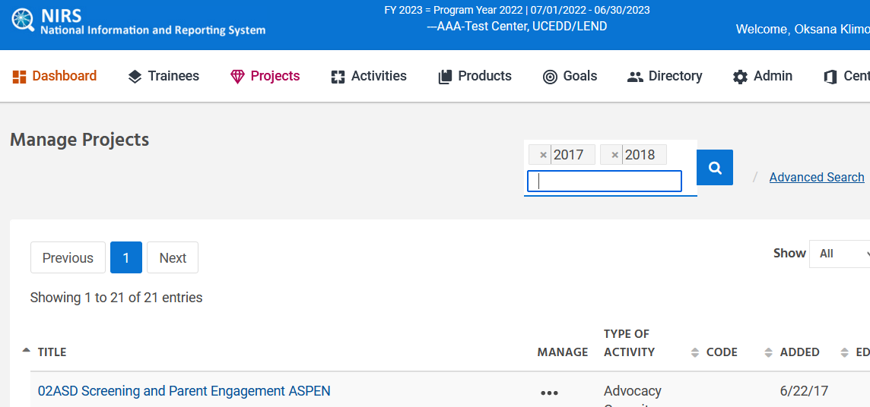

1. Advanced Search

The projects dataset has a unique search field: keywords. The keywords option includes data entered into the keyword field and description field.

Advanced searches in the Projects dataset can be used for a variety of purposes, such as searching for various grant information or collaborating agencies.

**Note:** The more criteria you select, the less records that will be received because it becomes more complex and precise the more that you add.

### 2.2.4 Standard & Custom Reports

### 2.2.4.1 Standard reports

There are a few reports that can be very useful, such as:

1. Project Data Entry Errors
2. Funds Leveraged (UCEDD/LEND)
3. Projects by Area of Emphasis and Funding Type (UCEDD/LEND)

**Note:** Many Standard Reports are enhanced to enable users to search across multiple fiscal years. For UCEDD/LEND programs/centers, data coordinators have UCEDD and LEND filter options for many of the standard reports.  By checking the box next to the program type(s), the resulting report will be filtered to include only what has been checked.

All standard reports can be converted to PDF for saving and/or printing on 8.5 x 11-inch paper.

### 2.2.4.2 Custom reports

Custom Reports can be found in the column View Data:

We would recommend organizing your query into categories. A query that will not be assigned to any category will be displayed in the category "no category."

Prefix indicates the database where the field Is located in the online form. For example **PROJECT** means that it comes from the Project dataset in the chart below. **CONTACT** means that it comes from the directory dataset.

The prefix is followed by the name of the field in online form. For example, PROJECT program type indicates that field “program type” in the project dataset.

In parenthesis will contain the field’s type. For example, (T) means that it is a text field. (N) will mean that it is a numerical field, and so on.

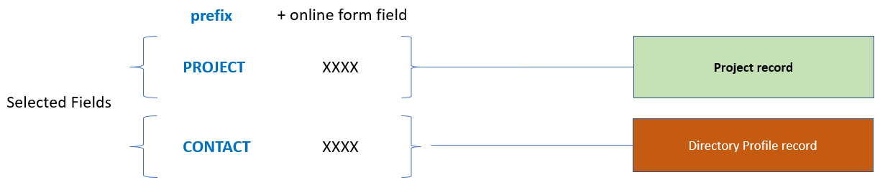

### 

**Scenario:** You have been tasked to compile a list of contact and grant information for each Project at your UCEDD/LEND. Below is a Project custom report with this in mind.

Selected fields:

* Project Program Type (to verify which type the funding sources are leveraged)
* Project Fiscal Year (to verify that all records are from the year I want)
* Project Title (name of record)
* Project Code (funding source)
* Contact last (contact's last name)
* Project Current FY Funding (how much $$)

Selection Criteria:

* Project Fiscal Year = current year

**Follow up question:** My program Director has asked me to graph funding amounts across the years. Is it possible to take information from this custom report into an excel sheet?

**Answer:** Yes! All custom reports are set up so that they can be taken directly into Microsoft excel.

**Step 1:** Ensure that the report is "showing" all records on display. Expand the view to show all records by filling in the number next to "show" and clicking "refresh" at the top of the report.

**Step 2:** Press Control + A to select the report in NIRS. Press Control + C on your keyboard to copy what you have selected.

**Step 3:** Open a new excel spreadsheet. In your excel sheet, click on cell A1. Press Control + P on your keyboard. This will paste the data into the excel sheet.

**Step 4:** To remove formatting, Press Control + A on your keyboard to select the entire excel sheet. On the top ribbon in excel, go to home > under style > select "normal" in the excel ribbon.

**Your excel sheet is now ready for use!**

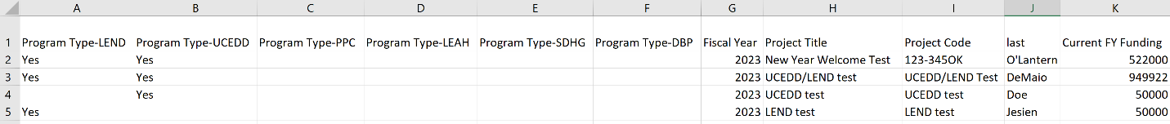

### 2.2.5 Administrative Tool: Manage User-Defined Fields

A long time ago data coodinators came to us because they wanted something extra on top of what was built into the datasets—if they spent time entering data into each dataset, they wanted a way to give back to their center/program in a way that was both meaningful and impactful. Through collaboration with Data Cordinators, we gave them user-defined fields. User-defined fields allow programs/centers to add up to 10 fields into each dataset. You can add any fields that you want. If you think of something that will be helpful to you and to your program, User-Defined fields are there for you to use.

For example, if your program is struggling with finding guest speakers, you may want to create a user-defined field in trainee surveys to identify former trainees who may be potential future guest speakers.

Individual programs/centers may add up to 10 fields to each dataset. Users must have Admin access to define these fields.

**To create a user-defined field:**

* On the main navigation bar, from the Admin pull-down menu, select “Manage User-Defined Fields”

* User-Defined Fields can be of two types: text and pull-down list. (**Note:** there is a request to add a checkboxes option.) **For a text box, leave the pull-down box empty. For the pull-down list display, type each choice on its own line within the text box.**
* In the “Where” column, select the dataset
* Click on the three dots and select “Edit” beside the field for which you want to provide a label, type in a label, and enter each option on a separate line. click Save at the bottom of the page.
* User-defined fields can be required. As with the rest of NIRS, required user-defined fields are marked with an asterisk (*). Failure to supply information in a required user-defined field will result in a popup window (saying there is a required field marked by an asterisk (*) at the bottom of the screen) when the user attempts to save a record without completing a required field.  
  Check/uncheck the “Required” box to toggle this option on and off.
* To remove a user-defined field, erase the current label leave the text box blank, and click Save. Data previously collected in that field will be deleted.
* Centers can deactivate user-defined fields. When a field is inactive, it will no longer display in the relevant data entry form. Still, the data will be maintained in NIRS and remain accessible through the Custom Report function.  
  Check/uncheck the “Inactive” check box to display/remove the display.

**Example of a User-Defined field (drop-down list) in the Projects Dataset:**



## 2.3 Homework for Project Dataset

**Add two Project records:**

1. For the first project record, add funding amounts Federal funding = $25,000.00 for “Healthy Start” under the HRSA funding source.
2. For the second project record, add funding amounts for Local funding = $17,000.00 for “Other” funding sources and specify the funding source.

# Activities Dataset

## 3.1 Introduction to Activities Dataset

Activities are the individual events or discrete processes, pursuits, or functions of a project and are often clearly measurable. Activity-level reporting focuses more on the work's impact (e.g., the number of students trained) than on any project's infrastructure.

Data collected in the Activities Dataset may be linked to particular projects identified in the Projects dataset.

**Note:** If an Activity Record is to be linked to a Project Record, the Project Record must be created before creating the Activity Record.

Information captured in the activities dataset is used by program/centers:

1. for annual reporting to MCHB   
   Helpful resource on [Discretionary Grants Information System (DGIS)](https://mchb.hrsa.gov/data-research/discretionary-grants-information-system-dgis). All forms in NIRS are built from request from the federal funder. Forms in NIRS match those requested on MCHB’s DGIS forms.
2. to highlight how funding dollars are being used around the community, in trainings, advocacy efforts, and so on around the core functions/area(s) of emphasis
3. to track demographic information and program effectiveness through satisfaction/evaluation data from individuals impacted by your services
4. to emphasize staff involvement and community/training efforts across the network

## 3.2 Manage Activities Records

### 3.2.1 Create Activities Records

When adding a new Activity record, the user must first select the Core Function, then the Program Type. Attention: the selection of Program Type is skipped for LEND-only, LEAH, PPC, and DBP Centers. It applies only to UCDD/LEND Centers.

Your first decision will be what Core Function you should choose for reporting activity. Let's review those closely.

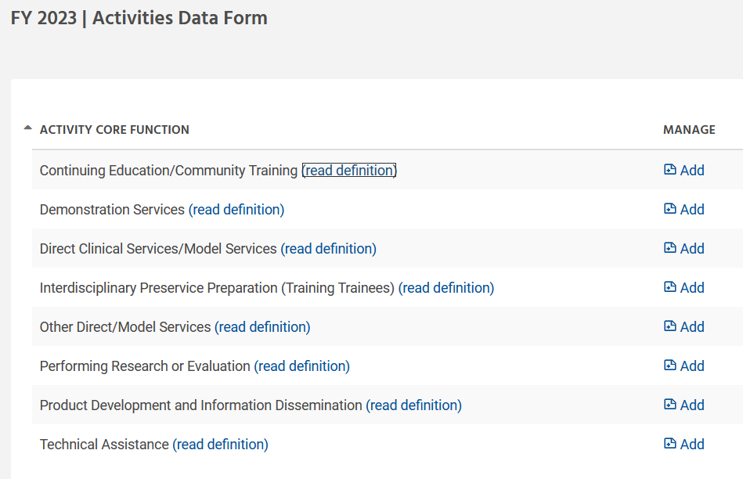

**Core function** – The Developmental Disabilities Assistance and Bill of Rights Act, or DD Act, which authorizes the UCEDD network, requires that the work of the UCEDD is aligned with the purpose of higher education and assists in implementing the purpose of the DD Act:

1. interdisciplinary training, including continuing education;
2. community service, including training, technical assistance, model, and demonstration services;
3. research including evaluation and analysis of public policy; and
4. information dissemination.

These are referred to as the UCEDD core functions.

All core functions are required of all UCEDDs except for model and demonstration services, which are optional.

**Resources:** [UCEDD Logic Model / Data Points in NIRS Crosswalk](https://www.aucd.org/docs/UCEDD%20Logic%20Model%202012%20&%20Data%20Points%20in%20NIRS.pdf)

[UCEDD Logic Model with Definitions](https://www.aucd.org/docs/UCEDD%20Logic%20Model%20Revised%202021.pdf)

The link "read definition" is beneficial in the activities dataset. Be sure to read the definition related to your center type:

More information about Core Functions (and other fields) can be found in [Data Dictionary](https://www.aucd.org/nirs/db/dd.cfm?tables=A).

Only one Core Function may be selected per Activity record. In contrast, multiple core functions may be selected for Project records.

The Add Activity form will open up based on the choices made with only the relevant fields to complete. Enter all the data in the Activity form and click the Save button.

We want to highlight the Add Activity form for UCEDD/LEND Programs/Centers. Activity forms will display the list of fields based on the selection of Program Types. There are three possible combinations:

UCEDD-only checkbox checked/ LEND-only checkbox checked/ UCEDD + LEND checkboxes checked

**Example:**

Let’s see what will happen if I check UCEDD-only. If you select UCEDD/LEND or UCEDD-only, the question “Are Certificates of completion or CEU’s (or their equivelants) offered?” will be required. The LEND-only form does not ask this additional information, so you may need to have additional information prepared when selecting the correct form.

|  |  |  |
| --- | --- | --- |
| **Core Function: Continuing Education/Community Training** | | |
| UCEDD-only | LEND-only | UCEDD+LEND |
|  |  |  |

I will point out in different core functions that collecting data that will be helpful in EHB reporting.

There are several fields that we would like to bring to your attention.

1. **Title of Activity**

Best practices are to provide a unique activity title for each record.

1. **Identifying Staff in the Activity Record**

The first line of the Staff Involvement pull-down menu is intentionally blank. Select staff name(s) from those already in the Center's Activity Staff pull-down menu by clicking on the desired name and then clicking on the 'Click to Link this Person to the activity button. Selected names will appear in the Activity text box below.

There may be instances where you might wish to enter staff names that are not in the pull-down menu (e.g., when you want to note the involvement of a staff member who has left the Center, faculty who are not part of your Center, etc.). Type the name directly into the larger Staff Involvement text box in this situation.

Note: When staff names are entered through the text box, they will not be available through the Staff Involvement field in the Search and Custom Reports functions; however, they will be available for searching through the Keyword search field.

Removing Staff Names from the Activity Record

Highlight the name in the Staff Involved in the Activity text box and hit the Del key on your keyboard. Click on the activity record's Save button to save the change and leave the record.

1. **Is this activity addressing the transitional needs to adult health care for youth with special health care needs?**

Responding “yes” to this question will prompt a follow up question, which feeds into the activity standard report “**CH 3 Performance Measure”**.

1. **Is this activity promoting and/or facilitating developmental screening and follow-up in your program?**

Responding “yes” to this question will prompt a follow up question, which feeds into the activity standard report “**CSHCN 3 Performance Measure”**.

1. **Types & Numbers of Participants**  
   That field is included in online forms for several Core Functions (e.g., Continuing Education/Community Training)  
     
   From the [Data Dictionary](https://www.aucd.org/nirs/db/dd.cfm?tables=A):  
   Required Field. For each category of participant, supply the number of participants in the corresponding box. Supply information on those who are the recipients of the activity (e.g., trainees, audience members, recipients of technical assistance, research subjects, and others). Do not include Staff or consultants who provided the activities (e.g., in the capacity of trainers, presenters, providers of technical assistance, researchers, etc.).

Identify participants in their primary role as related to the activity and do not double count them under more than one type of participant. For example, a seminar designed for social workers may include participants who, in addition to being social workers, are also a family member of a person with a disability. However, because those participants attended this seminar primarily in their role as social workers, they should be counted only once under Professionals & Para-Professionals.

**Note**: The term Participants in the Activity dataset does not mean Target Audience. The term Target Audience is used in the Project dataset. Two different terms are used to capture two different data elements.

1. **Agencies Collaborating on the work of the Activity:**

Required Field. Check all categories that apply. A text box is provided to specify the actual name of the agency(ies). The specification of agency name(s) is optional.

**Note**: In FY 2013, the list of options was been extended, and is now the same with the one in the Collaborating Agency field in the Projects dataset. A large or multi-year project may have different collaborators for different activities or at different stages of the project, so all collaborators are identified in the project record. In contrast, activities have a typically smaller number of collaborators.

In FY 2013, the field Primary Agency Collaborating/Recipient of TA was added for MCHB Training Programs. It is a drop-down menu, and the options are the same with those in the checkbox list under Agencies Collaborating on the Work of the Activity. The Primary Agency Collaborating field is a single-choice field to match the MCHB reporting requirements. For UCEDD/LEND records, the option selected from Primary Agency Collaborating will automatically be selected in the checkbox list as well.

Collaboration is conceptualized broadly to include any substantial interaction on an activity or project, even if a formal memorandum of agreement is not signed between organizations/agencies. Information on collaboration is collected in both the Project and Activity datasets. **Collaborating agencies may or may not be the same as funding sources, which are captured in the Projects dataset.**

**Note:**Of particular interest are collaborations with State Title V Agencies, MCHB-funded programs, Developmental Disabilities Councils, Protection & Advocacy Agencies, and UCEDDs.

**Frequently asked questions:**

**Question #1: Can I change the Activity Core Function if an Activity is accidentally added with the incorrect Core Function?**

**Answer: YES, and it is very easy to fix it:**

1. Search for the respective Activity
2. Click on the **View button**

1. From the New Core Focus drop-down menu, select the correct Core Function
2. Click on **Save As button**
3. The Activity form opens up with the appropriate fields for the newly selected Core Function. All fields that apply to the initial Core Function are pre-filled with previously entered data. Complete all the required fields for the current Core Function and save the record.
4. **Important!** Search the original Activity, with the incorrect Core Function, and delete it - this does **not** happen automatically.

**Question #2: Can I save past Activity Records into a New Fiscal Year (the Save As New Function)**

**Answer: Yes.**

Many projects span multiple years; however, NIRS requires a separate Project Record (and thus Activity Records) for each Fiscal/Program year.

To create a new fiscal year Activity Record for a multiyear project:

1. Find the activity using the Search or Advanced search functions.
2. Click on the **View button** to display the Activity Record.
3. Click on the **Save As New button** in the upper right corner of the screen. An Activity Record entry form, pre-filled with the activity information, will be displayed. Modify this form as necessary for the current fiscal year and click Save.

### 3.2.2 View, Edit, Delete

To view, edit, and delete an Activity Record, begin on the Manage Activities screen.

Reminder: by default, list display activities for the current fiscal/program year.

### 3.2.3 Search Activities records

1. Search by Fiscal/Program year

1. Advanced Search

Or

A multiyear button can be used to identify multiple years to search.

Keywords are words included in title, brief discreption, and keywords fields provided in the activity records.

### 3.2.4 Standard & Custom Reports

### 3.2.4.1 Standard reports

Standard reports are helpful with annual reporting to MCHB. Activity Standard reports pull data entered by data coordinators in the activity dataset. Standard reports in the activity dataset were built with the same layout and design to match the design and layout of report in the EHB. Thus, responses in the below standard reports may be a helpful resources to inform reporting in the EHB.

* **Activity Data Entry Errors**  
  Helpful standard report for data cleaning.
* **CH 3 Performance Measure**   
    
  Responses are based on the types and number of participants entered in activity records where the question “Is this activity addressing the transitional need adult health care for youth with special health care needs?” = YES.

Example in activity records of question provided below (selection(s) must be made in the follow up question “Through what processes are you promoting and/or facilitating the transition to adult health care for youth with special health care needs”)

* **CSHCN 3 Performance Measure**   
    
  Responses are based on type and number of participants entered in activity records where the question “Is this activity promoting and/or facilitating developmental screening and follow-up in your program?” = YES

Example in activity records of question provided below (selection(s) must be made in the follow up question “Through what processes are you promoting and/or facilitating developmental screening and follow-up in your program”)

* **Training 04: Collaborative Interactions**Helpful for reporting on the degree to which your training program collaborates with State Title V (MCH Block Grant) agencies and other MCH-related programs.
* **Continuing Education/Community Training: MCH Collection**This report provides information from Activity records with the core function “Continuing Education/Community Training”. MCHB training Programs may use this report to help identify their most significant CE activities to report to MCHB.
* **Activities by Discipline and Classroom Student Contacts**  
  This report provides the number and percentage of activity records and classroom student participants, organized by the discipline of course or class indicated in the activity records.
* **TA/Collaboration: MCH Collection**

Helpful report for identifying and summarizing all technical assistance activities, their reciepents, and target audiences. It also highlights the top 8-10 most significant activities in the past year.

### 3.2.4.2 Custom Reports

Let's go over the process of creating a custom report. ** Be sure that no standard reports can help you before you build a custom report.

We would recommend organizing your query into categories. A query that will not be assigned to any category will be displayed in the category "no category."

**Step 1:** formulate your data question and understand what data will answer that question. For our exercise, we will use the following scenario:   
  
**Which activities offer continuing education credit through our training program?**

**Step 2:** Complete the Title, Category (no pull-down list, so must remember existing category name if want to place report into an existing category), etc.

Select the fields: use the chart to understand what fields are listed

Prefix indicates the database where the field Is located in the online form. For example **ACTIVITY** means that it comes from the Activity dataset in the chart below. **QTY** is adeprecated field, which means that the fields are no longer in use, but options are maintained for historical purposes.

The prefix is followed by the name of the field in online form. For example, ACTIVITY program type indicates that field “program type” in the activity dataset.

In parenthesis will contain the field’s type. For example, (T) means that it is a text field. (N) will mean that it is a numerical field, and so on.

Since activity records are linked with your projects, NIRS can help!

Include in an Activity custom report the following selected fields:

* Fiscal Year
* Title
* Brief Description (what the activity is about)
* Activity Partic. Total (to see the total number of participants)
* Activity Duration (how long in hours)–
* Continuing Education Credits (whether continuing education credits are offering)
* Collaborating Agencies (who also contributed with the activity)

Selection Criteria:

* Fiscal Year = current year

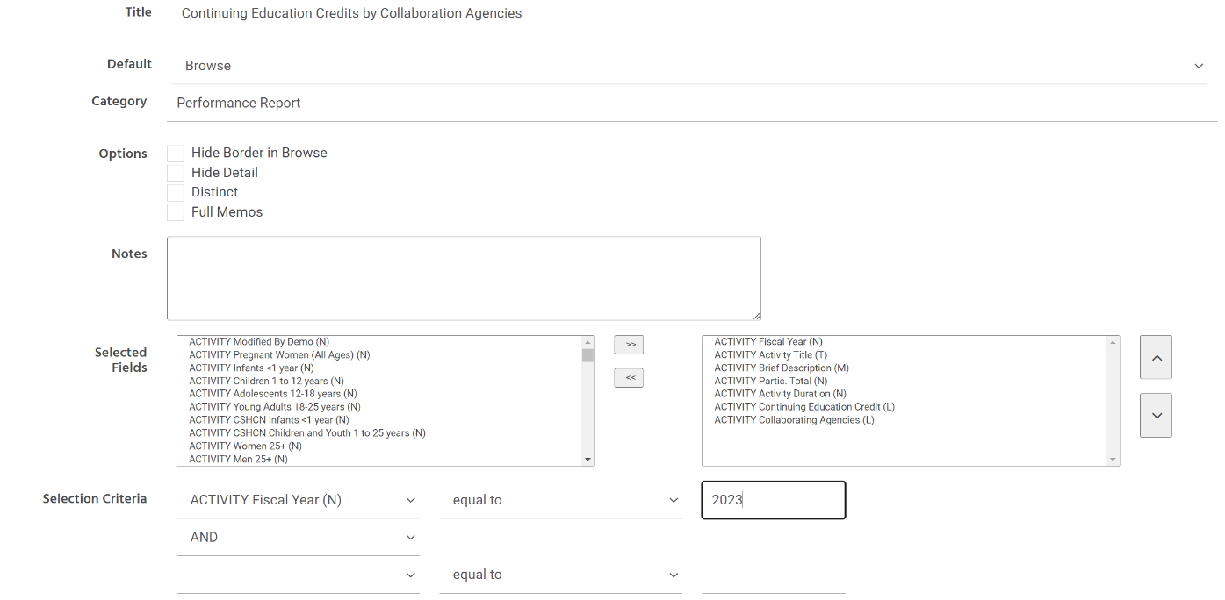

**Best practices when building custom reports:**

* Ask, “What do you want to capture in the custom report?”
* Break down your question into simple, actionable steps to help guide your process.
* Begin with testing "selected fields" first
  + Selected fields are the list of questions in the online form that you want to include in the report.
* Ask, “Which data points will help me verify the data I matched to?". These pieces of data may be helpful to include in “selected fields”.
* Run the report after each revision to verify the responses in your query.
* Have the dataset open in NIRS in a different browser (i.e., Chrome, Firefox, Microsoft Edge) to compare questions on the form with selected fields/selection criteria to ensure the correct options are accurate.
* Lastly, custom reports take practice! AUCD is here to help if you get stuck. Send a note to [NIRS@aucd.org](mailto:NIRS@aucd.org) and we are happy to help guide you in the right direction.

### 3.2.5 Administrative Tool: Manage User-Defined Fields

Individual programs/centers may add up to 10 fields to each dataset. Users must have Admin access to define these fields. We will quickly remind you where to find User-Fined fields.

**To create a user-defined field:**

* On the main navigation bar, from the Admin pull-down menu, select “Manage User-Defined Fields”

* User-Defined Fields can be of two types: text and pull-down list. (**Note:** there is a request to add a checkboxes option.) **For a text box, leave the pull-down box empty. For the pull-down list display, type each choice on its own line within the text box.**
* In the “Where” column, select the dataset
* Click on the three dots and select “Edit” beside the field for which you want to provide a label, type in a label, and enter each option on a separate line. click Save at the bottom of the page.
* User-defined fields can be required. As with the rest of NIRS, required user-defined fields are marked with an asterisk (*). Failure to supply information in a required user-defined field will result in a popup window (saying there is a required field marked by an asterisk (*) at the bottom of the screen) when the user attempts to save a record without completing a required field.  
  Check/uncheck the “Required” box to toggle this option on and off.
* To remove a user-defined field, erase the current label leave the text box blank, and click Save. Data previously collected in that field will be deleted.
* Centers can deactivate user-defined fields. When a field is inactive, it will no longer display in the relevant data entry form. Still, the data will be maintained in NIRS and remain accessible through the Custom Report function.  
  Check/uncheck the “Inactive” check box to display/remove the display.

Example of usage of Use-Defined Fields in Activities dataset for UCEDD/LEND program/center type:

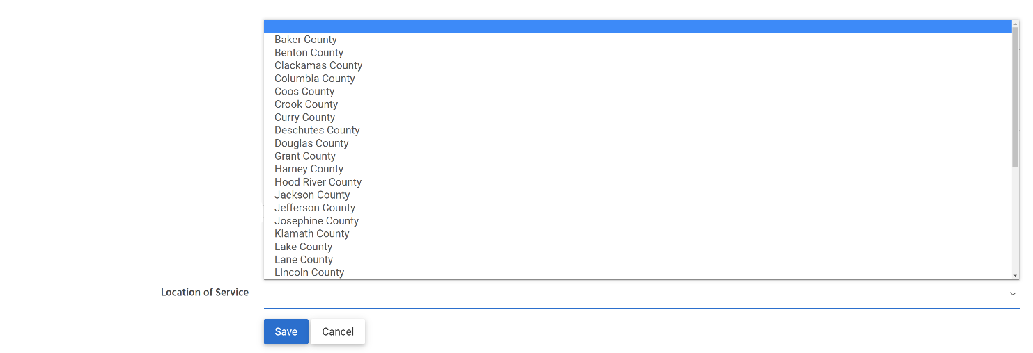

## 3.3 Homework for Activities Dataset

1. What Core Function do you assign the following activities:
   1. Your program provides information and insights on serving those with autism on AUCD’s Autism Special Interest Group (SIG)
   2. Conducting a seminar to teach current trainees on how to conduct a specific developmental screening
   3. Research study to assess social factors on developmental outcomes in high-risk NICU infants
   4. Sending faculty as a guest speaker to discuss stigmatization and barriers to treatment for mothers and infants born with Neonatal Abstinence Syndrome (NAS)
2. Add an activity record to core function Continuing Education/Community Training.
   1. Select yes to question “Is this activity promoting and/or facilitating developmental screening and follow-up in your program?”
   2. Make any selections in the follow up question “Through what processes are you promoting and/or facilitating developmental screening and follow-up in your program?” **Note:** multiple options may be selected.
   3. Enter numbers in “Types and Numbers of Participants”
   4. Enter information for all other required fields and save the record at the bottom of the page.
   5. Run activity standard report “CSHCN 3 Performance Measure” (Note that the standard report will provide totals based on the selections above for the 2 outlined questions above).
3. Add another activity record (any Core function):
   1. Select Yes to the question “Is this activity addressing the transitional need adult health care for youth with special health care needs?”
   2. Make any selections in the follow up question “Through what processes are you promoting and/or facilitating the transition to adult health care for youth with special health care needs”
   3. Complete the rest of the form and save the record.
   4. Run activity standard report CH3 Performance Measure

# 4.0 Products Dataset

## 4.1 General Information about Products

The Products Dataset is intended to capture information on various materials produced and disseminated by the network (i.e. any deliverables). The products may be linked to Faculty/Staff records (from the Activity Staff list.)

Product forms have been customized based on product type so that the specific fields may differ between several product records. A list of Product types with links to their definition can be found on Add Product page:

## 4.2 Products and NIRS Public Search

## 4.3 Create Product Record

Add Product record is a 2-step process:

1) select Products > Add Product from the main menu

2) select Product/Publication Type.

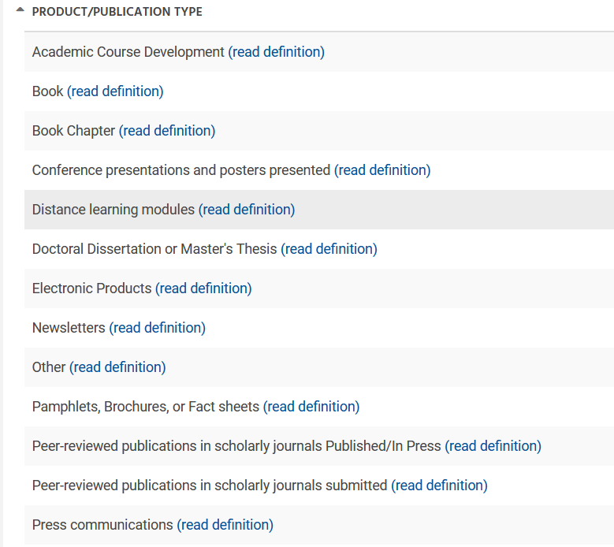

Select the appropriate publication/materal type. A description of each type of material is listed under “read definition” with helpful examples.

Product records are intended to capture information such as title, author, date of publication, and the fiscal year in which it is being reported. The records also have fields for providing a brief description, indicating alternative formats, ordering, and cost information. The product record may be edited during the current fiscal year.

Online forms look the same for LEND, LEAH, DBP, and PPC center types. UCEDD/LEND has one additional field:

The specific fields differ between product types.

**Note for UCEDD/LENDs:** when selecting LEND and/or UCEDD, additional information may be required to save the form, so it will be helpful to prepare ahead of data entry. Forms may require different information by request of the federal funder(s). For example, author type is not required for UCEDD records, but is required for LEND records.

Fields that we want to bring your attention to:

A) **Authors**  
  
List of profiles from Admin > Activity Staff

B) **Ordering Information, Name**  
  
The list of profiles from the Directory dataset. Allow programs/centers to list contact information for a faculty member, which will also be listed on the AUCD online public search.

C) **\* Include(d) into DGIS/EHB export for**

D) **Volume/ Number/ Supplement/ Pages**   
  
Unique to material type “Peer-reviewed publications in scholarly journals Published/In Press: Publication”. These are required fields.

E) **Keyword and brief dscreption**  
  
 It will be helpful as this how keyword search works. These fields will be used in the AUCD Public online search located on the aucd homepage.

**Best Practices:** Though not required, the two fields “**Brief Description**” and “**Keyworks**” fields can be helpful for those searching on AUCD online search to find the work your Program/Center entered.

F) **Alternative Formats**  
  
Check all options that apply for alternative formats in which the product was actually disseminated.

* 1. Option: Language other English, will bring drop-down with all languages entered across the network.

* 1. A new language option can be added to the list at the bottom of the list next to “Add new language” if the desired option is not already included in the drop-down.

**Best Practices:** Giving unique titles for each activity and product record will ensure that you can find it easily should you need to search or update information for it later on.

Please also note that the list of material types in NIRS match with the list of material types in the MCHB’s EHB.

The list of required fields in NIRS for each material type also match with required fields in the EHB.

Since required fields match in NIRS and EHB, this allows us to export data to MCHB.

This is a benefit of NIRS that we pointed out in day one of the boot camp. NIRS is also open throughout the year to allow you more time to collect and prepare your data for reporting.

**Frequently asked questions:**

**Question #1: If I reported a Submitted publication, but it gets published. Should I 1) keep the submitted record and create a newly published one? Or move the submitted record to the published type?**

**Answer: It is recommended to report the product twice, once when it is submitted, and again as a separate entry once it has been accepted for publication.** The rationale for this is that when you submit for publication, the publishing company typically has edits before it can be officially accepted. This means that the product that is submitted is typically not the end result, culminating in additional work and is a different product overall once it has been accepted, hence why it is recommended to report twice.

**Question #2: I have entered in a online published article (i.e. pubmed, plos) but do not have the page or volume number. It will not allow me to save without this information. What do I do?**

**Answer:** These are required fields, but as long as something is written in them the form will allow you to save. Put a zero in these spaces.

**Best Practices:** remember to come back for these questions if new information becomes available.

## 4.4 List, View, and Delete

Two pages (Add and Manage) display products for the current Fiscal/Program Year.   
  
1) Add page = grouped by Type category;   
2) Manage = list of all products

The Product Manage screen alphabetically displays each product record in the current fiscal year by title.

To view all records for a particular product type, select Add Product. The right-most column, Total Type Items, provides each product type's total number of product records. The numbers are also links; click on the number for the desired category - this will display, in alphabetical order, all the product records for the respective product type.

## 4.5 Managing and Searching Projects records

**Changing the Product Type**

If a Product is accidentally added with the incorrect Product Type, it is very easy to change the Type:

* Search for the respective Product
* Click on the View button to its left
* From the New Material Type drop-down menu, select the correct Type  
  Graphical user interface, text, application

  Description automatically generated
* Click on **Save As** button in green
* The Product form opens up with the appropriate fields for the newly selected Product Type. All fields that applied to the initial Product Type as well previously entered data. Complete all the required fields for the current Product Type and save the record.
* Search the original Product, with the incorrect Product Type, and delete it - this does not happen automatically.

**Saving Past Product Records into a New Fiscal Year (the Save As New Function)**

Many products are available for dissemination over multiple years; however, NIRS requires a separate Product Record for each year. To create a new FY Product Record for a multiyear project, first find the product using the Manage or Search functions. Second, click on the View button to display the Product Record. Third, click on the Save As New button in the upper right corner of the screen. A Product Record entry form, pre-filled with the product information, will be displayed. Modify this form as necessary for the current fiscal year and click Save.

**Searching Records**

1. Search by Fiscal/Program year

1. Advanced Search

Or

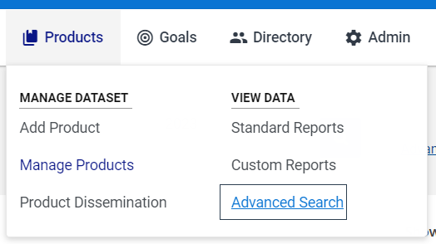

A multiyear button can be used to identify multiple years to search.

The keyword field in Advanced search is looking through the keywords fields and Brief Description.

## 4.6 Product Dissemination Tool

The Product Dissemination tool is used for UCEDD reporting to ACL. UCEDDs and LEND/UCEDD Centers will use this tool to report on dissemination across the material types.   
  
**Note:** the information about Product dissemination is not updated in Data Dictionary.

## 4.7 Standard & Custom Reports

### 4.7.1 Standard Reports

Standard reports are helping with annual reporting to MCHB.

Example of reports that can help to report Performance Measures (Products, Pubs, and Submissions Data Coll Form, Part 1.)

**Helpful Product standard reports:**

* Product Data Entry Errors
* Publications List in APA Style
* Products, Publications, and Submissions Data Collection Form, Part 1

### 4.7.2 Custom Reports

We would recommend organizing your query into categories. A query that will not be assigned to any category will be displayed in the category "no category."

Prefix indicates the database where the field is located in the online form. For example **CONTACT** means that it comes from the directory dataset in the chart below. **PRODUCT** means that it means that it comes from the product dataset. **DISSEMINATION** means that t comes from the dissemination tool. **QTY** is adeprecated field, which means that the fields are no longer in use, but options are maintained for historical purposes.

The prefix is followed by the name of the field in online form. For example, PRODUCT program type indicates that field “program type” in the product dataset.

In parenthesis will contain the field’s type. For example, (T) means that it is a text field. (N) will mean that it is a numerical field, and so on.

We will use the following scenario for our custom report in the products dataset:  
  
**A current LEND trainee is interested in what kind of research previous trainees have completed around autism to get ideas on what they should do for their research. You goal: compile a list of all products that involved autism as a topic of interest (from all years at your Program).**

In product custom reports, in the selected fields, you could put:

* Title
* Publication name
* Keyword1
* Keyword2
* Keyword3
* Keyword4
* Keyword5 (keywords can be helpful to see general topics at a glance)
* Author(s) (who completed the product)
* Brief Description

In the selection criteria, you could select:

* “PRODUCT Brief description” in the first drop-down box, “like” in the second drop down, and then type “Autism” in the third box. This will return all records where the product title, brief description, or keywords have the word “Autism” in it.
* If you are a UCEDD/LEND, you could also add a second criteria such as: “Product Program Type”, “Like”, “LEND” (to make sure you only select records designated LEND-only or LEND/UCEDD)

The above example will pull all examples of products completed at your program across all years that have autism listed somewhere in the brief description.

## 4.8 Administrative Tool: Manage User-Defined Fields

Individual programs/centers may add up to 10 fields to each dataset. Users must have Admin access to define these fields. We will quickly remind you where to find User-Fined fields.

**To create a user-defined field:**

* On the main navigation bar, from the Admin pull-down menu, select “Manage User-Defined Fields”

* User-Defined Fields can be of two types: text and pull-down list. (**Note:** there is a request to add a checkboxes option.) **For a text box, leave the pull-down box empty. For the pull-down list display, type each choice on its own line within the text box.**
* In the “Where” column, select the dataset
* Click on the three dots and select “Edit” beside the field for which you want to provide a label, type in a label, and enter each option on a separate line. click Save at the bottom of the page.
* User-defined fields can be required. As with the rest of NIRS, required user-defined fields are marked with an asterisk (*). Failure to supply information in a required user-defined field will result in a popup window (saying there is a required field marked by an asterisk (*) at the bottom of the screen) when the user attempts to save a record without completing a required field.  
  Check/uncheck the “Required” box to toggle this option on and off.
* To remove a user-defined field, erase the current label leave the text box blank, and click Save. Data previously collected in that field will be deleted.
* Centers can deactivate user-defined fields. When a field is inactive, it will no longer display in the relevant data entry form. Still, the data will be maintained in NIRS and remain accessible through the Custom Report function.  
  Check/uncheck the “Inactive” check box to display/remove the display.

Example of a User-Defined field in the Product dataset:

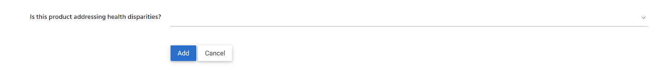

## 4.9 Homework for Products Dataset

Please classify and create records for the following products:

For the questions below, please use the following product:

1. <https://pubmed.ncbi.nlm.nih.gov/34383481/>
   1. What material type is the provided product?
   2. Create a record in NIRS for that product.

For the questions below, please use the following product:

1. <https://www.aucd.org/conference/detail/session_presentation.cfm?id=15094>
   1. What type of material is the provided product?
   2. Create a record in NIRS for that product.

For the questions below, please use the following product:

1. <https://www.youtube.com/watch?v=s8louMZBNvE>
   1. What type of material is the provided product?
   2. Create a record in NIRS for that product.
2. Select the product with the material type “Conference Presentations and Posters Presented” and convert it into the product with Material Type “Book”

## 5.0 Closing Remarks

Please send any homework questions to [NIRS@aucd.org](mailto:NIRS@aucd.org). Day Four of the boot camp will also begin with an opportunity to answer and discuss questions.

Alternatively, Office TA hours are also available every Thursday and Monday during the boot camp. Times, dates and zoom links are provided below.

Thank you everyone for joining! We look forward to seeing everyone at day three of the boot camp!

**Boot Camp Day 1 Office TA Hours:**

[Thursday 1/19/2022 (11:00AM-12:00PM EST)](https://us06web.zoom.us/j/87685631759)

[Monday 1/23/2022 (4:30PM-5:30PM EST)](https://us06web.zoom.us/j/85447876564)

**Boot Camp Day 2 Office TA Hours:**

[Thursday 1/26/2022 (11:00AM-12:00PM EST)](https://us06web.zoom.us/j/87685631759)

[Monday 1/30/2022 (4:30PM-5:30PM EST)](https://us06web.zoom.us/j/85447876564)

**Boot Camp Day 3 Office TA Hours:**

[Thursday 2/2/2022 (11:00AM-12:00PM EST)](https://us06web.zoom.us/j/87685631759)

[Monday 2/6/2022 (4:30PM-5:30PM EST)](https://us06web.zoom.us/j/85447876564)