NIRS Boot Camp Day 2 Script
Table of Contents
1.0 Questions and Answers (Q&A) from Boot Camp Day One 2
2.0 Trainee Dataset 3
2.1 General Information about Trainees and Trainee Dataset (5 – 7 min) 3
2.1.1 Introduction to UCEDD-Trainees vs LEND Trainees 4
2.2 NIRS Trainee Dataset 6
2.3 Manage Long/Medium Term Trainee (MAIN and ANNUAL/YEAR Records) 9
2.4 Manage Short-Term Trainee Records 18
2.5 Trainee Surveys 21
2.5.1 Two, Five, and Ten years post training (Follow-up Survey) 21
2.5.2 Annual Trainee Contact Update (Mini Survey) (5 min) 29
2.6 Advanced Search 30
2.7 Standard & Custom Reports 32
2.7.1 Standard Report 33
2.7.2 Custom Reports 34
2.8 Additional Feature(s)/Tool(s) 39
2.8.1 Administrative Tool: Manage User-Defined Fields 39
2.8.2. Quick Email Tool 40
3.0 Homework 42
4.0 Closing Remarks 44

Introduction
Learning Objectives for Today’s Session:
By the end of today’s session, participants will learn how to:
- Locate NIRS resources on the AUCD website
- Understand the differences between program year and fiscal year
- Understand trainee types
- Manage trainee records in NIRS
- Manage trainee surveys
Helpful Links for Today's Session:
NIRS Resources – central location for all NIRS related tips sheets and other helpful documents.
User’s Guide - provides essential technical assistance to users of the NIRS system
Data Dictionary - the term Centers is used to refer to ALL organizational units that use NIRS
Tip Sheet on Trainee Type and MCHB Training Programs definitions – Tips sheet on Trainees for MCHB Training Programs.
Discretionary Grants Information System (DGIS) - Contains an overview of DGIS and other helpful resources

Welcome back! We will start with checking the Homework. We plan to spend up to 30min answering your questions.
The rest of Day 2 of Bootcamp will be dedicated to covering the Trainee dataset: entering, searching data, running reports, and collecting data through the trainee surveys.

1.0 Questions and Answers (Q&A) from Boot Camp Day One

Questions and answers (Q&A) from the audience on Day One of the NIRS Boot Camp.

2.0 Trainee Dataset

2.1 General Information about Trainees and Trainee Dataset (5 – 7 min)

- Federal Reporting spans from July 1st - June 30th each year. HRSA may reference this time period as the Period of Performance in your Notice of Funding Opportunity (NOFO).
  - For example, the period of performance for this current grant cycle is July 1st, 2022 - June 30th, 2023.
- NIRS terminology:
  - Program Year (PY): federal reporting term that is notated with the year the training program begins.
  - Fiscal Year (FY): federal reporting term that is notated with the year the training program ends.
  - Example: PY2022 indicates Program Year and is the year it began (2022). In contrast, the time frame between July 1st, 2022, and June 30th, 2023, ends in 2023, which is the Fiscal Year notated as FY2023.
- The Program Year and Fiscal year appear at the top of every page in NIRS.
In our example, PY2022 and FY2023 both refer to the same time frame between July 1st, 2022 and June 30th, 2023.
Trainee definition: trainees are the individuals in a Center's/program’s training program.
The Trainee dataset is designed to capture trainees' demographic and contact information. Information captured in this dataset is used:
- by program/center to produce demographic information on their trainees, track the progress of individual trainees
- by program/center for annual reporting to MCHB
- by AUCD to aggregate data across the network and present a snapshot of the size and demographics of the network's trainees each year
We will spend the whole session talking about Trainee data. Trainee data is vital to you. You are required to include trainee records in Electronic Handbook (EHB). As we mentioned earlier, you can manually add long-term trainees at the end of the Program year in the EHB or if you are using NIRS, AUCD will export your data from NIRS and submit those to the Maternal and Child Health Bureau (MCHB).
Benefits of using NIRS in Trainee Dataset:
- Tools available to determine those who submitted surveys and those who need to be surveyed
- Pre-created surveys that are in the format required by MCHB.
- Standard reports which provide quantitative and qualitative data on trainees and surveys
- TA support throughout the year
During today's session, we will bring your attention to the field(s) required for EHB.
Helpful Resources: Tips sheet on Trainee type and definitions for MCHB Training Programs
There are three Trainee categories:
- Long-Term
- Intermediate/Medium-Term
- Short-Term

2.1.1 Introduction to UCEDD-Trainees vs LEND Trainees

Introduction to Core Functions:
Core Functions
The Developmental Disabilities Assistance and Bill of Rights Act, or DD Act, which authorizes the UCEDD network, requires that the work of the UCEDD is aligned with the purpose of higher education and assists in implementing the purpose of the DD Act:
- interdisciplinary training, including continuing education;
- community service, including training, technical assistance, model, and demonstration services;
- research including evaluation and analysis of public policy; and
- information dissemination.
These are referred to as the UCEDD core functions.
All core functions are required of all UCEDDs except for model and demonstration services, which are optional.

Introduction to UCEDD vs LEND Trainees:
Core Function: Interdisciplinary Pre-service Preparation
The instructional program offered by the UCEDD:
- integrates knowledge and methods from two or more distinct disciplines;
- integrates direct contributions to the field made by people with disabilities and family members;
- examines and advances professional practice, scholarship, and policy that impacts the lives of people with developmental and other disabilities and their families;
- is designed to advance an individual’s academic or professional credentials; and
- takes place in an academic setting or program.
It may:
- lead to the award of an initial academic degree, professional certificate, or advanced academic credential; and
- contribute to a discipline-specific course of study offered by the UCEDD or another academic department.
UCEDD Trainee - Intermediate (40-299 contact hours) and long-term trainees (300 or more contact hours) participating in a UCEDD interdisciplinary or discipline-specific training program.
Resources: UCEDD Logic Model / Data Points in NIRS Crosswalk
UCEDD Logic Model with Definitions
Helpful Resources for LEND Programs:
LEND Notice of Funding Opportunity 2021-2026 (NOFO)
- For any questions on what is considered a LEND trainee, please contact your MCHB/HRSA Project Officer.

2.2 NIRS Trainee Dataset

We thought that we would use the chart to explain the trainee data structure:

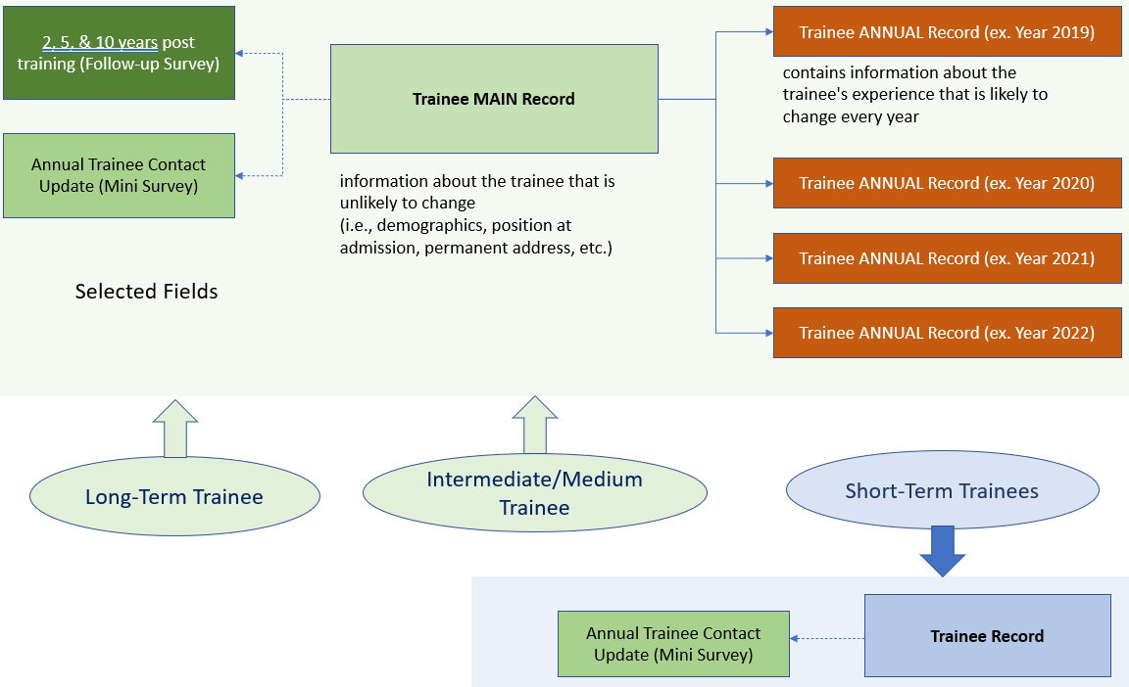

For MCHB reporting, you will report trainees that match the following criteria:
- LEND, LEND/UCEDD, PPC, DBP, and/or LEAH Trainee
- Long-Term
- Trainees completed the training program 2, 5, and 10 years ago.
Now we have completed our overview of what trainees are, let's learn how to collect data on trainees.

Now we will get familiar with the NIRS Trainee Dataset and online forms included in that dataset. You will log in to NIRS and find the "Trainees" tab in the main horizontal menu.
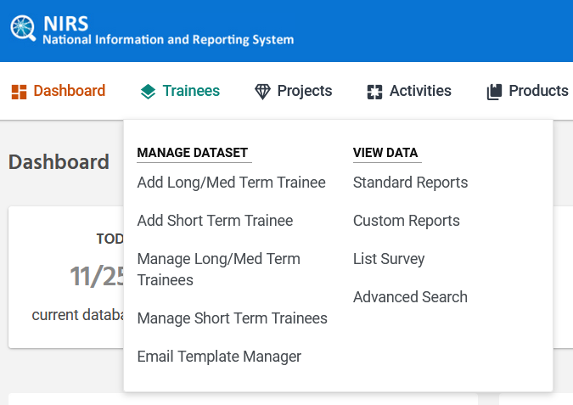
Every NIRS Dataset includes a list of sub-menu items grouped into two columns. The left column contains links to the online forms for data entry. The right column provides links to the reports and other tools to access data for the selected dataset.

Every page included in the Trainees Dataset provides a set of support links located at the top right corner:
Advanced Search = link to the tool for searching Trainee Dataset data
Survey Instructions = link to instructions that will take you directly to the section designated to trainee survey information in the User's Guide. Be sure to select a chapter that aligns with your center's type. LEAH centers should be reading about LEAH Survey.
NIRS is an application used by different center types (UCEDD, LEND, UCEDD/LEND, LEAH, DBP, and PPC.) The Data Dictionary contains information covering all program types listed above.

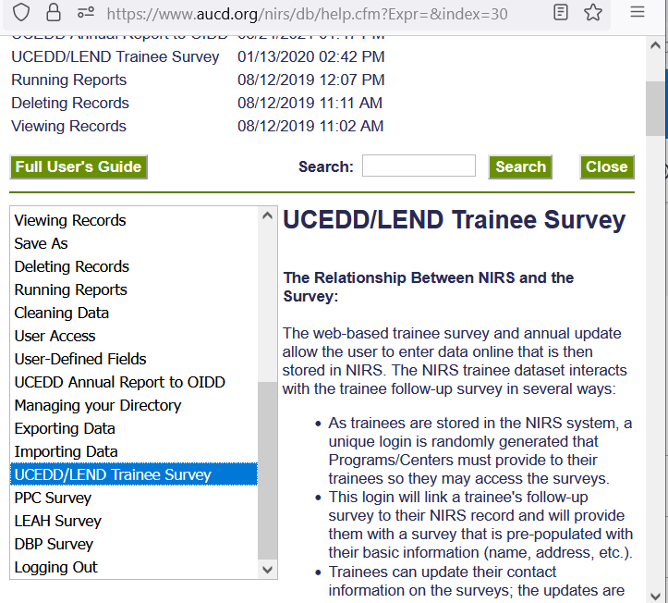

SA Tool: how to read results = instructions for outdated trainee self-assessment. You can ignore that link.
Data Dictionary = Link to the collection of names, definitions, and attributes about data elements being used or captured in each NIRS dataset.
Note: when using the Data Dictionary, be aware that you need select information that matches your center type.
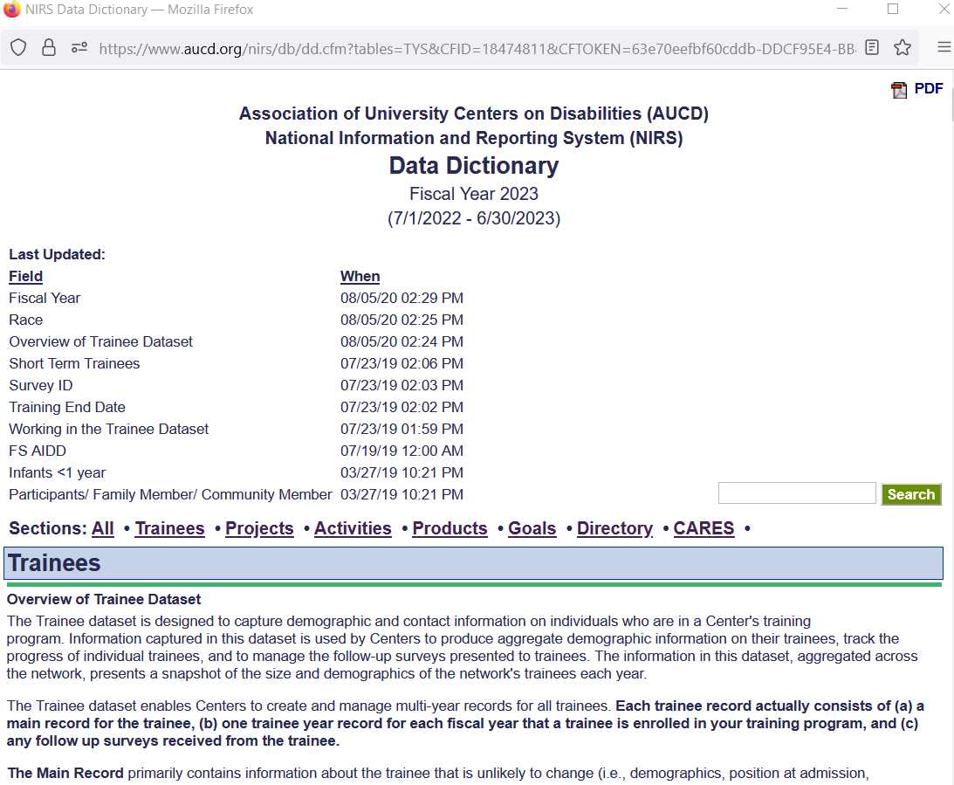
Best Practices: Trainees Timeline:
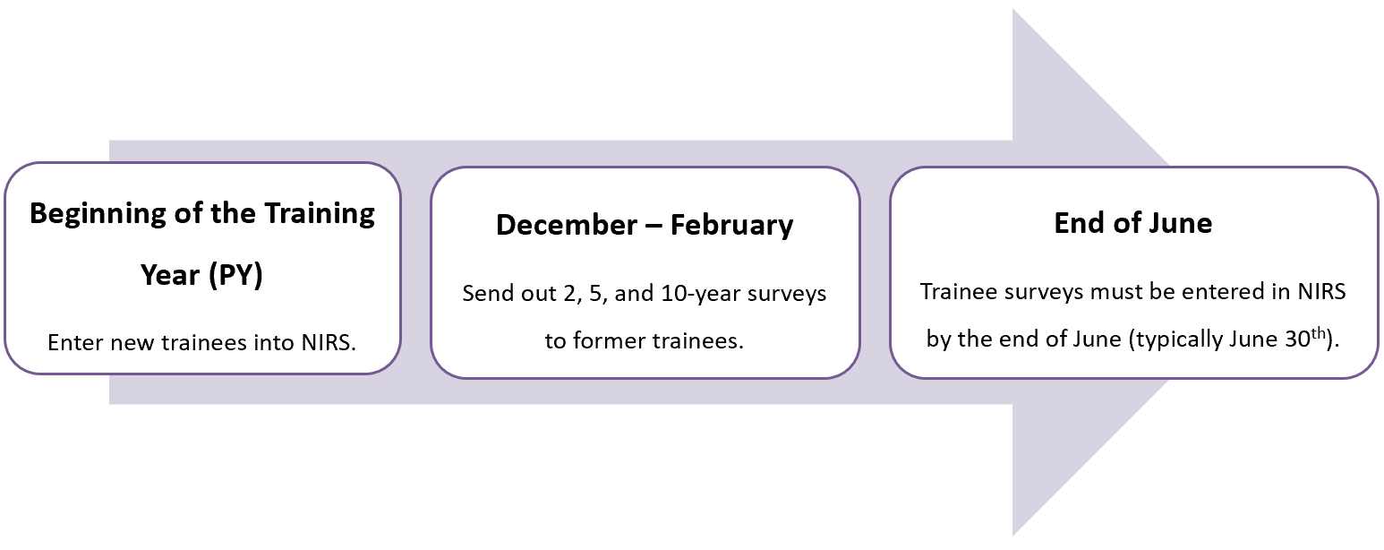

2.3 Manage Long/Medium Term Trainee (MAIN and ANNUAL/YEAR Records)

Now that you know the Trainee dataset layout, let's start sharing best practices for entering trainee data into the NIRS.
Step 1: When working with trainee data, your first task is determining to what category the Trainee belongs (Long-term, Medium-term, or Short-term.) For training purposes, let's say our Trainee is a Long-term trainee who completes 300+ hours of didactic and experiential training.
Step 2: After we have determined the trainee’s category, we can select the correct form to enter data. Based on the trainee data structure diagram, you remember that you need to complete two forms (main and year/annual record.) Link Add Long/Medium Term Trainee will take you to the Trainee Main Record online form.
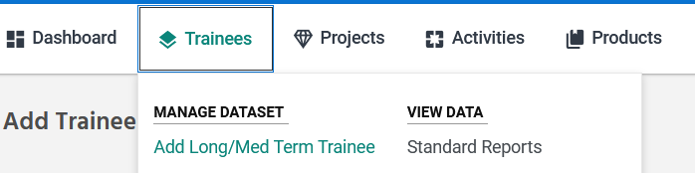
Here is the Main form. The main form contains the same list of fields for all center types. All Required fields are marked with "*."
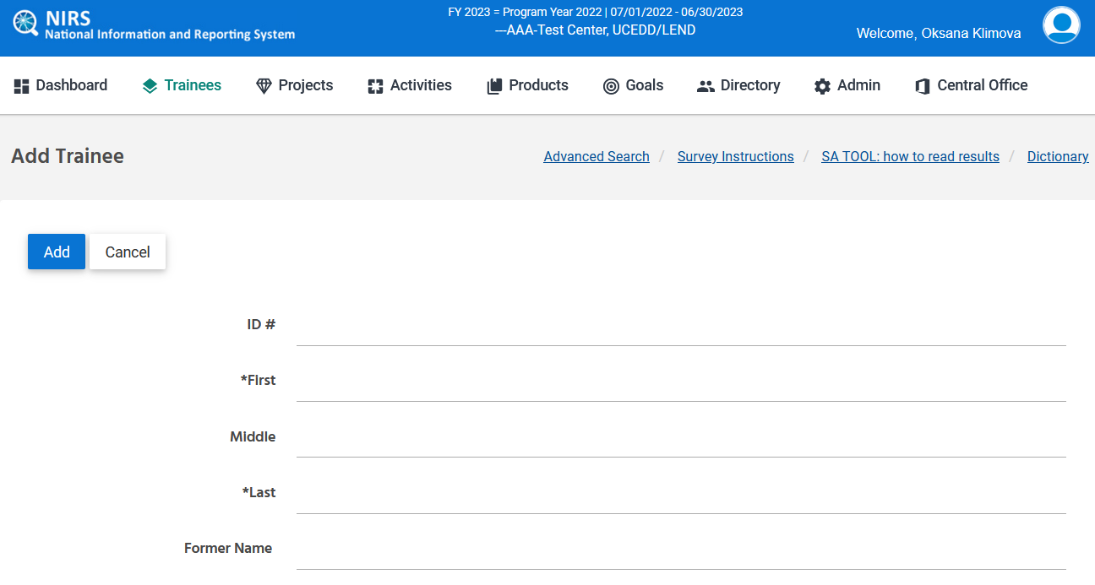
We will complete the form. The following required fields are fields that are required by EHB trainee forms. I will also note required fields and fields that are included in data sent to MCHB.
Main Trainee online form:
- Name (First and Last)
- Email—important but not required.
- Academic Degree/Credential Achieved degree Other
- City
- State
- Country
- Race
- Ethnicity
- Gender
Annual Trainee online form (EHB Export):
- Academic Level (or Student Type in EHB)/ Other Academic Level
- Discipline/ Discipline Other
- Degree Program
- Enrollment Status (Student Status in EHB)
- Year Start Date and Year Completion Date
- Is this a LEND trainee?
- Does the LEND trainee have MCH support?
- Support Amount
- Support Type/ Support Type Other Description
Additional Fields from the submitted survey:
- Employment Setting (response to question #6 in UCEDD/LEND survey | each survey type (LEND, LEAH, PPC, DBP) will have unique question numbers )
- Does your current work relate to Maternal and Child Health (MCH) populations (response to question #2 in UCEDD/LEND survey | )
- Working For PublicHealth (response to question #4 in UCEDD/LEND survey | )
- Working With Underserved Populations (response to question #5 in UCEDD/LEND survey | )
- Has Leadership By PM10 (response to question #12 in UCEDD/LEND survey | )
- Has Interdisciplinary BY PM12 (response to question #11 in UCEDD/LEND survey | )
Field Name | Trainee Survey question (PY2022/FY2023)
WorkingInMCH | Does your current work relate to Maternal and Child Health (MCH) populations ((i.e. women, infants and children, adolescents, and their families including fathers and children or young adults with special health care needs)?
WorkingForPublicHealth | Do you currently work in a public health organization or agency (including title V)?
WorkingWithUnderservedPopulations | Does your current work relate to underserved or vulnerable populations?
HasLeadershipByPM10 | If you are currently in the fields of developmental disabilities, and are participating in leadership activities, please select in which of the following settings or capacities these activities occur:
HasInterdisciplinaryBYPM12 | Have you done any of the following interdisciplinary activities since completing your training program? (check all that apply)

All forms in NIRS are built off forms in MCHB’s EHB.
Helpful Links: Discretionary Grants Information System (DGIS)
We will go over a few of the definitions for these categories We encourage you to use the Data Dictionary and Trainees tab to look for field descriptions if you are unsure of what that field means.
We will introduce fields that we receive most questions about.
*Position Setting of Trainee at Admission=Provide the position setting upon admission to your Program. This could be described as a Government Agency, Post-secondary Setting, Hospital, Non-Profit, For-Profit, Public Health/Title V, Schools or School System, and UCEDD/LEND. For example, if the Trainee worked as a teacher in a school, then enter "school" as a response. "Upon admission" refers to the Trainee's position at the time of admission or acceptance to the training program.
*Position Title at Admission=Supply the Trainee's primary position title upon admission to your Program. For example, if an incoming trainee was an elementary school teacher upon entering your master's Program, use "elementary school teacher" as the title. If not employed before admission, then put "not applicable" or "student" as appropriate.
Annual Trainee Contact Update: Current place of employment = field found in trainee main record. Question filled out when Trainee completes annual contact survey. It is asking for the employer's name that the Trainee is employed by when they were admitted into your Program.
If completed in a mini-survey/annual survey, it is asking for the name of their current employer at the time that the survey is completed. For example, if an incoming trainee was an elementary school teacher upon entering into your Program, you will want to put the name of the school system that they are employed with. If they were not employed prior to admission, it is okay to put "N/A". Some data coordinators find this information through resumes that trainees send during the admissions process.
Annual Trainee Contact Update: Current job position/title = field found in trainee main record. Question filled out when Trainee completes annual contact survey. It is asking for the professional title of the position that they held when they were admitted into your Program. For example, if an incoming trainee was an elementary school teacher upon entering into your Program, use "elementary school teacher" as the title. If they were not employed prior to admission, it is okay to put "N/A" or Student" where appropriate. Some data coordinators find this information through resumes that trainees send during the admissions process.

ANNUAL/YEAR form
After completing the MAIN form, you will be prompted to the ANNUAL/YEAR form. ANNUAL/YEAR form is the same for the following Program/Center types, LEND, LEAH, DBP, and PPC. UCEDD/LEND ANNUAL/YEAR form includes fields related to the UCEDD program/center because one form serves both program types to minimize the effort to track trainees.
At this training, we will share the YEAR form for UCEDD/LEND program/center.
Annual Trainee online form (EHB Export):
- Academic Level (or Student Type in EHB)/ Other Academic Level
- Discipline/ Discipline Other
- Degree Program
- Enrollment Status (Student Status in EHB)
- Year Start Date and Year Completion Date
- Is this a LEND trainee?
- Does the LEND trainee have MCH support?
- Support Amount
- Support Type/ Support Type Other Description
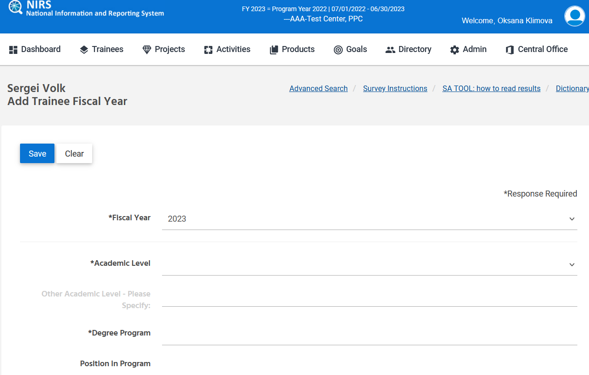

We will complete the form and review some commonly asked questions from fields in the data dictionary
*Current Contact Hours = Enter the actual number of contact hours for the current reporting period only. NIRS will automatically add the hours across years for trainees. Do not supply a range of hours.
Note: The response for this item must be nine or more hours for the current reporting period. If there are fewer than nine hours to report, enter trainee information 1 of 2 ways. 1) either as a short-term trainee if they meet the definition of a trainee in accordance with the NOFO, or 2) in the Activities dataset under the field Types and Numbers of Participants. For example, if a trainee does not meet the definition of a trainee outlined in the NOFO (I.e. shadowed only once in your clinic, does not engage interdisciplinarity with didactics & was engaged with activities at your clinic for <9 hours), these individuals may be best captured in the activities dataset.
*Enrollment Status = Select whether they are considered full-time or part-time, based on their their current school status.
*Is this a LEND trainee? = select yes or no based on whether they are considered a LEND trainee at your Program. This is the field that will dictate whether they are considered a LEND trainee for survey purposes. Note that this question will differ based on your program type. I.e., DBP training programs will see “Is this a DBP Trainee?” instead.
After submitting the YEAR form, you will be prompted on the page that displays the list of all trainees for the current fiscal year (2023.)
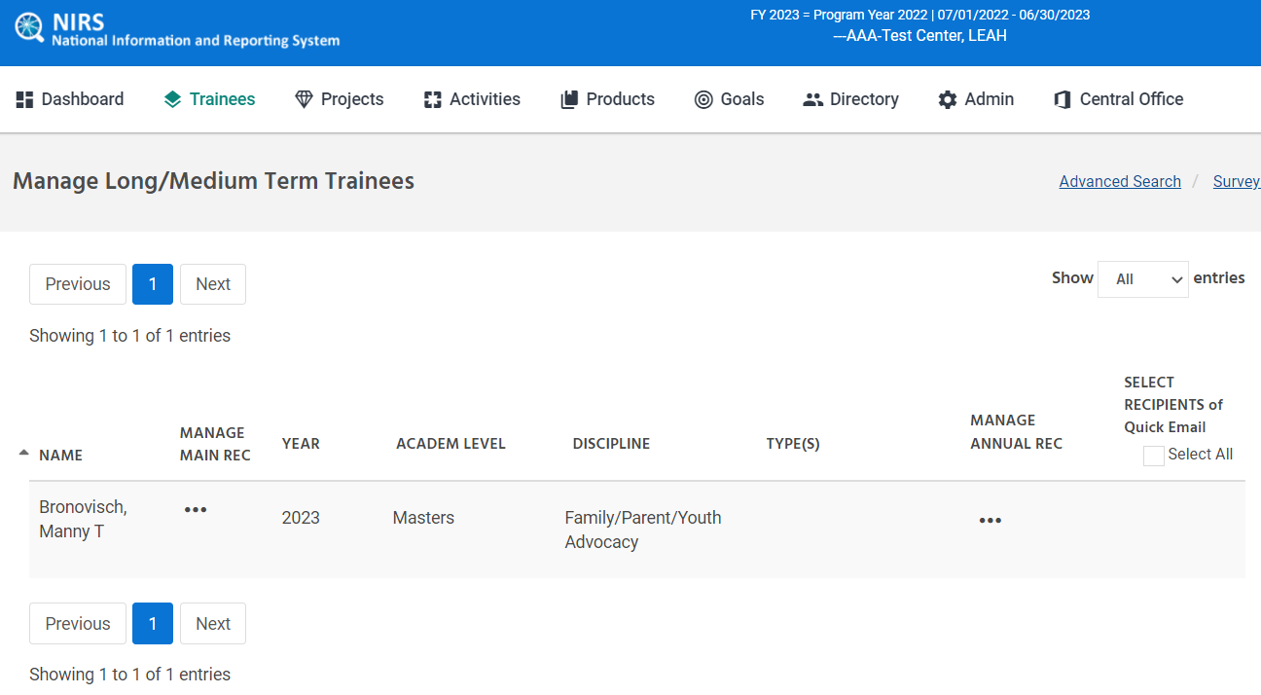
That's the correct Long-Term Trainee record.
Let's talk more about ANNUAL/YEAR Records. We want to cover the following often-asked questions.
Question #1: Should I create a MAIN and ANNUAL/YEAR pair for subsequent years if the Trainee will stay in the Program for several years?
Answer: NO; after you create a pair of MAIN + ANNUAL/YEAR records for their first year, you can add only the ANNUAL/YEAR record for consequent training years.
Best Practice: Main records should be entered only once ever for each Trainee. If a trainee is returning for an additional year and already exists in NIRS, you will want to first search for them in the trainee dataset > advanced Search (more on this later).
There are three ways to add subsequent trainee year records to the MAIN trainee record from the Trainee List/Edit screen:

- Click on the View button on the MANAGE MAIN REC. Click the Add Trainee Year Record button.
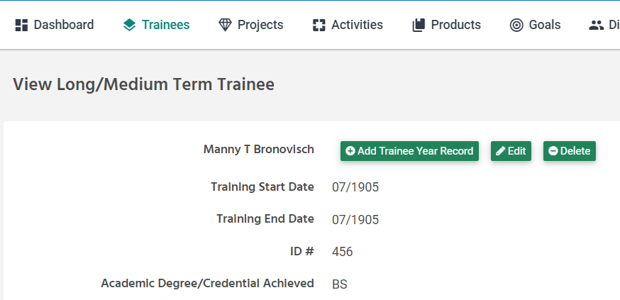
- Click the Add button on any year record under the MANAGE ANNUAL REC.
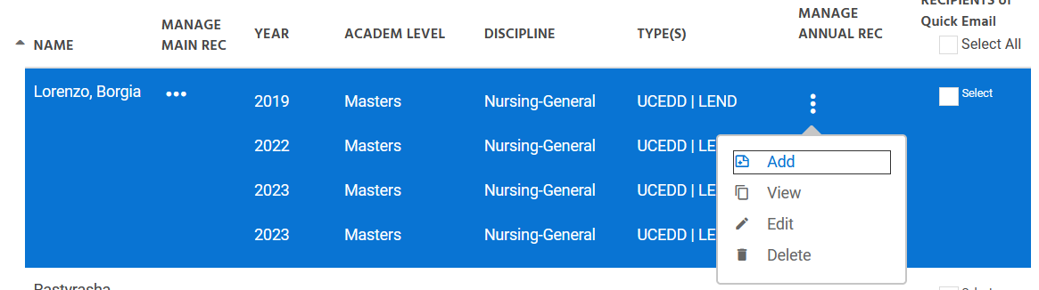
- Click on the View button on any year record. Click on the Save As button in the upper right corner of the screen. Modify any fields that require updating with new information and hit the Save button.
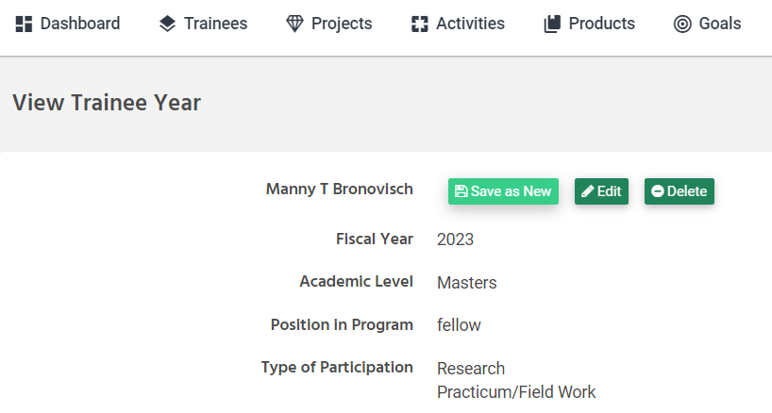
Question #2: what should I do if I submit only the MAIN trainee record and forget to submit the ANNUAL/YEAR record?
Answer: Trainees that do not have pair of submitted forms (MAIN + ANNUAL) can be found in the Trainee Data Entry Errors report.
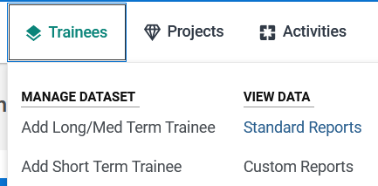

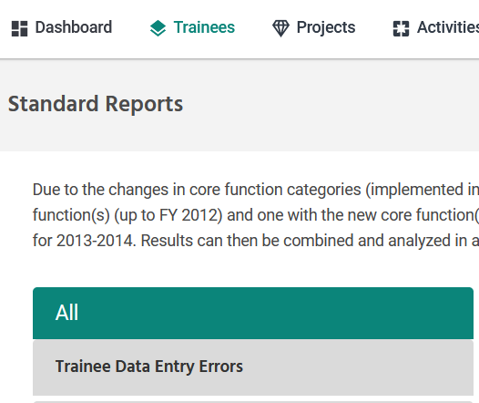
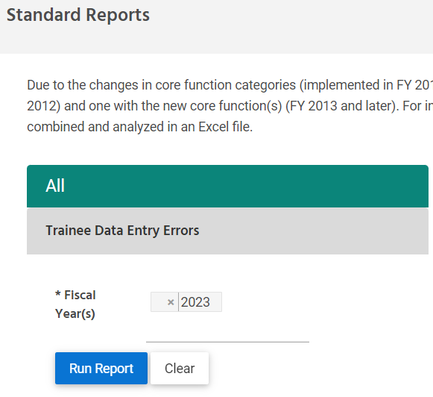
The report runs the same for all program/center types. The error should have the words: “Trainee missing Year record”.
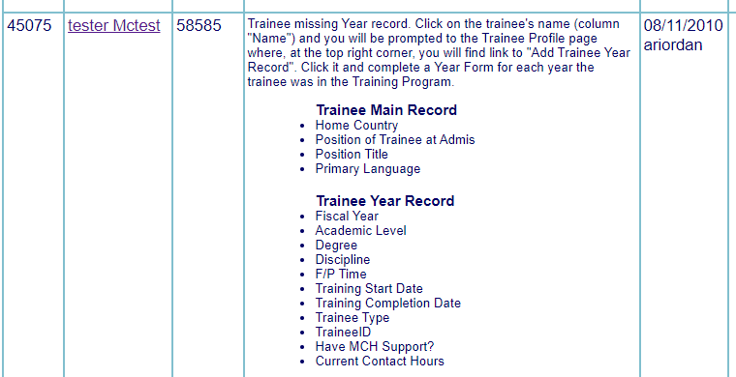

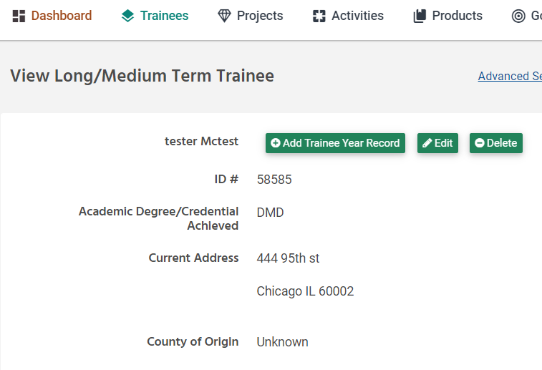

2.4 Manage Short-Term Trainee Records

We covered how to add records for Long/Medium Term Trainees. Let's review the form for Short-Term Trainee. I want to remind you that trainees who complete 40 or fewer hours of didactic and experiential training will be considered short-term (as long as they satisfy the other requirements outlined in your NOFO). Remember that you will want to reach out to your project officer at HRSA/MCHB for questions on the qualifications for who is considered a trainee at your LEND/PPC/DBP/LEAH training program. Based on the trainee data structure diagram, you may remember that you need to complete only one form.
The form for short-term trainees is identical for all program/center types (LEND, UCEDD/LEND, LEAH, DBP, PPC.)
Link Add Short Term Trainee will take you to that online form.
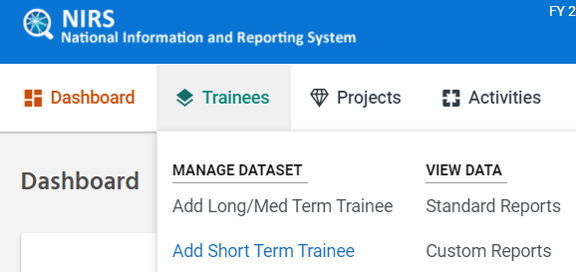

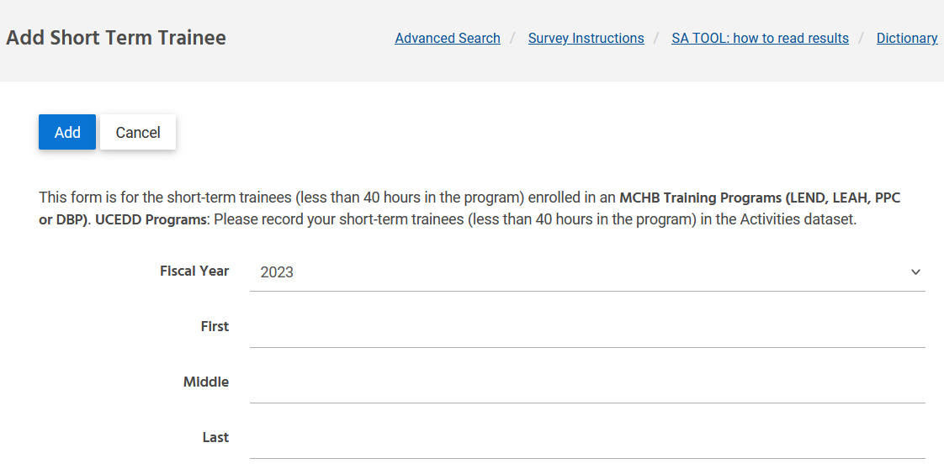
If the form is saved correctly, you will be prompted to the Manage Short Term Trainees page.
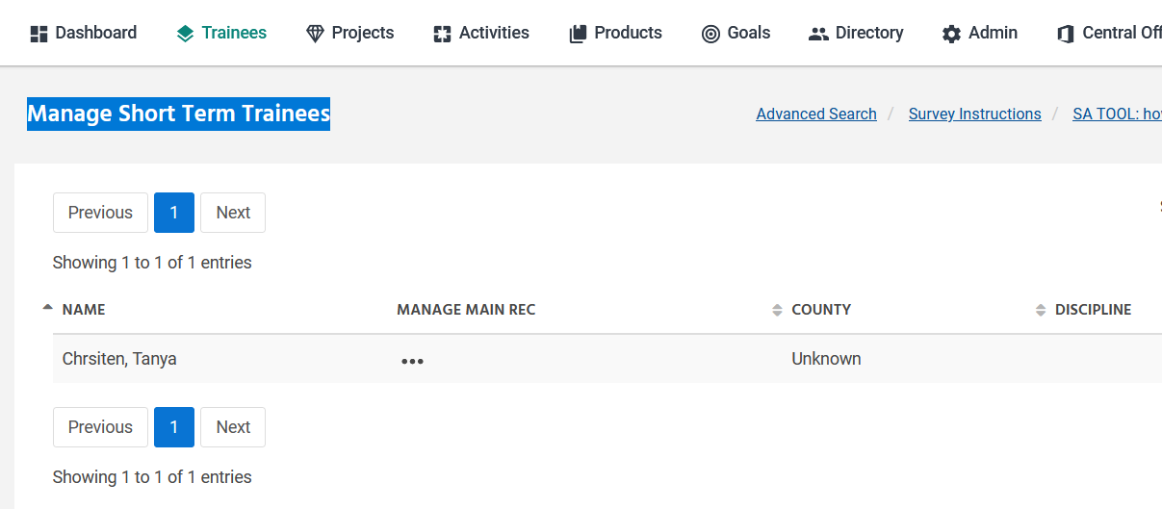
Often we had a question: Can I roll Short-Term Trainee into Long/Medium Trainee? Is it possible?
Answer: Yes, if you click the EDIT button under MANAGE MAIN REC.
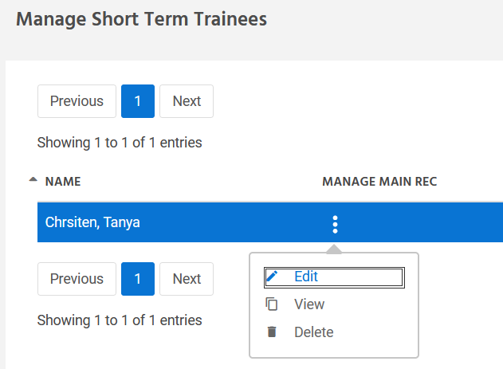

You will see the green button, Convert Record to Intermediate/Long-Term.
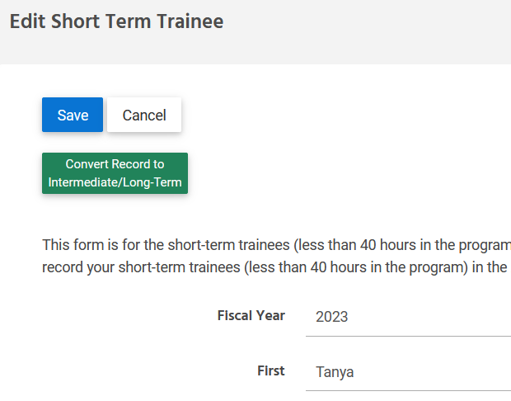
The conversion will do the following:
- create the MAIN record based on information in the short-term form
- create an ANNUAL/YEAR record for the current fiscal year
- delete record short-term record
BE AWARE: When converting short-term trainees to MAIN and ANNUAL/YEAR forms, you must edit both forms and provide the missing information.This is because the form will be incomplete. MCHB requests more information for Long and Medium-term trainees, so please be aware of the additional required fields before converting a trainee.

2.5 Trainee Surveys

Now that we have completed discussing entering trainees, we will now go over trainee surveys.
Based on the Trainee data chart, remember that there are two types of surveys, 2, 5, & 10 years post training (Follow-up Survey) and Annual Trainee Contact Update (Mini Survey). Let's review each type carefully.
Online forms for both survey types include fields for Personal/Contact information. The fields are identical to the Personal/Contact information fields in the Trainee MAIN Record. So, if the Trainee updates that information when completing a survey, those fields are automatically updated in the Trainee MAIN record.

2.5.1 Two, Five, and Ten years post training (Follow-up Survey)

Before we get into common asked question, I want to point out the survey instructions that can be accessed in the trainee dataset. If we could please also link those in the chat please. I would highly recommend carefully reading the information provided in the User's Guide.

Be sure to select the information that matches your program/center type:
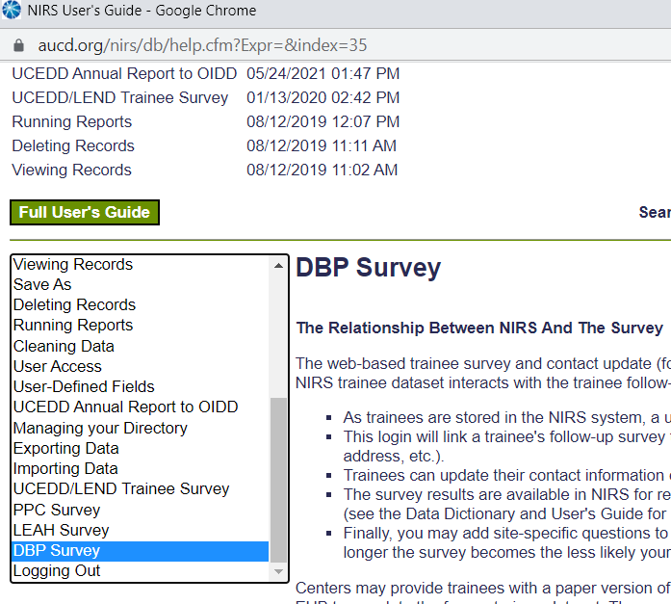

Trainee Follow up survey is one of the most intense TA support areas. We built our training based on the most commonly asked questions.
Question #1: How would I know who needs to submit a Follow-Up Survey?
(It says 2, 5, and 10 post-completion from our training program)
- Use trainee dataset > standard report > under LEND, LEAH, PPC, DBP, scroll all the way to the bottom of the screen and select "Long Term Survey Info (2018+)".
  - Fiscal Year = current year
  - Standard Report will contain all fromer trainees from two, five, and ten years ago who completed your training program.
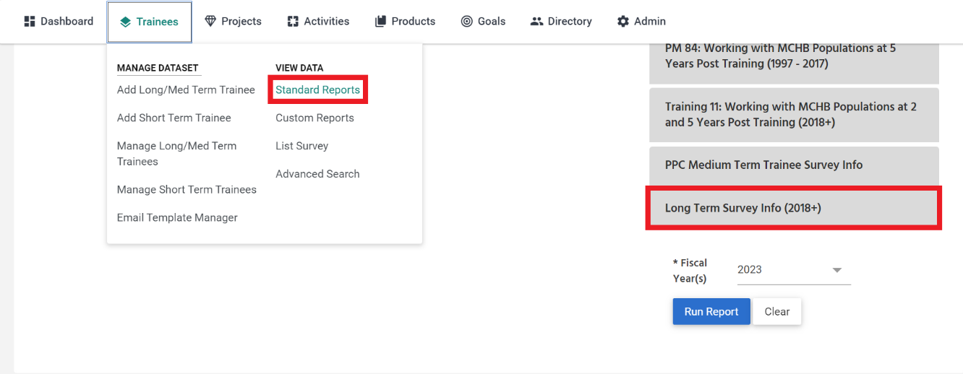

- Trainee Standard Report "Long Term Survey Info (2018+)" contains several fields
  - Terminal Year (year that Trainee completed your training program
  - Type (T= Long-term trainee type, I=intermediate/medium trainee type)
  - Type of Trainee (whether they are LEND, UCEDD, DBP, LEAH, and/or PCC trainee)
  - Name
  - Address
  - City
  - State
  - Zipcode
  - Phone
  - Email
  - 2nd Email
  - Survey Login (password for their trainee survey)
  - Surveys & survey completion dates for their 2, 5, & 10 year surveys (these fields will be empty if the surveyed has not completed by the Trainee yet)
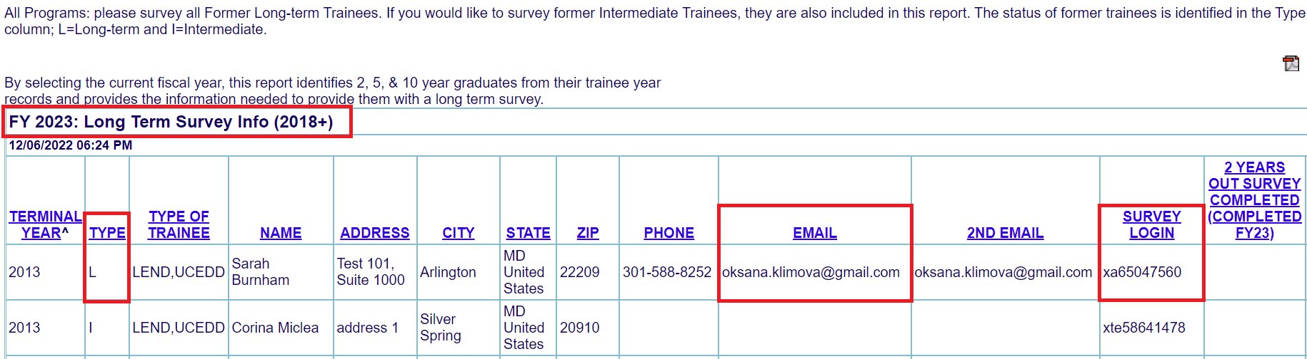
As mentioned, the “Long-Term Survey Info (2018+)” standard report pulls data from each trainee MAIN records that graduated 2, 5 & 10 years ago from your training program. For example, in FY2023/PY2022 (dates included are July 1, 2022- June 30, 2023), then the standard report will contain a list of trainees that graduated/completed your training program in terminal year=2013 (10 years ago), 2018 (5 years ago) & 2021 (2 years ago)
- MCHB is only interested in surveys from long-term trainees every two, five, and ten years post completion from your Program, so you will want to send surveys to trainees with type="L" in the "Long Term Survey Info (2018+)" trainee standard report.

Question #2: Where can I find a link to the survey for my program/center?
1) Link to surveys is found in the survey instructions in the trainee dataset. This links to the user's guide.
- In NIRS, survey instructions are found at the top of the page in the trainee dataset > manage long/med term trainees.
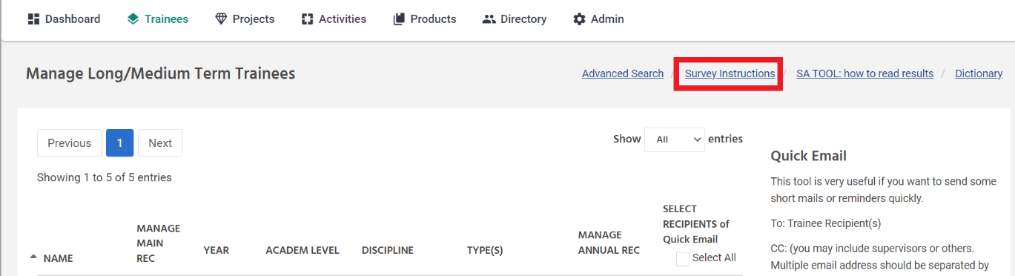
- This will take you into the user’s guide where the survey links are located. Make sure to pick the correct survey page based on the which program the trainee is affiliated with (UCEDD/LEND or LEND-Only, UCEDD-Only, DBP-Only, LEAH-only, PPC-Only).
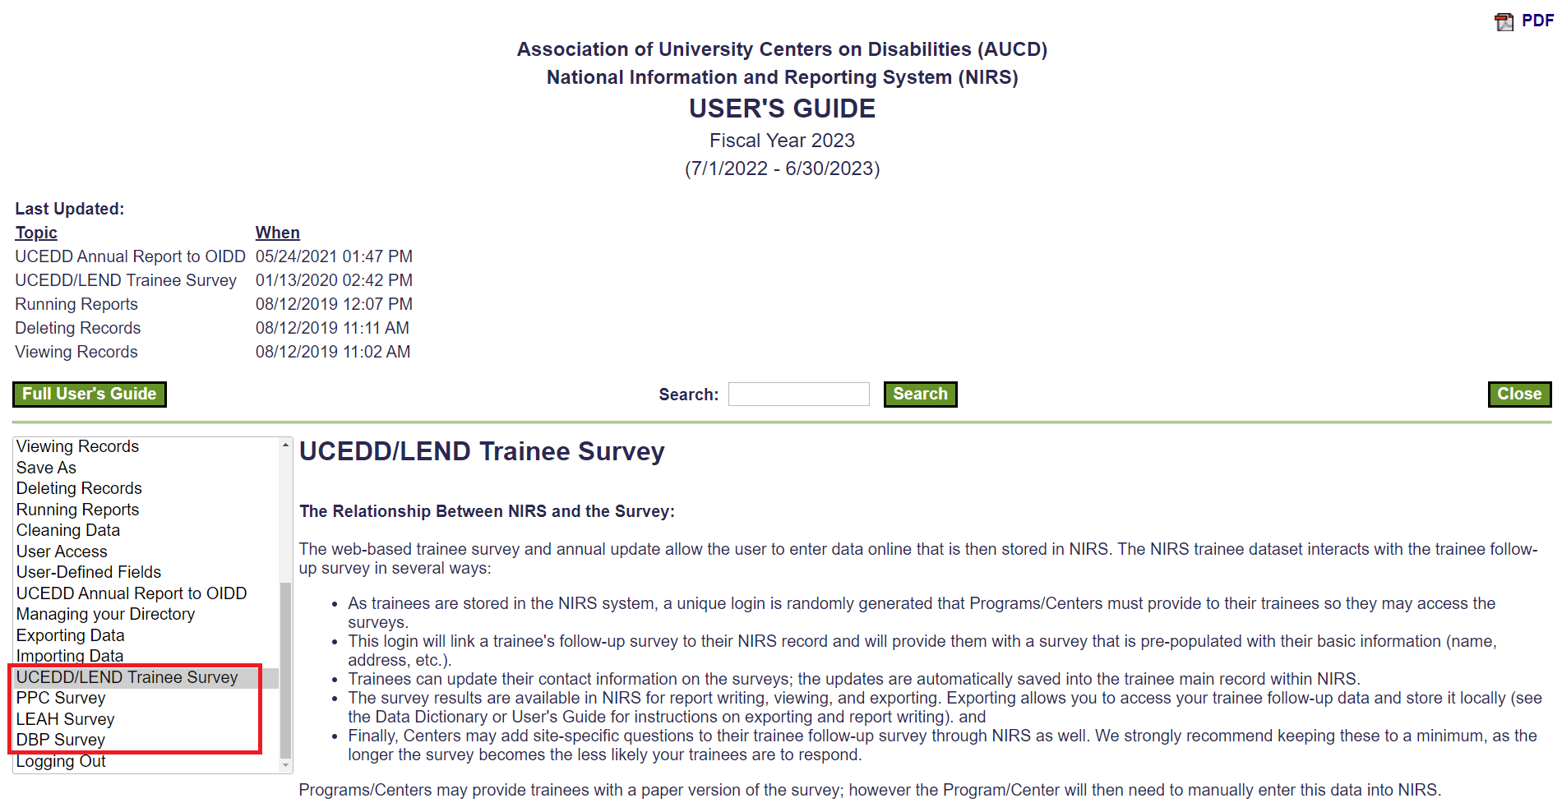
- Survey links are farther down on the page, highlighted in yellow. Make sure to send trainees correct survey link based on their trainee program type (UCEDD/LEND or LEND-Only, UCEDD-Only, DBP-Only, LEAH-only, PPC-Only).
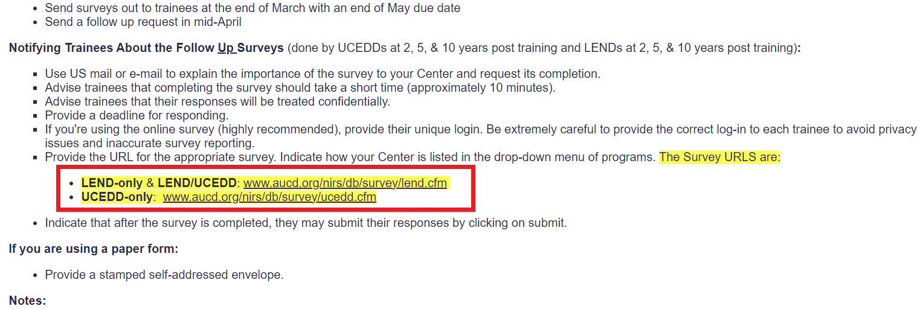
Helpful Resources:
Direct link to User's Guide
Direct Link to NIRS Resources Page
Question #3: I see that survey is password protected. Where can I find a password for a former trainee?
There are two easy places where trainee unique logins are found
- At the bottom of their Trainee main record
- The trainee’s main record is accessed from trainee dataset > manage long/med term trainee > click the three dots under “manage main rec” > select “Edit”
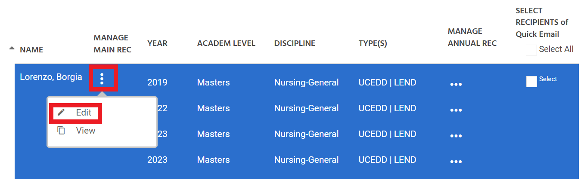
- Their unique survey login is at the bottom of their main record
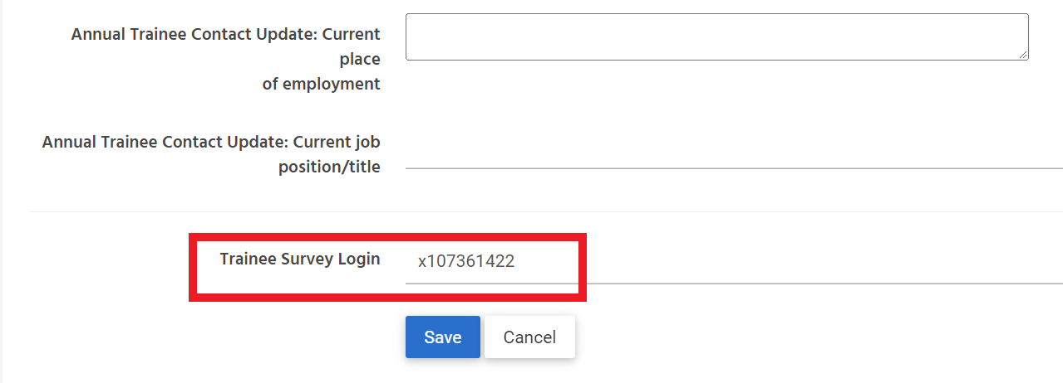

2) And in the trainee standard report "Long Term Survey Info (2018+)".
- Located Trainee dataset > standard reports > under LEND, LEAH, PPC, DBP, scroll all the way to the bottom of the screen and select "Long Term Survey Info (2018+)". Run the report.
- Their unique Trainee Survey login is listed under field 'Survey Login'
Question #4: What should I send to trainees when we send survey to them?
Information to collect for surveying long-term trainees:
- Find the Name of your Program
(found on the ribbon at the top of the screen in NIRS)
- Find the survey link for your program type
(found in the survey instructions in the NIRS User's Guide)
- Find their unique survey password for long-term trainees
("Long Term Survey Info (2018+)" trainee standard report)
- Find the Trainee’s email/contact information
("Long Term Survey Info (2018+)" trainee standard report)

What to include in the email invitation to long-term trainees:
- Name of Program as listed in NIRS
- Survey link
- Their unique Trainee Survey login password
- Deadline to complete the survey (optional)
Sample Email to Trainees Regarding the Trainee Survey:

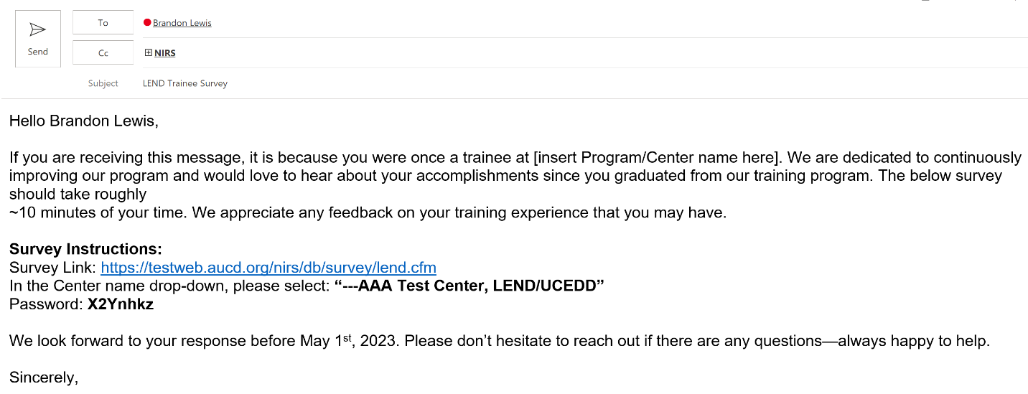
Best Practices: CC a NIRS administrator on the email to assist with follow up and if the trainee has any questions.

Question #5: What is the best Communication strategy with former trainees about the survey?
- First, determine the most efficient way to contact former trainees.
  - If by email, you could either email trainees manually, or use the Quick Email Tool in NIRS
    - The Quick email Tool will be covered later today in section 2.8.2. Quick Email Tool
  - If email is not the trainee’s preferred contact method or contact via email does not work, other options could include contacting them via social media, phone number, or by mail, just to name a few.
    - This is where the Mini-survey will help—see section 2.5.2 Annual Trainee Contact Update (Mini Survey).
  - Survey response rates may vary from year to year.

Question 6: How would I know who submitted the survey and who has not?
- Review the list survey in trainee dataset
  - List of former trainees who have submitted/completed the trainee survey can be found in trainee dataset > list survey
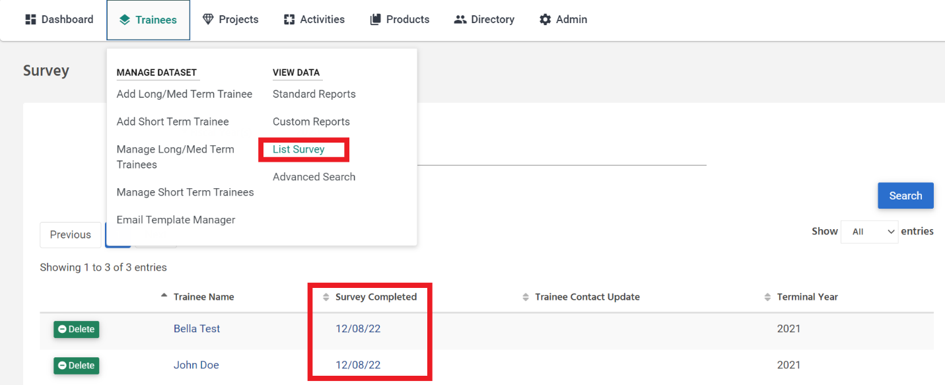
  - List survey will contain all trainees who have completed trainee survey.
  - You could compare the list survey with long-term trainees in the standard report "Long Term Survey Info (2018+)" under LEND, LEAH, PPC, DBP
Additional Information about Follow-Up Survey:
- Attention to UCEDD/LEND: your program/center includes trainees for UCEDD and LEND. You should be careful when providing link to trainees.
LEND/UCEDD trainees must use the following link for the survey:
LEND-only & LEND/UCEDD: www.aucd.org/nirs/db/survey/lend.cfm
If the trainee is UCEDD-Only, please use the following survey link instead:
UCEDD-only:www.aucd.org/nirs/db/survey/ucedd.cfm
- Data collected in the Follow-up Survey is reported to MCHB during the NIRS- DGIS export/import process annually. As a NIRS administrator, you can use Admin Tool, DGIS Export, Data Review 2019+, to review the data that will be reported to MCHB at the end of the fiscal/program year. You can use the tool at any time during the year.
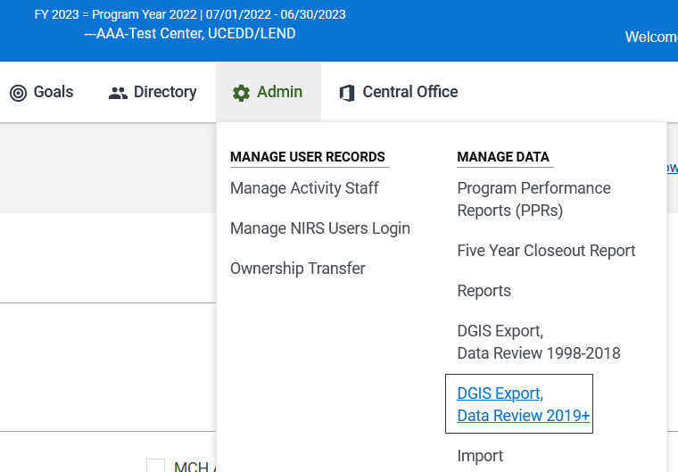
We will cover the tool in detail on Day Four of the Bootcamp.
I now want to briefly cover the mini-contact survey.

2.5.2 Annual Trainee Contact Update (Mini Survey) (5 min)

The Annual Update is used to obtain the most recent contact information annually. You are not required to use the annual update; however, we have found that those who get updated contact information every year tend to have higher response rates on their follow-up surveys.
The survey form contains the same fields for all program/center types.
Live Environment: http://www.aucd.org/nirs/db/update
TEST Environment: https://testweb.aucd.org/nirs/db/update/

2.6 Advanced Search

Now we have completed trainee surveys, we will now go over trainee advanced searches. These can be used to locate trainee records entered into NIRS.
To locate the record, use one of two options:
- Use the Manage pages or 2) Use the Advanced Search function.
Note: Manage pages display data only for the current fiscal/program year.
In all NIRS datasets, you can access the Advanced Search page a) from the top menu or b) by clicking the link at the top right corner of every page included in the dataset.
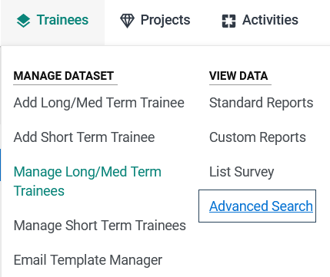
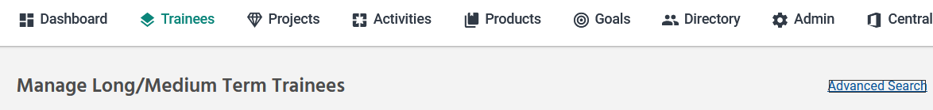
A full description of the search advanced search feature can be found in the User's Guide, section Searching Records
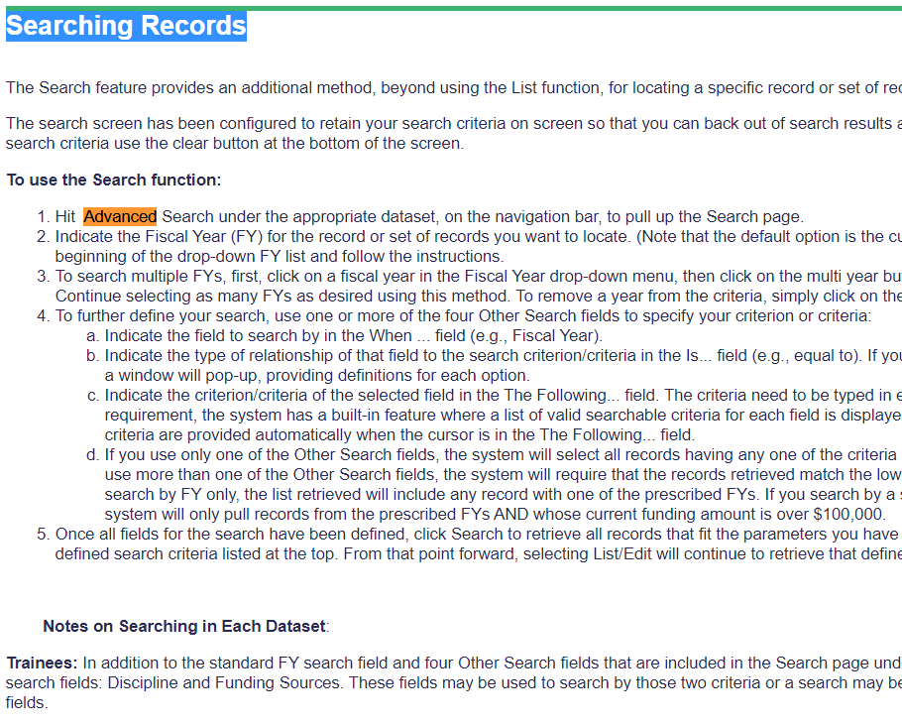

The Trainees Dataset also has a few unique search fields: Trainee Type, Funding Source, and Discipline. These three fields are commonly requested, so we have created the advanced search with these fields in mind.
Advanced searches in the trainee dataset can be used for a variety or purposes. One example is if you have a specific trainee in mind, you can use advanced searches to find them (example below).
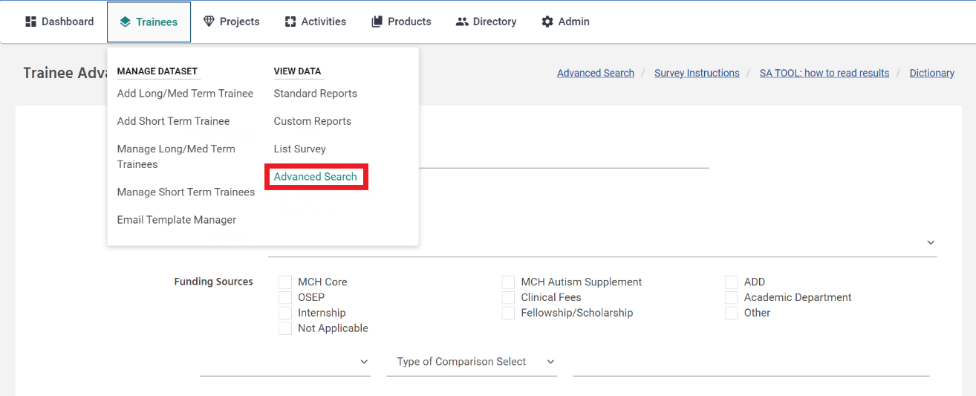
- In the trainee dataset > advanced search, Select Fiscal Year= "All Years" in the drop down
- In the selection criteria below funding sources, select "Trainee Last Name" from the first drop down box, choose "Like" from the middle drop-down box, and then type in the trainees last name in the third text box. Click the search button at the bottom of the page.
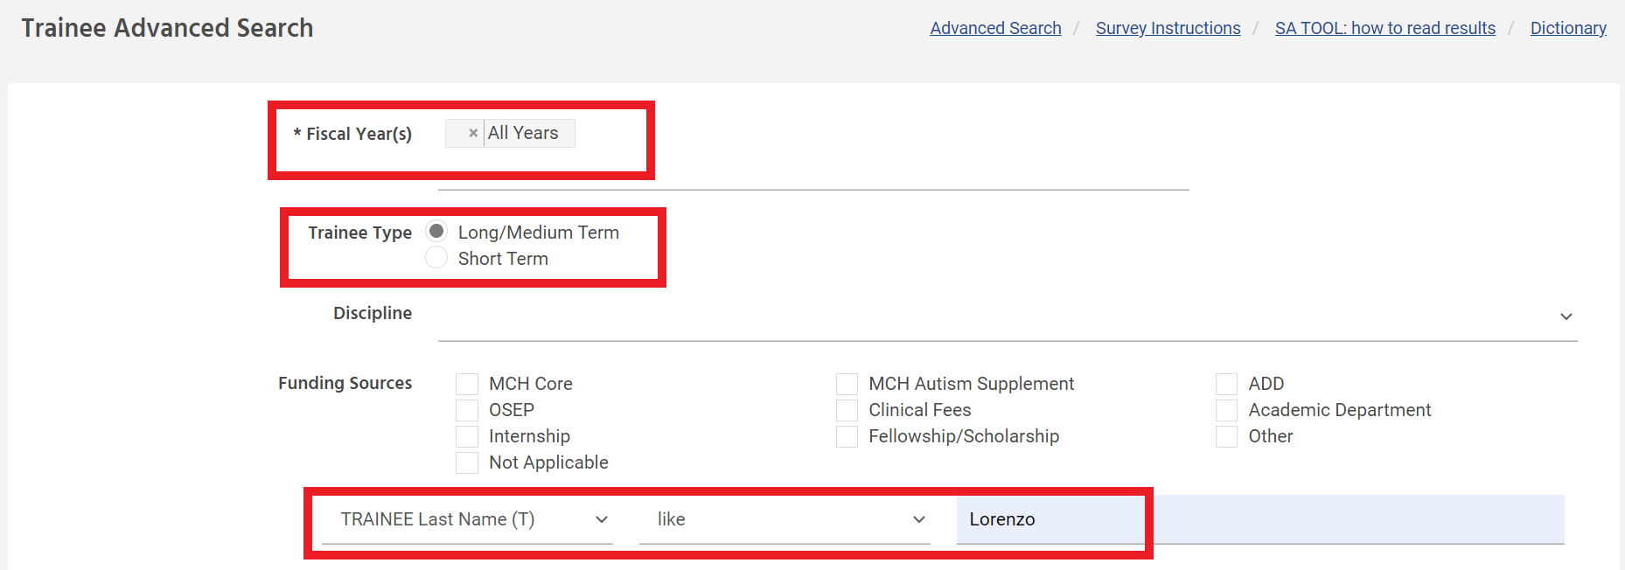
This will show you a list of all trainees with a name similar to the one you searched regardless of spelling, where you can access their main record, view existing annual records from all years that they were a trainee, or add new annual records if they are returning to your Program for the upcoming year.

2.7 Standard & Custom Reports

Each dataset has standard and custom reports which use data entered by data coordinators from that dataset.
Standard reports: predefined reports where the report's content is fixed, and the data coordinator selects the preconditions, such as the last name, etc., in the Directory dataset. These reports are generated from the Program/Center submitted data to that dataset.
Custom (or User-defined) reports: reports created by the data coordinator, where the data coordinator defines the report content.

2.7.1 Standard Report

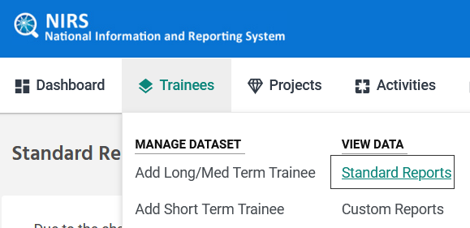
The Standard Reports are displayed on each dataset's under three headers: ALL, UCEDD, and LEND. This relates to center/program type. I.e. All and LEND, LEAH, PPC, DBP columns will be relevant to MCHB reporting, while the UCEDD column may not be useful for MCHB training programs.
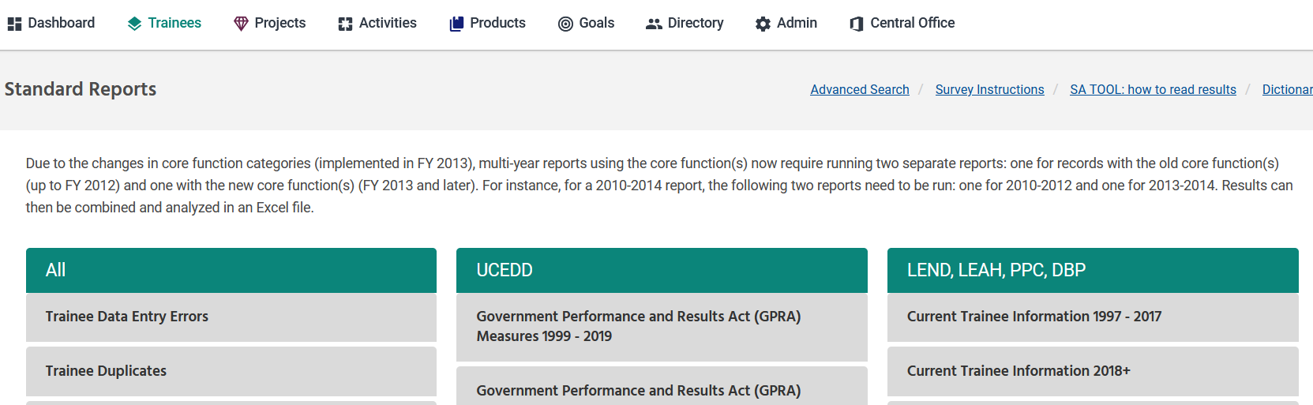
Note: Many Standard Reports are enhanced to enable users to search across multiple fiscal years. Users have UCEDD and LEND filter options for many of the standard reports. By checking the box next to the program type(s), the resulting report will be filtered to include only what has been checked. [scroll through reports]
All standard reports can be converted to PDF for saving and/or printing on 8.5 x 11-inch paper.
We will talk through the top 3 most important trainee standard reports.
- Trainee Data Entry Errors
- Trainee Duplicates
- Long term Survey Info (2018+)
- The Trainee Data Entry Errors trainee standard report can be used to:
- Identify trainees who may not have a complete main/annual record
- Identify trainees who do not have a main and annual record pair
- The Trainee Duplicates standard report:
This is a helpful data quality tool. Trainees are allowed a trainee long-term/medium term record and a short term record. This may be a helpful tool to check trainenes who have duplicate entries. You could use the report to determne if a trainee has multiple short term records or multiple long/medium term trainee records in the same year.
- The Long term Survey Info (2018+) trainee standard report is a very helpful tool to help with surveying trainees.
These are the 3 most common trainee standard reports I hear data coordinators using. Feel free to explore the other standard reports in the trainee dataset. We will continue on to custom reports.

2.7.2 Custom Reports

Custom Reports can be found in the column View Data:
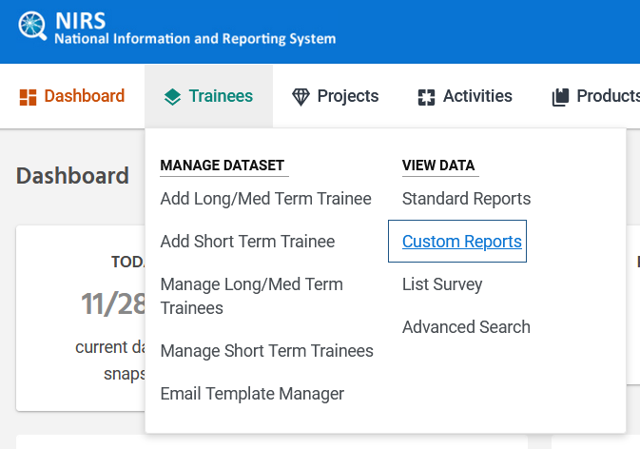
We would recommend organizing your query into categories. A query that will not be assigned to any category will be displayed in the category "no category."
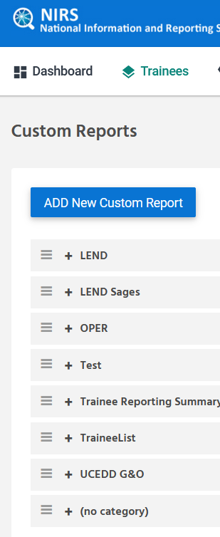

Let's go over the process of creating a custom report. ** Be sure that no standard reports can help you before you build a custom report.
Step 1: formulate your data question and understand what data will answer that question. For our exercise, we will ask: What Foreign Languages are our trainees speaking? (below is the existing report to copy)
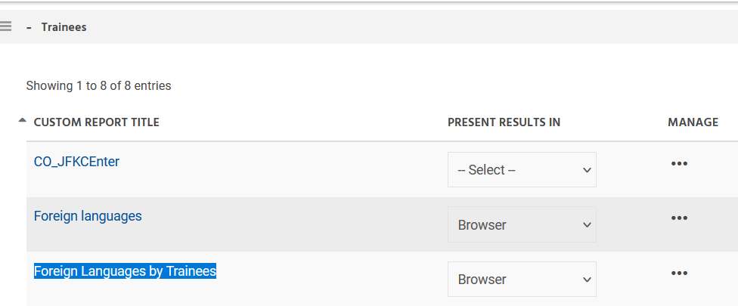

Step 2: Complete the Title, Category (no pull-down list, so must remember existing category name if want to place report into an existing category), etc.
Selected fields: use the chart below to understand what fields are listed.
Prefix indicated the database where the field Is located in the online form. For example TRAINEE means that it comes from the Trainee’s main record in the chart below.
The prefix is followed by the name of the field in online form. For example, TRAINEE last indicates the trainee’s last name from the main record.
In parenthesis will contain the field’s type. For example, TRAINEE last (T) means that it is a text field. (N) will mean that it is a numerical field, and so on.

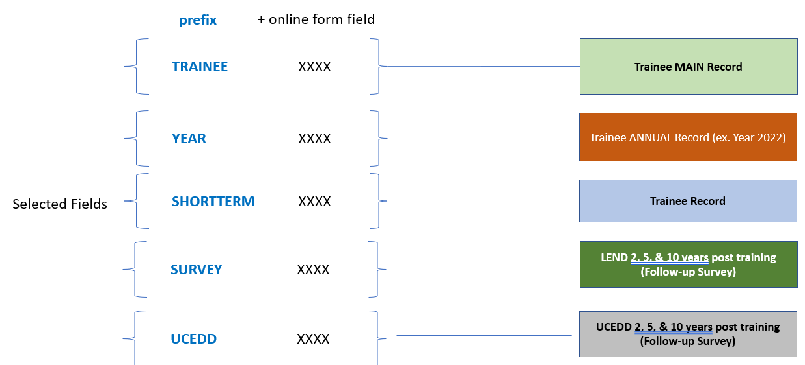

In advanced searches and custom reports, "Selected fields" are the list of questions in the online form. They are the pieces of information you want to include.
Selected fields that start with "TRAINEE" are questions included in the Trainee main record, "YEAR" are list of questions included in the trainees annual (year) record, "SHORTTERM" are from the short term trainee's form, and "SURVEY" maps to list of LEND-only or UCEDD/LEND trainee survey questions, while UCEDD maps to list of questions on UCEDD-only trainee survey.
You can click the "<<" and ">>" to add/remove fields into the custom report. You can click on the options to select them, and then click >> or << to move them over. Options included on the right are the ones that have been selected.
"Selection criteria" are the specifications that you want to refine your data to.
Note: The more fields included in selection criteria, the less records you will receive when you run the report. Each selection criteria further refines your data, meaning less records will fit into all criteria with each new addition.
For example, "Trainee Fiscal Year", "not blank" will return all historical trainee annual records where fiscal year is not missing. "Like" can be a nice selection for the middle column when dealing with text fields (i.e. Title, first/last name, where you manually enter text responses), since it will return all data similar regardless of spelling.
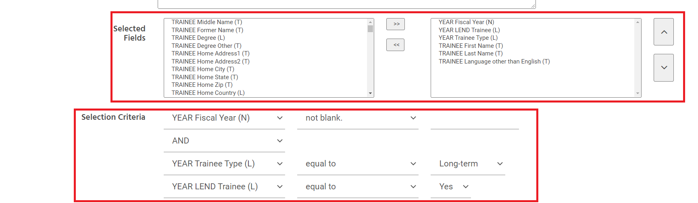
Sort and Group By – ASC and DESC group by option allows you to sort information. Ascending (ASC) will sort fields (AZ) and descending (DESC) will sort fields (ZA) order.
Boxes below this field contains a list of fields selected in "Selected Fields". Similar to above, you can click the "<<" and ">>" to add/remove fields into the sort and group by box. You can click on the options to select them, and then click >> or << to move them over. Options included on the right are the ones that will be sorted by. Options at the top will be sorted by first, followed by the second option on the list, and so on.
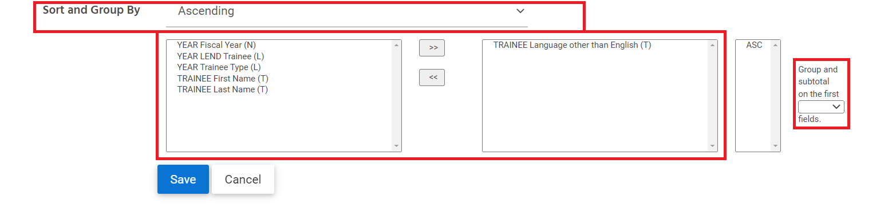
Groups and subtotal on first ___ fields: This field allows you to create totals for rows. For example, it may show you aggregate totals of each category instead of raw data (such as the total number of trainees in each trainee discipline category)
When all selections are complete, save the report. Return to the custom report page in the dataset.
To run a custom report, first select "browser" under 'Present Results in'. Then, click on the 3 dots under manage and select "run". This will bring up the report.
Note that when you run a custom report, it will not show all records that have been pulled. At the top of the screen, you can see how many records are being shown. You can expand the display by entering the number of records you want to see next to "Show" and selecting "Refresh"
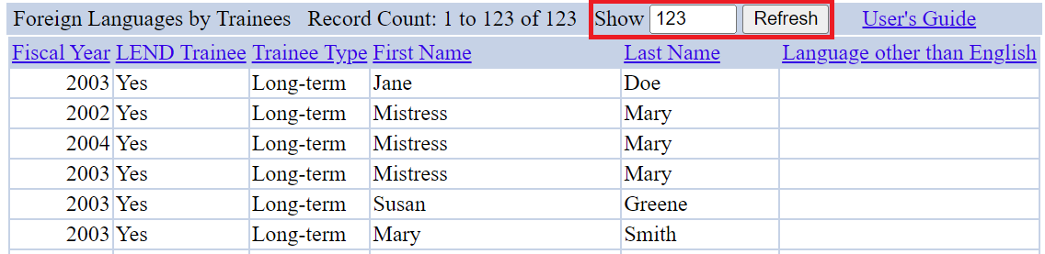
Best practices when building custom reports:
- Ask, “What do you want to capture in the custom report?”
- Break down your question into simple, actionable steps to help guide your process.
- Begin with testing "selected fields" first
  - Selected fields are the list of questions in the online form that you want to include in the report.
- Ask, “Which data points will help me verify the data I matched to?". These pieces of data may be helpful to include in “selected fields”.
- Run the report after each revision to verify the responses in your query.
- Have the dataset open in NIRS in a different browser (i.e., Chrome, Firefox, Microsoft Edge) to compare questions on the form with selected fields/selection criteria to ensure the correct options are accurate.
- Lastly, custom reports take practice! AUCD is here to help if you get stuck. Send a note to NIRS@aucd.org and we are happy to help guide you in the right direction.

2.8 Additional Feature(s)/Tool(s)

Now finished custom reports in the trainnees dataset, we will now cover a very interesting and helpful tool to help you track data internally and to add questions into the form that will be unique to your program.

2.8.1 Administrative Tool: Manage User-Defined Fields

Individual programs/centers may add up to 10 fields to each dataset. Users must have Admin access to define these fields.
To create a user-defined field:
- On the main navigation bar, from the Admin pull-down menu, select “Manage User-Defined Fields”
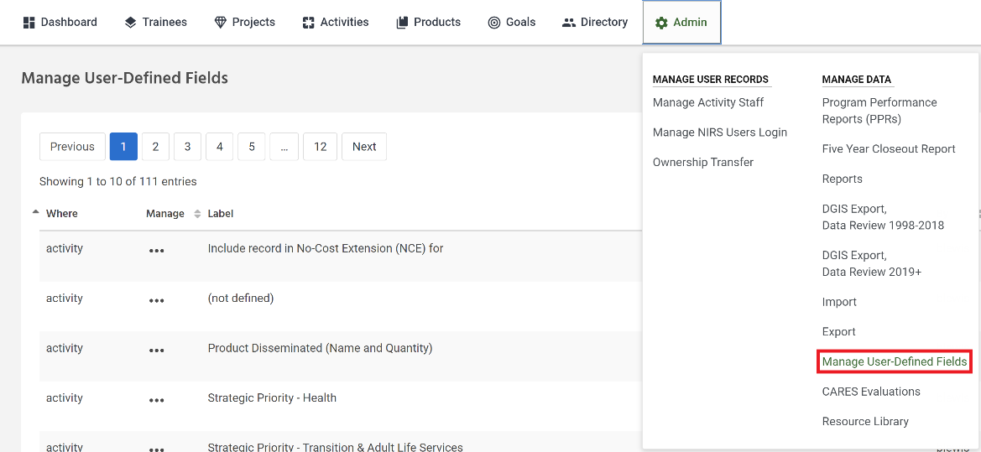
- User-Defined Fields can be of two types: text and pull-down list. (Note: there is a request to add a checkboxes option.) For a text box, leave the text box empty below the label. For the pull-down list display, type each choice on its own line within the text box.

- In the “Where” column, select the dataset

- Click on the three dots and select “Edit” beside the field for which you want to provide a label, type in a label, and enter each option on a separate line. click Save at the bottom of the page.

- User-defined fields can be required. As with the rest of NIRS, required user-defined fields are marked with an asterisk (*). Failure to supply information in a required user-defined field will result in a popup window (saying there is a required field marked by an asterisk (*) at the bottom of the screen) when the user attempts to save a record without completing a required field.
Check/uncheck the “Required” box to toggle this option on and off.
- To remove a user-defined field, erase the current label leave the text box blank, and click Save. Data previously collected in that field will be deleted.

- Centers can deactivate user-defined fields. When a field is inactive, it will no longer display in the relevant data entry form. Still, the data will be maintained in NIRS and remain accessible through the Custom Report function.
Check/uncheck the “Inactive” check box to display/remove the display.
Example of a User-Defined field (text-box) in the Trainee’s main record:

2.8.2. Quick Email Tool

Email Template Manager
Quick email tool can be used to send an email to trainees from with NIRS. Email sent with this tool will be sent from NIRS@aucd.org. You could use the Quick email tool in 2 ways: 1) to connect with former trainees about surveys or 2) to connect with current trainees
- To find trainees you need to survey, try using the trainee advanced search with fiscal year = years needed from 2, 5, & 10 years post completion from your training program
  - For example, in FY 2023, I would need to include long-term trainees who completed the trainee program in 2021 (2 years ago), 2018 (5 years ago), & 2013 (10 years ago)
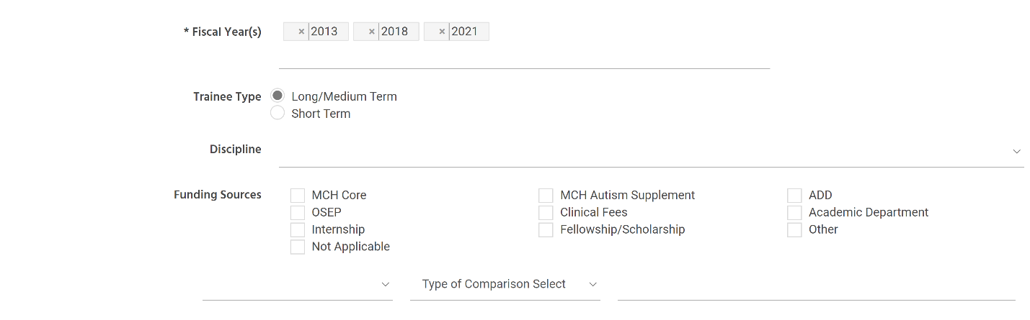
- To connect with current trainees, the Quick Email tool is found on the right side of screen in the trainee dataset > manage long/med term trainee
- Under Select Recipients of Quick email. Check the select box for trainees you wish to send survey about.
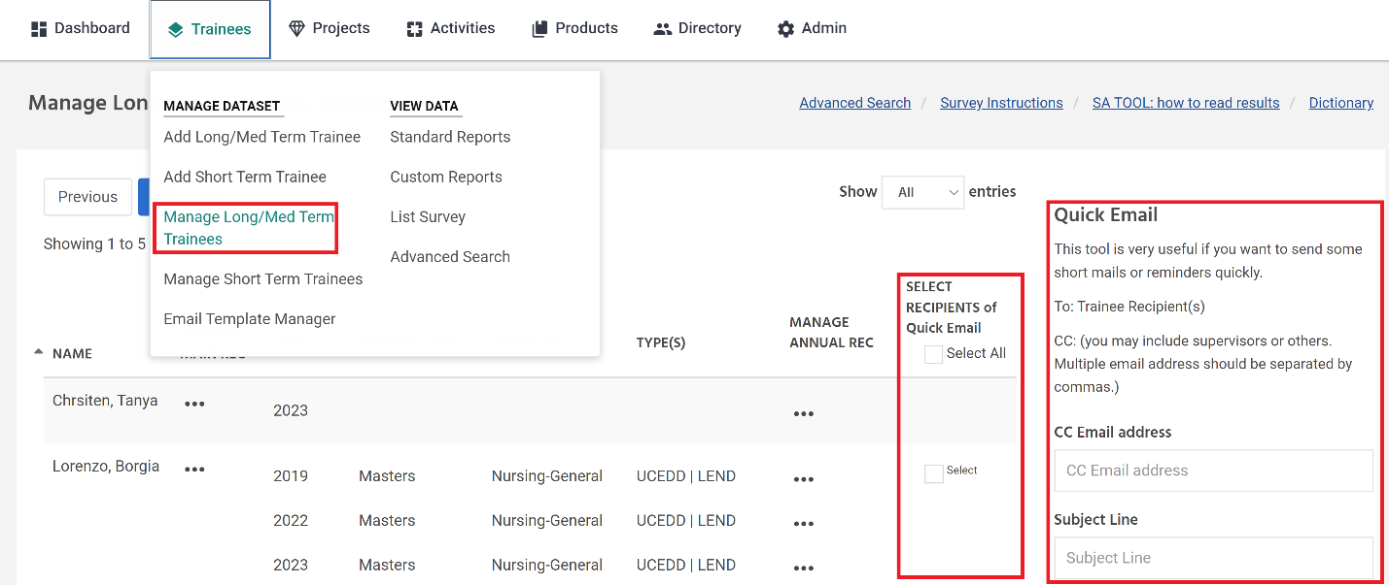
- On far right of screen, there is a quick email prompt. Steps to use the tool below:
  - Under CC Email Address, put your email or the email of a NIRS administrator who can assist Trainee with survey if they have questions (and to assist with follow up)
  - Create a Subject line (i.e. "LEND Trainee Survey")
  - Write email with list of instructions on how to complete survey in the "Content" field
  - Click preview to review the email before it is sent. You can select "email" to send the message
Note: Emails sent from the tool will come from NIRS@aucd.org, and may not be easily recognizable by the recipients. Emails may also be automatically sent to a spam inbox, so it may be helpful to send a test email and/or to follow up using your faculty email.

This concludes our introduction to the trainee dataset. Homework is optional. We will also be hosting Office TA Hours if you have any questions. We will also open the next session of the boot camp with questions. On the technical side, we are giving you a link to the test center so you will not affect real data at your program.

Homework
Note: For training purposes, the links provided below are for the test environment. This is to provide a safe space to practice without affecting real data on the live version of NIRS.

- Find the Trainee's Dataset section in the Data Dictionary
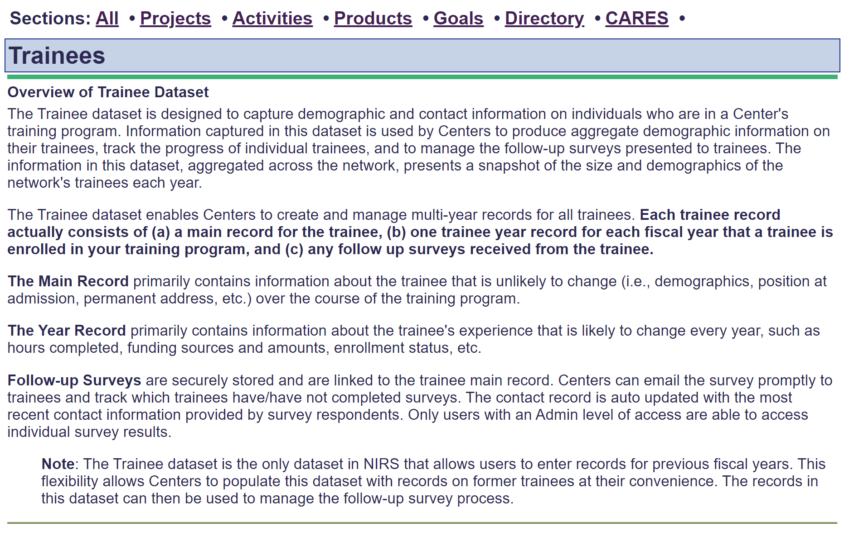
- Add a new Long-term Trainee with Annual records for 2022 and 2023
- Go to trainee dataset > Add Long/Med term Trainee
- Fill in the trainee’s details in their main record and save the page.
- Fill in the trainee’s details in their annual record for 2023 and save the page.
- Go to trainee dataset > Manage Long/Med Term Trainee
- Find the trainee you just added to the menu.
- Add a new annual record for 2022. Enter the trainee’s details and save the page.
- You may return to trainee dataset > Manage Long/Med Term Trainee to check that it is saved correctly. You should see that the trainee has one main record and two annual records.
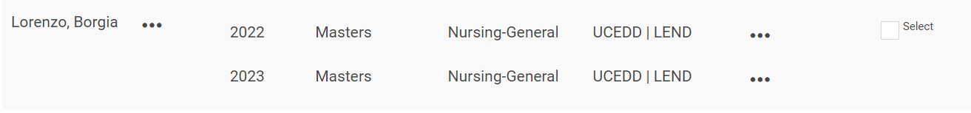

- Add only the new main trainee record. Save the screen. DO NOT CREATE AN ANNUAL RECORD. Close the browser window with the empty annual form open.
- Run trainee Standard Report "Trainee Data Errors"
- Find the trainee’s name that you entered in the list.
- Fix the problem of missing annual record.
Hint: Click on the Trainee's name in the standard report to view their Trainee record.
- You can return to the standard report to check that it is saved correctly. Note that the trainee will no longer be listed.
- Using the information from a long-term trainee listed in the "Long Term Survey Info (2018+)" trainee standard report, draft an invitation email to submit the survey (select one trainee).
Include the following information in your instructions:
  - Name of the Program as listed in NIRS
  - Long-term trainee Survey link
  - Their unique Trainee Survey login
  - Deadline to complete the survey (optional)

- Using the instructions from the email you drafted in question #4, submit a trainee survey as if you were the Trainee.

  - Complete and save the survey.
  - Return to trainee dataset > list survey to find submitted the submitted survey.

Survey Links for TEST environment:
Trainee Program Type | Survey Link
LEND-only & LEND/UCEDD: | testweb.aucd.org/nirs/db/survey/lend.cfm
UCEDD only: | testweb.aucd.org/nirs/db/survey/ucedd.cfm
PPC-only: | testweb.aucd.org/nirs/db/survey/ppc_long.cfm
LEAH-only: | testweb.aucd.org/nirs/db/survey/leah.cfm
DBP-only: | testweb.aucd.org/nirs/db/survey/dbp.cfm

4.0 Closing Remarks

Please send any homework questions to NIRS@aucd.org. Day Three of the boot camp will also begin with an opportunity to answer and discuss questions.
Alternatively, Office TA hours are also available every Thursday and Monday during the boot camp. Times, dates and zoom links are provided below.
Thank you everyone for joining! We look forward to seeing everyone at day three of the boot camp!

Boot Camp Day 1 Office TA Hours:
Thursday 1/19/2022 (11:00AM-12:00PM EST)
Monday 1/23/2022 (4:30PM-5:30PM EST)

Boot Camp Day 2 Office TA Hours:
Thursday 1/26/2022 (11:00AM-12:00PM EST)
Monday 1/30/2022 (4:30PM-5:30PM EST)

Boot Camp Day 3 Office TA Hours:
Thursday 2/2/2022 (11:00AM-12:00PM EST)
Monday 2/6/2022 (4:30PM-5:30PM EST)

