**NIRS Boot Camp Day 1 Script**

**Contents**

1.0 Administration of NIRS Accounts 5

1.1 Request to open NIRS account for Your Center Name (time = 5 min) 5

1.2 Login to NIRS 6

1.3. Manage Personal Information 8

1.4 Manage NIRS Users' Logins 8

2.0 Directory Dataset 11

2.1 General Information about the Directory dataset 11

2.2 Add faculty/staff profiles 14

2.3 Manage Faculty/Staff Profiles 16

2.3 Reports for Faculty/Staff Profiles 17

2.3.1 Standard Reports 18

2.3.2 Custom Reports 18

3.0 Manage Activity Staff (former Staff Involvement) 21

4.0 Homework 24

5.0 Closing Remarks 26

**Introduction**

Learning Objectives for today’s Boot Camp session, participants will understand and be able to:

1. Identify the Roles of AUCD/MCHB & Partnership
2. Federal requirements/performance reporting for MCHB/HRSA
3. NIRS Admnistration: Manage NIRS Users Login
4. AUCD Online Directory: Manage Center Information, Manage Faculty | Staff Profiles
5. Manage Activity Staff

**During our presentation we will be using abbreviations:**

**DGIS/ EHB**

**DGIS =** Discretionary Grant Information System

**EHB =** Electronic Handbooks

Initially released in October 2004, the Discretionary Grant Information System (DGIS) is a web-based system that allows grantees to report their data online to the Maternal and Child Health Bureau (MCHB) through HRSA's Electronic Handbooks (EHBs) as part of grant application and performance reporting processes.

Below is a diagram that explains how reporting data gets in DGIS/EHB.

**Benefits of NIRS vs other applications**

NIRS is an application that helps centers collect data that should be reported to Federal agencies. Each center can select a different application; many are on the market. We want to highlight the main benefit of using NIRS.

1. No cost is associated with using NIRS and storing data for multiple years. Other application may charge to maintain historical data, though we do not for NIRS.
2. NIRS was built from the specifications of the federal funder. This means that information is already in format the federal funder desires when it appears in your federal reporting.
   1. AUCD also coordinates with MCHB to import your data directly into Electronic Handbook (EHB) to decrease duplication of data entry.
3. There is TA support from AUCD’s ITAC team
4. NIRS pre-build reports provide quantitative and qualitative data that can be used for reporting to Federal agencies.
5. Ownership and storage of historical data at your program
6. Leveraging network expertise
   1. Program/Center data prominently promotes the public search for products and projects on the AUCD website.
   2. Online AUCD Directory

Note: For each dataset, we will point out the required data for performance reporting. Also, we will point out the pre-built reports that can be used to complete the Performance measures.

That concludes our introduction. We will now begin with NIRS. We provided a login to everyone via email to complete homework and follow along if you wish. The login credentials are separate from the live version of NIRS, so that everyone can practice without worry of affecting real data.   
  
During each session we will provide list of Helpful links for the session.

**Helpful Links for Today’s Session:**

**NIRS Resources** - <https://www.aucd.org/template/page.cfm?id=449>

**What is NIRS:**

Short definition: NIRS is a web application that helps programs/centers with performance reporting by collecting required data for federal funders.

The NIRS application contain a collection of Datasets.

**Dataset** = A data set is a data collection on a specific subject. NIRS has the following datasets:

**Trainees**-trainees in your training program and trainee surveys   
**Projects**-funding and collaborations at your program/center   
**Activities**-what you are doing around those funding dollars in the community/in your training program   
**Products**-what came out of those activities  
~~Goals –~~ outdated/ will skip  
**Directory**-Center, faculty, and staff information  
**Modules**-Tools for federal reporting and data import/export

Each NIRS dataset in NIRS includes the following pieces:

* Data entered by the Data Coordinator or Faculty/Staff
* Data Search for the Dataset
* Data Reports (list of reports set up by AUCD and tool where you can set up custom reports)

Now we are ready to start.

# 1.0 Administration of NIRS Accounts

## 1.1 Request to open NIRS account for Your Center Name (time = 5 min)

Your Program decided to start to collect data and use the NIRS system … what is your next step?

You start by sending an email to [**NIRS@AUCD.ORG**](mailto:NIRS@AUCD.ORG).  
  
Your email should include the following information:  
  
**Subject**: Request to open NIRS account for Your Center Name  
**Provide the required information in the email**:

Program Name

Department

Organization

Postal Address

Main Phone

Main Fax

Main Email

Website

Program Type (possible options: LEND, UCEDD/LEND, LEAH, DBP, or PPC)

Logo

Contact Information: email address (es) of Faculty/Staff/Data Coordinator(s)/ Director(s) who will be the primary contact and NIRS data manager. That person(s) will be assigned the highest access level (Administrator.)

\***Note**: Faculty/Staff/Data Coordinator(s)/ Director(s) who will be the primary contact will carry the title NIRS Data Coordinators, even if it may not be their title in the Program.

**\*Note:** Center data are password-protected; only you can see your Program data; data belong to your program/center, not AUCDs.

You will receive a Welcome email from AUCD when your Program NIRS account is set up. A welcome email will include the following:

* Link to NIRS
* Name of your Program/Center
* List of names who have Administrator access to NIRS.
* Individual encrypted emails with login credentials will be sent to those users at the same time.

## 1.2 Login to NIRS

With a NIRS User account, you can **log in to NIRS**.

* 1. Pull login information from the AUCD email
  2. Login to NIRS (the AUCD website link or direct link)

AUCD website: <https://www.aucd.org/template/index.cfm>

Direct Link to LIVE Version: <https://www.aucd.org/nirs/db/>

* + 1. Select the login page for your Center type
    2. Select your center name from the pull-down list of centers
    3. Fill in the credentials for the Username/Password
    4. Login

If you see the dashboard – SUCCESS!

## 1.3. Manage Personal Information

## 1.4 Manage NIRS Users' Logins

Every person using NIRS (managing data, running reports, etc.) will need an account (username and password.) Reminder: NIRS is a case-sensitive password-protected system.

Your next step is to create accounts for the NIRS users at your Program/Center.  
Data Coordinators will make a strategic decision about who will enter data into NIRS. There are two options (pro & cons):

|  |  |
| --- | --- |
| Option A: Data Coordinator(s) enter all data in NIRS | Option B: Faculty/Staff enter data in NIRS/;Data Coordinator(s) check data for quality and consistency |
| * Central data management | * Training faculty/staff |
| * Higher Consistency in data entry | * Data quality check |
|  | * Less Burden on data manager to complete all data entry |

Below is a step-by-step instruction on how to add a new NIRS User Login:

**STEP 1:** Log in to NIRS

**STEP 2:** Find the Admin tab > Manage NIRS Users Login

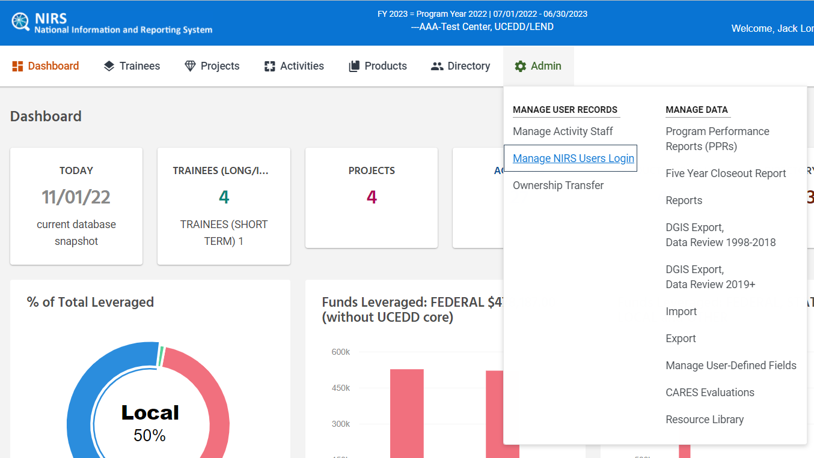

**STEP 3:** Select "Add New NIRS login" highlighted in blue at the top left of the screen

**STEP 4**: Enter the name, username, password, and email of the person you are adding to NIRS.

* You may enter a username and password of your choosing. These will be used to log into NIRS from the [login page](https://www.aucd.org/nirs/db/index2.cfm).

**STEP 5:** Scroll down the page and select the datasets and level of access. It is up to each Center/Program to decide the level of access and what data staff have access to—some Centers/Programs prefer to divide and conquer, while others prefer full access for staff. Definitions for the “Access level” field and how different access levels affect the individual’s permissions are listed at the bottom of the page.

**Permissions:**

|  |  |
| --- | --- |
| Read Only | users have access to view all data fields, except for personal/contact information in trainee records |
| Assist | users have access to standard reports, including reports limited to those with "Admin", but cannot enter or modify data |
| Read/Write Own | users have access to view all data fields, except for personal/contact information in trainee records that they did not create, and they may edit all records that they created |
| Read/Write | users have access to view and edit all data fields |
| Admin | users have Read/Write access, plus access to export the data and access to this form |

**STEP 6:** Make sure to save any changes at the bottom of the page.

* Double-check that it saved correctly by going back to Admin dataset > Manage NIRS Users logins. You should see your selections have been correctly saved under 'Access to Datasets' and 'DIR MGR' if Directory Manager was checked was selected

**Select a combination of the Dataset (s) + permission for each Profile.**

Email the user their credentials, along with instructions on how to log in.   
* You can set up a Login/Username only once. You could not edit it.

* It's an internal decision on how to train faculty/staff to use NIRS/ AUCD can assist (online training modules etc.)

# 2.0 Directory Dataset

## 2.1 General Information about the Directory dataset

The Directory is designed to assist the network, federal/state agencies, and the general public to quickly locate people by their interests and expertise.

Data from the Directory dataset is propagated into AUCD Online Directory and Projects and Products datasets. **Profile data from the Additional Information section is not displayed for public users.**

**AUCD Online Directory**

The Directory is public-facing and assists policymakers and stakeholders across the network find contact information within the network. <https://www.aucd.org/itac/directory/directory.cfm?program=LEND,DBP>

Note that the **Directory dataset** is also used in the **Projects** and **Product Datasets.** I will now show fields in these two datasets where the faculty listed in your directory will appear in.

The “**Contact” field** in the **Projects dataset** (near the top of the page).

The “**Name” field** near the bottom of the page under Ordering ifnormaton in the **Products dataset**.

Data for Online Directory is managed in NIRS > **Directory dataset**

**The Directory dataset** is the Dataset that contains data about a) the Program/Center profile and b) the list of Faculty/Staff profiles.

**Note:** The directory dataset contains data not associated with the fiscal/program year.

1. You already provided Program/Center information for your center’s Profile. You can edit it at:

Directory > **Manage Center Information**

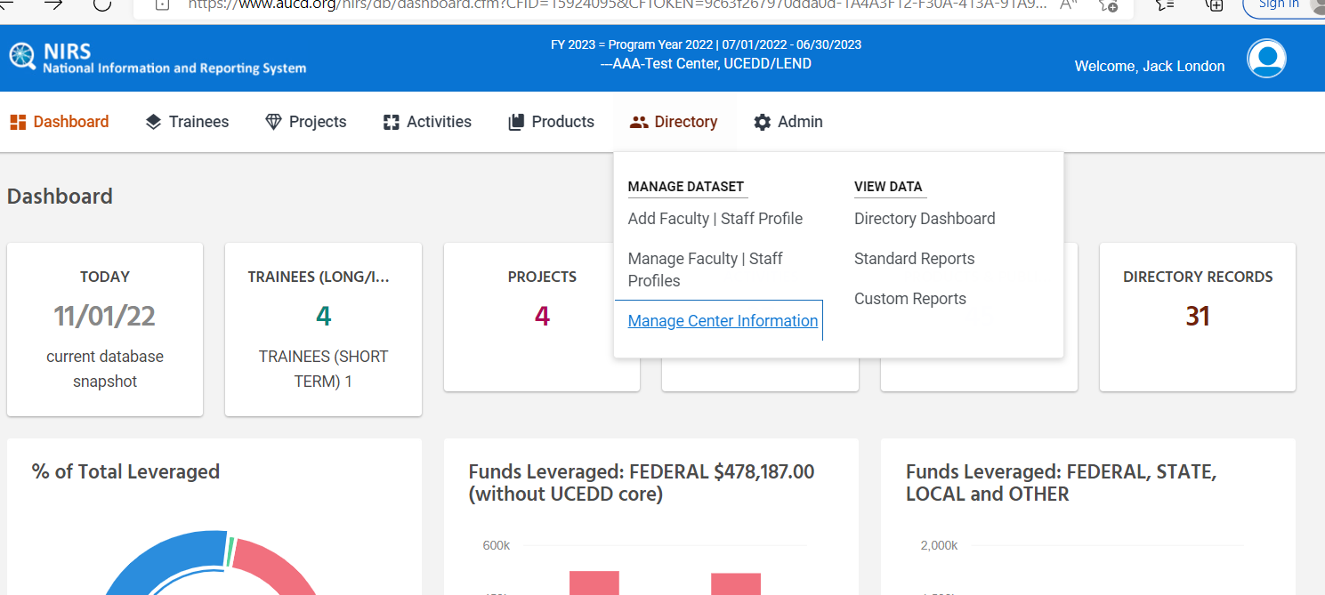

1. Each center lists Faculty/Staff for the Program/Center.
2. **Note:** Only users with admin access and access to the directory dataset (directory manager = yes (DIR MGR=YES)) can edit directory information for **everyone** at their Center/Program.

## 2.2 Add faculty/staff profiles

There are two ways to add faculty/Staff to your center and display those in Online Directory.

1. Use **NIRS > Directory** dataset to add a member profile to Online Directory
2. Ask Faculty/Staff to submit an online profile for Online Directory
3. **I will first show you Steps for NIRS > Directory approach:**

**Note**: With this approach, be sure to review the online profile form to confirm that you have all information for the required fields.

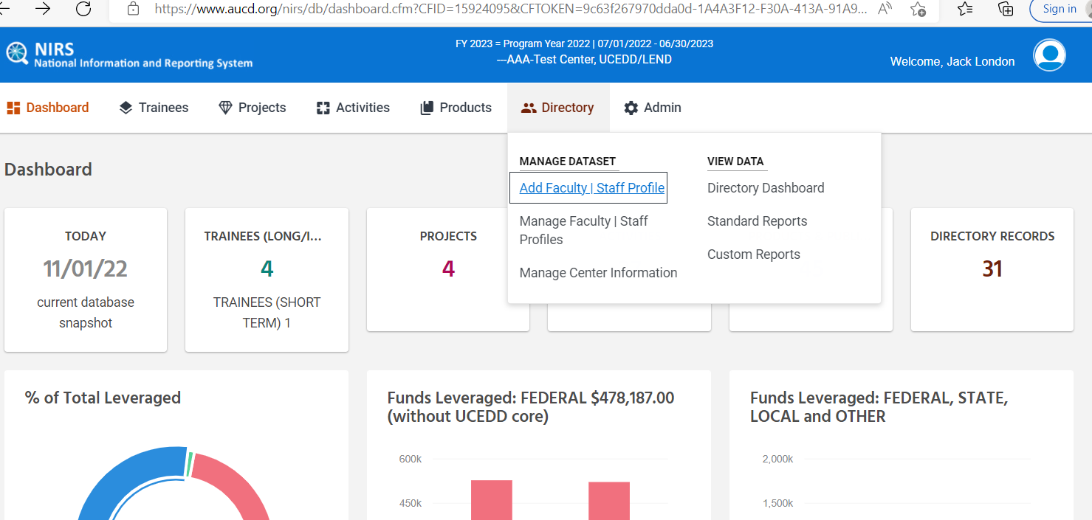

Username and password for online AUCD profile is separate from NIRS login. Online Directory Faculty/Staff Profile display controls by the field:

* **Display** – profile will be displayed in Online Directory
* **Display + DO not display** – Profile will be displayed in the Project & Product Contact information list
* **Inactive –** hidden but kept in NIRS for historical reasons

Faculty/Staff can be submitted in online profile. NIRS administrators will need to conduct a review process. You as NIRS administrators can choose to accept or reject the profile.

* **Pending Submission –** faculty/staff work on submitting their online Profile.
* **Waiting for Approval –** faculty/staff application submitted and waiting for review by Data Coordinator
* **Rejected -** faculty/staff application rejected

1. **Steps for Ask Faculty/Staff to submit an online profile for the Online Directory approach:**

You can add a new profile from Online AUCD Directory by going to your program in the directory and clicking on “Not yet in the directory? Register to Manage your profile online”

Or **Direct Link:**

Email link to the online form to faculty/staff: <https://www.aucd.org/directory/dir_contact_edit.cfm?staffid=0>

You will be notified by email when a new profile is submitted. Note that nw faculty profles are not automatically approved. A review process is required. All submitted profiles will have the "Waiting for Approval" status in the field *Member status in the online Directory. As the Data coordinator, you will decide how to proceed with the Profile.

Reminder: Faculty/Staff can log in to AUCD Online Directory to update their Profile at any time. They will not have access to NIRS data.

Note: data from the section Additional Information will not be displayed on the public Online Directory.

Only information related to professional experience and activities should be submitted in the profile.

## 2.3 Manage Faculty/Staff Profiles

There are two places in NIRS that can help you manage profiles in the future:

1. View list of all profiles: Manage Faculty | Staff Profiles

1. Directory Dashboard: program/center information which will allow you to search and manage faculty/staff information.

That wraps up entering data into the directory dataset. We will then segway into reports in NIRS for Faulty/Staff Profiles.

## 2.3 Reports for Faculty/Staff Profiles

Each dataset has standard and custom reports which use data entered by data coordinators from that dataset.

**Standard reports**: predefined reports where the report's content is fixed, and the data coordinator selects the preconditions, such as the last name, etc., in the Directory dataset. These reports are generated from the Program/Center submitted data to that dataset.

**Custom (or User-defined) reports:** reports created by the data coordinator, where the data coordinator defines the report content.

## 2.3.1 Standard Reports

The list of Standard Reports is the same for all types of programs/centers.

For UCEDD/LEND program/center type, you can select for what kind of program you are pulling reports, UCEDD-only, LEND-only, UCEDD + LEND.

## 2.3.2 Custom Reports

Custom Reports can be found in the column View Data:

We would recommend organizing your query into categories. A query that will not be assigned to any category will be displayed in the "no category" group.

Let's go over the process of creating a custom report.   
**\*\*** Be sure that no standard reports can help you before you build a custom report.

**Step 1:** formulate your data question and understand what data will answer that question. For our exercise, we will ask: ***What Names include the letter M in the first name?***

**Step 2:** Complete the Title, Category (no pull-down list, so must remember existing category name if want to place report into an existing category), etc.

Select the fields: use the chart to understand what fields are listed

**Prefix** is the name of the table in database where profile data is stored.

Then will have **online form field**, which will match fields in the dataset/table in the database.

Then in parathesis will note **field type**, for example. (T) for text field, (N) number/numerical

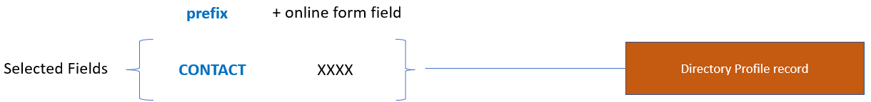

In our example of staff with letter M in their first name, first start with creating a unique title and category.

**Selected fields** are which data fields from the online form you want to include in the report. Scroll down the list on the left side and then click the >> << to move the options between the 2 screens. Fields on the right side are the ones that have been selected.

For our example, I am just going to select “CONTACT first (T)”, which tells us it is from the directory profile, faculty member first name, and it is a text field.

**Selection criteria** are how you want to refine your data selections. We are interested in staff with letter “M” in their first name, so I will select “CONTACT first (T)” in the first drop-down again for staff first name, “Like” in the second drop-down (“like” is a nice option here because it will return all responses with a similar spelling), & then type the letter “m” in the 3rd box.

Scroll down the page and save the report.

We have now created our first Custom report. You can see there is a new category “Staff by Letter”, and I can click on the - & + nxt to it to expand/collapse the category.

Let’s run our first custom report. “Present Results in” drop down select “Browser”. The “browser” option will open results in a separate tab. Other options will download the search into a .CSV file. Feel free to explore the other options throughout the boot camp.

Under “Manage” click on the 3 dots. You can Run the report and edit if you need to make changes to the report later. Run the report.

At the top of the screen, you will want to check “Count”. It will not show all results if there are more than 50, so you may need to enter the total number of results and click refresh.

Once you do, you will see the results of our query.

We have finished reviewing directory dataset. We will now begin with the third profile type: Activity staff.

# 3.0 Manage Activity Staff (former Staff Involvement)

Let’s recap: There are a total of 3 categories of profiles in NIRS. We have gone over the first 2:

1. NIRS login for Data Coordinator/Faculty/Staff who are entering data into NIRS
2. Online AUCD Directory for Faculty/Staff
3. Users included in the Staff Involvement list

**Note:** Each profile type is separate with a unique purpose in NIRS.

**NIRS User logins** allow access to the NIRS application. Your data is password protected and is managed/maintained by the program/center that the data belongs to.

**Online AUCD Directory profiles** are public-facing profiles designed to assist the network, federal/state agencies, and the general public to quickly locate people by their interests and expertise.

**Activity staff** allow you to record staff involvement for those who may not be faculty at your program. Data coordinator’s requested this feature a number of years ago so that they did not need to create directory profiles for people who were not faculty at their program/center. For example, a guest speaker who participated in an activity or product at your program.

The **Staff Involvement** List will be used in the **Activity** and **Product** Datasets.

Example of "Staff Involvement" in Activities dataset (top of the activities record):

Example of "Author" question in Products dataset (top of the page):

Only those with level of access = Admin in NIRS can add, modify, or delete staff names in the Activity Staff section. Faculty and Staff listed in the Activity Staff section will be listed in the Activities and Products datasets pull-down menu.

**What should I do if the staff person I want to select is not listed in the pull-down menu?**

In NIRS, you can find the activity staff in the **admin dataset > manage activity staff**

**STEP 1:** If your access level is Admin, then you can see the Admin menu on the navigation bar. From the Admin menu, select Activity Staff.

**STEP 2:** Click on the blue "Add New Activity Staff" button at the top of the page.

**STEP 3:** Type in the Staff's name (be careful of spelling mistakes). Click Save.

* The new name will now be included in the Staff Involvement pull-down menu in the Add Activity/ or Product screen.

Activity Staff can delete records in admin dataset > Manage Activity Staff. The information about related Activities and Products will still be stored in the database.

**To edit/delete an activity staff member:**

**STEP 1:** go back to admin dataset >manage activity staff.

**STEP 2:** Find the staff member in the drop down, and under "manage", click on the 3 dots. This will bring up 2 options: edit & delete.

* The "edit" option will allow you to change the spelling and change how their name is listed in the display.
* The "delete" option will prompt you to confirm. Once Confirmed, their name will be deleted from the list. Note that deleting is final and cannot be undone.

That concludes the introduction to activity staff. Homework is optional. We will also be hosting Office TA Hours if you have any questions. We will also open the next session of the boot camp with questions. On the technical side, we are giving you a link to the test center so you will not affect real data at your program. We will now go into homework tasks.

# 4.0 Homework

**Note:** For training purposes, the links provided below are for the test environment. This is to provide a safe space to practice without affecting real data on the live version of NIRS.

1. **Log in to the TEST Center** (<https://testweb.aucd.org/nirs/db/>)

1. **Create two new NIRS users:**
   * NIRS Administrator for All datasets.
     + - Log in with your newly created credentials
       - When you log in, You should have administrative access to all datasets. On the top ribbon, you should see the following datasets and be able to add/edit all records for:

* + Read/Write Own for Activities and Products datasets.
    - Log in with your newly created credentials.
    - When you log in, you should have limited access in NIRS. On the ribbon at the top of NIRS, you should only see 3 options: dashboard, activities, and products and only be able to edit records you created.

1. **Submit AUCD Online profiles as a faculty member.**

Locate and review the directory submission form on the AUCD Online Directory.

**Note:** LEAH and PPC programs should skip questions #3 and #4. LEAH and PPC programs do not have an AUCD Online Directory.

* Find your program in the directory:

**LEND-Only & UCEDD/LEND Directory:** <https://testweb.aucd.org/directory/directory.cfm?program=UCEDD,LEND>

**DBP/LEND Directory:** <https://testweb.aucd.org/itac/directory/directory.cfm?program=LEND,DBP>

* New faculty/staff can request to create a new faculty profile
* **Reminder:** New faculty/staff profiles are not automatically approved. Don’t forget to review their profile in NIRS and to change their display status in the directory dataset: <https://testweb.aucd.org/nirs/db/>

1. **Create a Faculty/Staff profile using NIRS.** 
   * Log in to NIRS: <https://testweb.aucd.org/nirs/db/>
   * Go to the directory dataset > Add Faculty | Staff Profile
   * Enter details for a faculty member (this can be any staff member at your Program, including yourself)
   * Approve the account
   * You may review the profile once it has been approved here (you will need to find your directory page on the search):

**LEND-Only & UCEDD/LEND Directory:** <https://testweb.aucd.org/directory/directory.cfm?program=UCEDD,LEND>

**DBP/LEND Directory:** <https://testweb.aucd.org/itac/directory/directory.cfm?program=LEND,DBP>

**4. Where can I find and edit information about my Center/Programs address, telephone number, social media platforms, logo, and website?**

1. Admin > Manage Activity Staff
2. Directory > Manage Faculty | Staff Profiles
3. Directory > Manage Center Information
4. Directory > Directory Dashboard
5. Both C & D
6. Both B & D
7. None of the above

**5. How can I gain access to the NIRS learning modules?   
*Hint:** Look at this page of the AUCD NIRS Resource website: <https://www.aucd.org/template/page.cfm?id=959>

# 5.0 Closing Remarks

Please send any homework questions to [NIRS@aucd.org](mailto:NIRS@aucd.org). Day two of the boot camp will also begin with an opportunity to answer and discuss questions.

Alternatively, Office TA hours are also available every Thursday and Monday during the boot camp. Times, dates and zoom links are provided below.

We look forward to seeing everyone at day two of the boot camp!

**Boot Camp Day 1 Office TA Hours:**

[Thursday 1/19/2022 (11:00AM-12:00PM EST)](https://us06web.zoom.us/j/87685631759)

[Monday 1/23/2022 (4:30PM-5:30PM EST)](https://us06web.zoom.us/j/85447876564)

**Boot Camp Day 2 Office TA Hours:**

[Thursday 1/26/2022 (11:00AM-12:00PM EST)](https://us06web.zoom.us/j/87685631759)

[Monday 1/30/2022 (4:30PM-5:30PM EST)](https://us06web.zoom.us/j/85447876564)

**Boot Camp Day 3 Office TA Hours:**

[Thursday 2/2/2022 (11:00AM-12:00PM EST)](https://us06web.zoom.us/j/87685631759)

[Monday 2/6/2022 (4:30PM-5:30PM EST)](https://us06web.zoom.us/j/85447876564)