Summary

Assessment of Performance Measures
Discussion




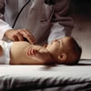

MCH Training Program
Workgroups

Prepared by:

Health Systems Research, Inc.
An Altarum Company
1200 18th Street, NW, Suite 700
Washington, DC 20036

April 24, 2007

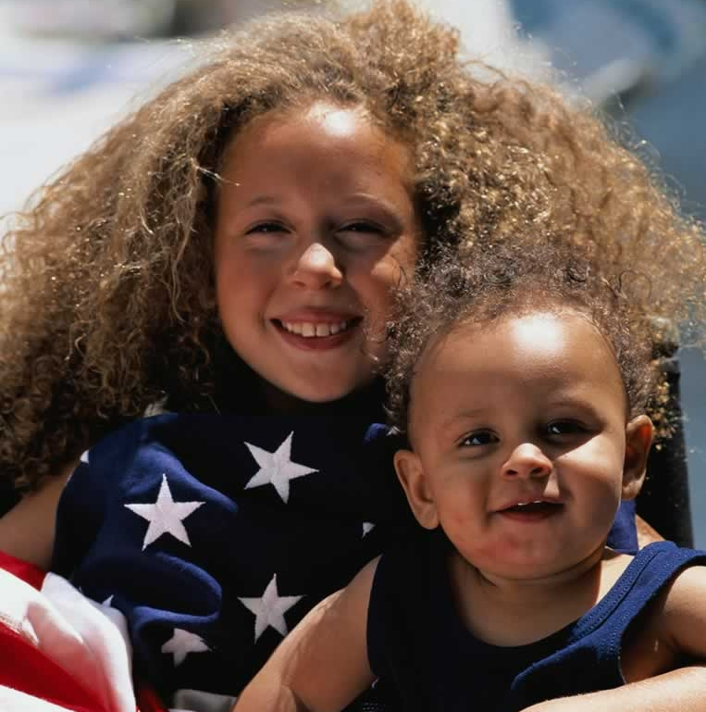

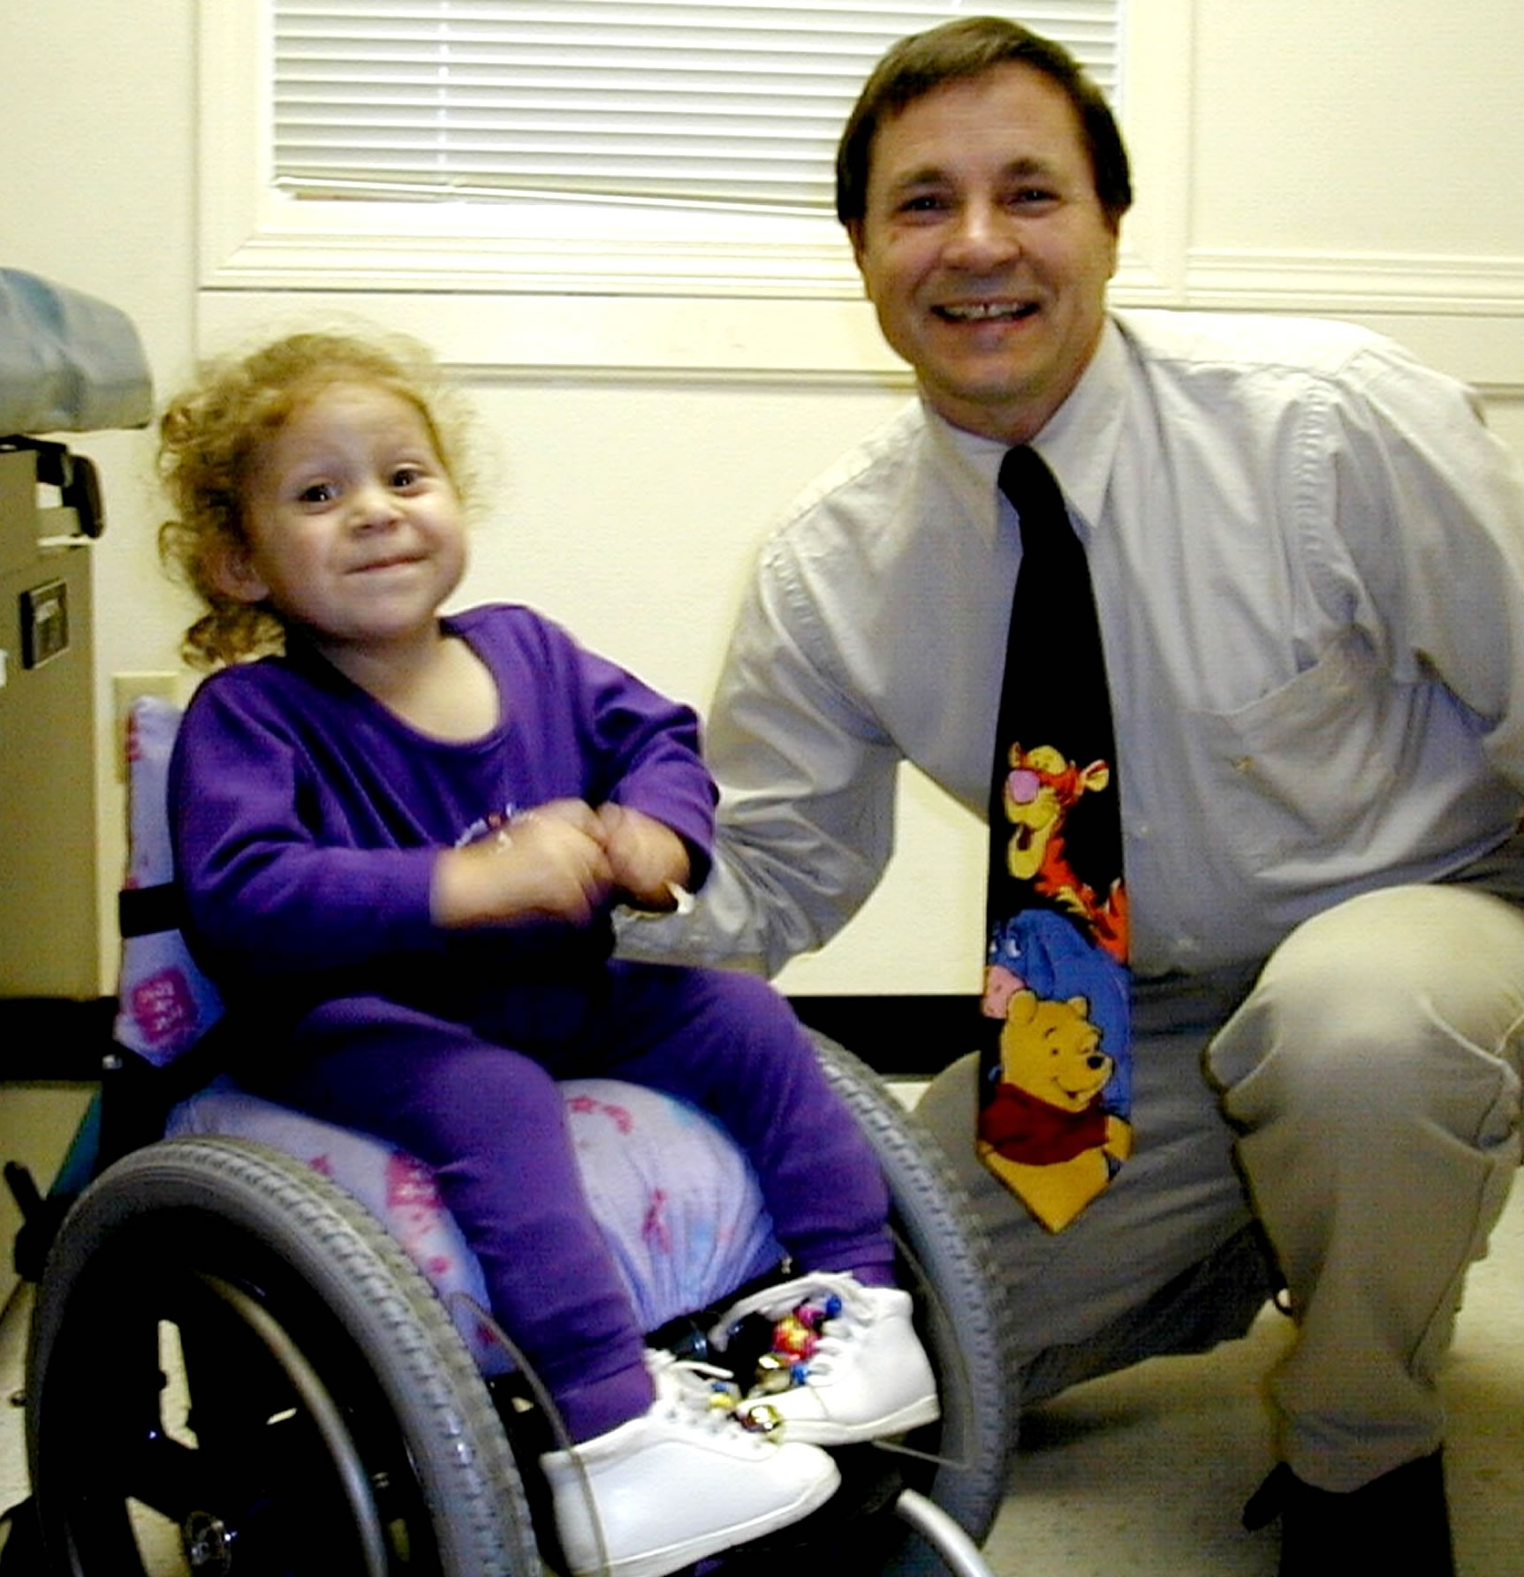

Introduction

The current MCH Training Program Performance Measures are scheduled for review by the HRSA Office of Management (OMB) in the near future. This review presents an opportunity to discuss and assess the measures regarding their appropriateness and usefulness and to make recommendations for improvement. To this end, the Maternal Child Health Training Program Resource Center housed at Health System Research, was asked to organize and facilitate discussions of the performance measures with members of each of the Resource Center workgroups. The workgroups are comprised of representatives from the MCH Training Program grantees and are focused on the following areas:

- Interdisciplinary Practice

- Faculty and Trainee Diversity

- Family-Centered and Family-Directed Care

- Reporting and Monitoring.

To focus the discussion, the following questions were developed and shared with workgroup participants.

Performance Measures Assessment
Discussion Questions
Assessment of Current Measures
1. Do you think the current performance measures adequately capture the intended impact of the MCH Training Program?

- What are the strengths and weaknesses in the current performance measures?
- Are there gaps in the performance measures? What else should be measured?
Reporting on Performance Measures
2. To what extent are the data reported by grantees viewed as being accurate and precise?

- Are grantees able to report the requested data each year?
- What measures have high rates of missing data?
Use of Performance Measures
3. How do you currently use the performance measures:

- To manage your program?
- To tell your program story?
- Other?
Adapted from MCHB Performance Measurement Discussion Guide: Draft – Mathematica Policy Research, Inc.
Discussion Summary

All long-term training programs must report on the following performance measures:

- Performance Measure 07: The degree to which MCHB supported programs ensure family participation in program and policy activities.

- Performance Measure 08: The percent of graduates of MCHB long-term training programs that demonstrate field leadership after graduation.

- Performance Measure 09: The percent of participants in MCHB long-term training programs who are from underrepresented groups.

- Performance Measure 11: The degree to which MCHB long-term training grantees include cultural competency in their curricula/training.

- Program Performance Measure 62: Products and Publications

In addition, individual performance measures for specific training programs are reported on the Project Performance/Outcome Measure Detail Sheet.

Workgroup participants were asked to meet with program colleagues to discuss their experiences with the Training Program performance measures; therefore participants were able to share their individual experiences and those of their colleagues. A total of twenty-four representatives of Training Programs participated in one of the four workgroup conference calls focused on a discussion of the program performance measures. Six representatives of the MCHCB Training Program also participated in the conference calls. The calls were conducted February – April 2007.

The following summary is organized by the discussion questions.

I. Assessment of Current Measures

Discussion questions: Do you think the current performance measures adequately capture the intended impact of the MCH Training Program? What are strengths and weaknesses? Are there gaps in the measures? What else should be measured?

General comments

Participants indicated that program performance measures (PPMs) are useful in many ways including the setting of goals for a program and stressing to colleagues the importance of the area being measured (E.g. Family-Centered Care). The current performance measurement system is seen as more systematic than it was in the past. However others were not clear about the purpose of the performance measures and how they are used beyond reports to Congress. Participants indicated that a better understanding of the purposes of the progress reports could lead to a strengthening of the quality of the reports. The sharing of performance measure data across MCH Programs was viewed as potentially helpful to the grantees. Participants also recommended exploring the potential alignment of PPM reporting with the NIRS reporting system.

While the PPMs predominantly measure the quantitative aspect of the program performance, the qualitative details which determine the impact of the measure are not well evaluated. Self-assessments and self-measures are open to the judgment of responders and are therefore quite subjective. Currently several measures do not require documentation or written justification to support the self-assessment scores (E.g. Family Centered and Cultural Competency elements.) Some PPMs describe double-barreled actions (two or more activities in one PPM) and it is difficult to respond when asked to report only one number for both activities.

A significant number of participants indicated that some of the individual program performance measures should apply to all programs and be defined in a way as to permit flexibility. These included performance measures focused on collaboration with the State Title V agency and interdisciplinary practice. Participants indicated that for MCH Training Programs to effectively promote system-building and leadership in the field they must be connected with Title V and promote interdisciplinary practice.

Participants agreed that the demographic information obtained (E.g. who is in the program, and where trainees go following graduation) via the reporting process is useful. The narrative section of the progress report was identified as useful in allowing grantees to describe aspects of the program that are not captured in the PPM data and to discuss “added value” and “overall impact”. The development of “norms” for the performance measures would be helpful. Recommendations were made about terminology and included substitution of the terms “youth, family, or parent” in place of “consumer” and to use the terms “curriculum or training” program in lieu of “course.”

Comments about Specific Program Performance Measures

- PPM 07. The degree to which MCHB supported programs ensure family participation in program and policy activities.

The family participation measure was viewed as important and the measure captures much of what is currently done by programs related to family participation. However the wording of the measure was seen as complicating the assessment of family participation efforts. For example, some programs may not be able to pay families (as identified in the measure) but do use other strategies to involve families. The question was also raised about how much Family-Centered Care (FCC) is appropriate? Many of the participants described their struggle regarding this measure give that the majority of programs are clinical in nature and the difficulty this presents in fitting FCC into the curriculum. Trainees come to the program with the primary goal of mastering clinical material, with everything else (E.g. FCC) seen as secondary. The measure also needs to clearly state that family involvement refers to involvement in training and not involvement in treatment activities. Participants indicated that this is not a one size fits all measure. It is difficult to incorporate all the markers for family-centeredness into non-clinical training programs. There appears to be a bias at times against incorporating a family viewpoint expressed by a staff, faculty, or student perspective into the training programs. Finally, the recommendation was made to modify the description of family-centered care to “family-centered and family-directed practices.”

- PPM 08. The percent of graduates of MCHB long-term training programs that demonstrate field leadership after graduation.

The strength of this PM is in its specificity. However the information it provides is somewhat limited. As broadly defined, most training program graduates are leaders in at least one area five years following graduation. As a result it is difficult to know exactly what information is attainable from this measure.

- PPM 09. The percent of participants in MCHB long-term training programs who are from underrepresented groups.

Some grantees are unclear whether the Federal definition of “underrepresented” applies to this performance measure. The federal definition is seen as very limiting since it does not include rural, low-income, or first generation college-educated. The Federal definition of “underrepresented” does not adequately capture underrepresented populations in particularly diverse areas like Miami. The level of understanding of what can and cannot be included under this performance measure and how it should be documented varies among grantees. While the field notes can be used to explain how the grantee has defined underrepresented, not all grantees use the notes.

- PPM 11. The degree to which MCHB long-term training grantees include cultural competency in their curricula/training.

While valuable, this PPM was viewed as subjective. Criteria for the measurement categories are needed. For example, what outcomes are needed to describe the measure as “completely met?” Should the diversity of the faculty be the same ratio as diversity in the community? If there are ten ethnic groups in a community, must all ten be represented on the faculty for this measure to be described as “completely met?” The need to separate measures for faculty and trainee diversity was identified as was the need for a broader definition of diversity that goes beyond race and ethnicity.

- PPM 62. The number of products and publications that were produced by a training program’s faculty and trainees each year.

Grantees generally respond to this PPM with the provision of a list of publications. However participants felt that this was inadequate and too detailed and there is a need to move away from the limitation of citation indices and include data about the utilization of these publications. It is important to measure (perhaps using proxy measures) knowledge to practice activities to learn how the materials were used and their impact. Publications are powerful indicators of what programs are doing but are not enough to tell a compelling story about the Program. Measures to assess the extent to which publications were disseminated and findings replicated would be useful. Poster and presentations at national professional meetings should also be reported here. Participants also indicated the need to consider and report program products developed and targeted to consumers and these are not currently captured in this PPM.

II. Reporting on Program Performance Measures

Discussion questions: To what extent are the data reported by grantees viewed as being accurate and precise? Are grantees able to report the requested data each year? What measures have high rates of missing data?

General Comments

The concepts addressed by the performance measures are important, but are often difficult to quantify. Most of the performance measures rely on the use of soft data and subjective measures often gathered through a collective group process rather than with concrete measurement tools. It would be helpful to have tools to assist grantees in conducting more systematic self-assessments to inform the performance measures. Questions were raised about “what should be counted? For example, when technical assistance is provided by the programs, do the grantees count the number of community agencies involved, the number of technical assistance events, or the number of individuals participating in the technical assistance?

Workgroup participants also commented on the costs associated with data collection indicating that these costs should be weighed against perceived benefits whenever programs are asked to report on data. Data should be requested in consideration of how they will be used.

It was noted that the Pediatric Pulmonary Centers have a specific PPM related to medium-term trainees but these data are not included in the EHB. Collecting data and then not being able to report it is frustrating for grantees and represents information lost to the MCHB.

Comments about Specific Program Performance Measures

- PPM 59. The degree to which a training program collaborates with State Title V agencies, other MCH or MCH-related programs.

Definitions for the elements of this PPM are unclear. It is difficult to know how to count “service” using the example provided on the data collection form. The service data reported is superficial and does not measure quality.

Consistency across programs in counting collaboration activities is also an issue. Participants reported that it is difficult to know when programs are collaborating with Title V agencies and how to improve this collaboration due to the lack of clarity about the funding of Title V agencies. Agencies are often confused as to whether or not they are supported with any Title V funding. In addition, Title V agencies may not be responsive to overtures from training programs.

- PPM 07. The degree to which MCHB supported programs ensure family participation in program and policy activities.
- PPM 11. The degree to which MCHB long-term training grantees include cultural competency in their curricula/training.

Both these measures request data about multiple activities within one element which makes self-scoring difficult and leads to inconsistent reporting across programs. If a program has completed some but not all of the activities listed for a specific element how should they score themselves?

- PPM 08. The percent of graduates of MCHB long-term training programs that demonstrate field leadership after graduation.

Tracking graduates 10 years after completion of the program is difficult. The more years graduates are out of the program, the harder it is to conduct follow-up. There is much variation in reporting on graduates and it was felt that programs with large numbers of trainees are in a better position than those with fewer graduates to do graduate follow-up. The trainee follow-up does not have qualitative measures of the real leadership roles of past trainees. It was also noted that there is no way to know the characteristics of those who do not respond to follow-up or those who are lost to follow-up as compared to those who do comply with follow-up requests.

Some grantees are forced to go through their University IRB for approval of the tracking process and therefore are limited in the number and types of contacts they can make with graduates. Participants indicated that grantees could do a better job with this measure with more support from MCHB; for example through the use of a centralized tracking system maintained through MCHB. Additional financial support is needed for grantees to capture information at specifically scheduled times to learn more about the impact of the training program on the work and careers of graduates.

There was significant discussion about the use of a narrative reporting format to obtain follow-up information. Information obtained in this format was seen as more descriptive and robust and that a “different story” was revealed when using narrative data from that obtained from quantitative performance measure reporting. However participants also agreed that the analysis of narrative data required considerable resources.

Participants recommended that MCHB compare progress made on each performance measure across programs from year to year and share this information with the grantees.

III. Use of Performance Measures

Discussion question: How do grantees currently use the performance measures?

Participants reporting using the performance measures to:

- Tell the MCH Training Program Story. The leadership competencies and PPMs are used to help explain to students why certain things are required in the Training Program. Tracking faculty products and trainees post-graduation is useful for telling others about how faculty members are addressing specific issues and what trainees do after they leave the program.

- Assess integration of important knowledge and skills. The measures are used to assess whether students are integrating particular concepts, knowledge, and skills, E.g. cultural competency into their training experience. Participants also reported using the measures to evaluate aspects of their program.

- Keep Program on Track. The data collection process was reported as helping to keep programs on track and forcing them to focus on MCH priorities. It also provides support for the inclusion of specific aspects of a program (E.g. family participation, cultural competency). The performance measures are a useful strategic planning tool for grantees as they articulate program direction and a focus on families and minorities groups. They force a review of progress made in regard to individual program goals and national MCH objectives. As one participant said, “PPMs are good reminders of what we should be doing”.

