Word Office 365
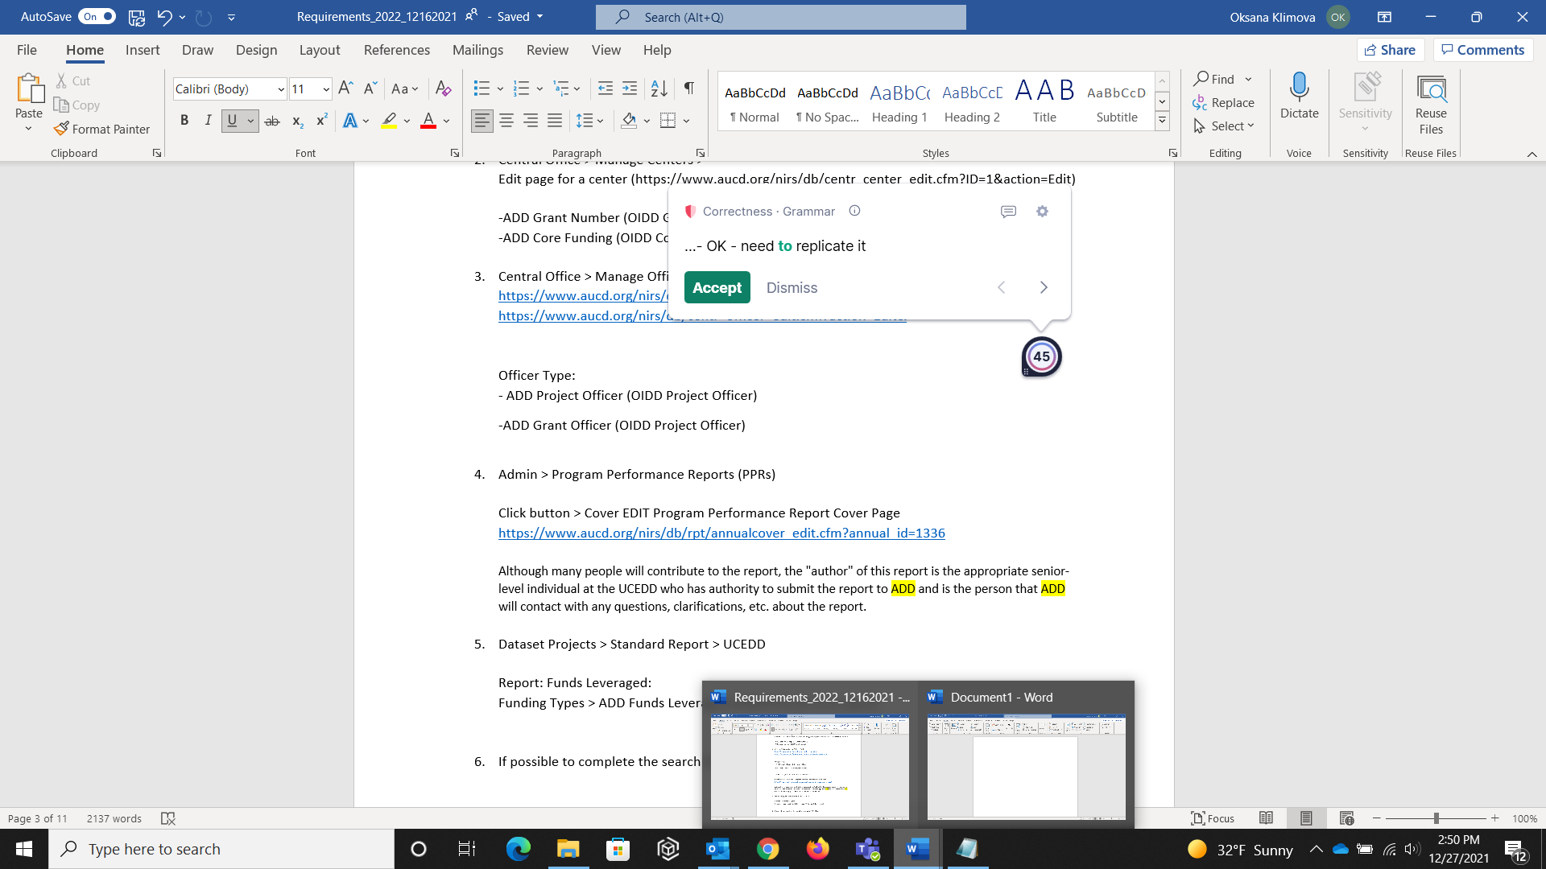

OUTLOOK Office 365

