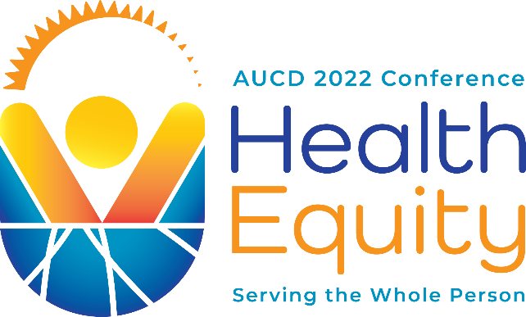

AUCD 2022 Conference Agenda
November 13-16, 2022

Sunday, November 13

8:00 AM – 5:00 PM: Sensory Break Room

9:00 AM – 11:30 AM: CECD, CORE, & MCC Council Meetings

10:00 AM – 11:30 AM: Public Policy Committee Meeting

11:30 AM – 12:30 PM: Lunch on your own
12:00 PM – 5:00 PM: Registration Open
12:30 PM - 3:00 PM: NTDC & COLA Council Meetings
3:00 PM – 6:00 PM: UCEDD Directors Meeting (Invite only)
3:00 PM – 6:00 PM: LEND Directors Meeting (Invite only)
4:00 PM – 6:00 PM: Trainee Networking Session
6:00 PM – 7:30 PM: Conference Welcome Reception

Monday, November 14

7:00 AM – 5:00 PM: Sensory Break Room

7:00 AM – 5:00 PM: Registration Open

7:30 AM – 8:15 AM: Networking Breakfast for Professionals with Disabilities
8:00 AM - 9:00 AM: General Hosted Continental Breakfast
8:30 AM – 10:00 AM: Opening Plenary
10:00 AM – 10:15 AM: Poster Set-up
10:15 AM – 11:30 AM: Concurrent Sessions
10:15 AM – 11:30 AM: Poster Symposia
11:30 AM – 2:00 PM: Lunch on your own
12:30 PM – 1:45 PM: SIG Meetings
1:45 PM – 2:00 PM: Poster Set-up
2:00 PM – 3:15 PM: Concurrent Sessions
2:00 PM – 3:15 PM: Poster Symposia
3:15 PM – 3:45 PM: Afternoon Snack Break with Exhibitors
3:30 PM – 3:45 PM: Poster breakdown and set-up
3:45 PM – 5:00 PM: Concurrent Sessions
3:45 PM – 5:00 PM: Poster Symposia
5:00 PM +: Dinner on your own
5:30 PM – 7:30 PM: AIR-P Research Day Symposium

Tuesday, November 15

7:00 AM – 5:00 PM: Sensory Break Room

7:00 AM – 5:00 PM: Registration Open

7:15 AM – 8:15 AM: Trainee-Professional Networking Breakfast
8:00 AM - 9:00 AM: General Hosted Continental Breakfast
8:30 AM – 10:00 AM: Leading Change Sessions
10:00 AM – 10:15 AM: Poster Set-up
10:15 AM – 11:30 AM: Concurrent Sessions
10:15 AM – 11:30 AM: Poster Symposia
11:30 AM – 2:00 PM: Lunch on your own
12:30 PM – 1:45 PM: SIG Meetings
1:00 PM – 2:00 PM: Book Signing with Emily Ladau
1:45 PM – 2:00 PM: Poster Set-up
2:00 PM – 3:15 PM: Concurrent Sessions
2:00 PM – 3:15 PM: Poster Symposia
3:15 PM – 3:45 PM: Afternoon Snack Break with Exhibitors
3:30 PM – 3:45 PM: Poster breakdown and set-up
3:45 PM – 5:00 PM: Concurrent Sessions
3:45 PM – 5:00 PM: Poster Symposia
5:00 PM – 6:30 PM: AUCD Honors Celebration
6:30 PM +: Dinner on your own

Wednesday, November 16

7:00 AM – 12:00 PM: Sensory Break Room

7:00 AM – 9:00 AM: Registration Open

9:00 AM – 12:00 PM: Closing Plenary
12:00 PM +: Hill Visits

