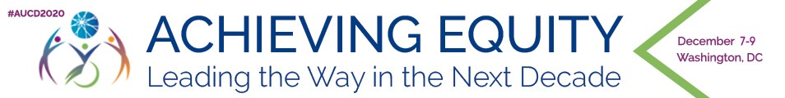

Agenda: 2020 AUCD Annual Conference

December 7-9 – Virtual

Monday, December 7
*Posters available on-demand from 12 – 4:45 pm.

12 – 1:15pm: Pre-recorded Opening Plenary: What is Equity and What does it Mean for the Disability Community?

Speakers:
- Daniel E. Dawes, Director, Satcher Health Leadership Institute, Morehouse School of Medicine, Atlanta, GA
- Larry Yin, MD, MSPH Director, USC UCEDD at Children's Hospital, Los Angeles, CA
- Mia Ives-Rublee, Disability Rights Activist, Co-founder of the 2017 National Women's March, Durham, NC
- Elver Ariza-Silva, Policy, Research interest, Communication, and Advocacy in Public Health - Culture & Linguistics, Washington, DC
1:15 – 1:45 pm: Break on your own
1:45 – 3:00 pm: Pre-recorded Concurrents Group 1 with live chat
3:00 – 3:30 pm: Break on your own
3:30 – 4:45 pm: Pre-recorded Concurrents Group 2 with live chat
4:45 – 5:00 pm: Break on your own
5:00 – 6:00 pm: Trainee Networking Session: Post-Plenary Debrief

Tuesday, December 8
*Posters available on-demand from 12 – 4:45 pm

12 – 1:15 pm: Pre-recorded Tuesday Leading Change Plenary: What is Equity and What does it Mean for the Disability Community?

Speakers:
- Joan Beasley, MD, Director, Center for START Services, Director, National Research Consortium on Mental Health in IDD, Research Associate Professor, University of New Hampshire, Concord, NH
- Joan Christopher, JD, Director, Community Services, Georgetown University Center for Excellence in Developmental Disabilities, Georgetown University Center for Child & Human Development, Washington, DC
- Luticha Doucette, Owner, Catalyst Consulting, Disability Rights Advocate, NCBI, Rochester, NY
- Tawara Goode, PhD, Director, National Center for Cultural Competence (NCCC) at Georgetown University Center for Child and Human Development (GUCCHD), Washington, DC
- Georgina Peacock, MD, MPH, FAA, Director, Division of Human Development and Disability and Disability (DHDD), the National Center on Birth Defects and Developmental Disabilities (NCBDDD),
CDC, Atlanta, GA
- Joseph Piven, MD, Director, Carolina Institute for Developmental Disabilities (CIDD), Thomas E. Castelloe Distinguished Professor of Psychiatry and Pediatrics, Chapel Hill, NC
- Hector Ramirez, Disability Rights Advocate, CA
- Britney Wilson, Staff Attorney, National Center for Law and Economic Justice (NCLEJ)

1:15 – 1:45 pm: Break on your own
1:45 – 3:00 pm: Pre-recorded Concurrent Sessions Group 3 with live chat
3 – 3:30 pm: Break on your own
3:30 – 4:45 pm: Pre-recorded Concurrent Sessions Group 4 with live chat
4:45 pm – 5:00 pm: Break on your own
5 – 5:30 pm: Pre-recorded Awards Ceremony

Wednesday, December 9
*Posters available on-demand from 12 – 5:00 pm

12 – 1:15 pm: Pre-recorded Closing Hill Plenary

Speakers:
- Senator Sherrod Brown, OH
- Senator Bob Casey, PA
- Congresswoman Katherine Clark, MA
1:15 – 1:45 pm: Break on your own.
1:45 – 3:15 pm: Live CEDC, CORE and MCC Council Meetings
3:15 – 3:30 pm: Break on your own.
3:30 – 5:00 pm: Live COLA and NTDC Council Meetings

