
AUCD Publication Order Form

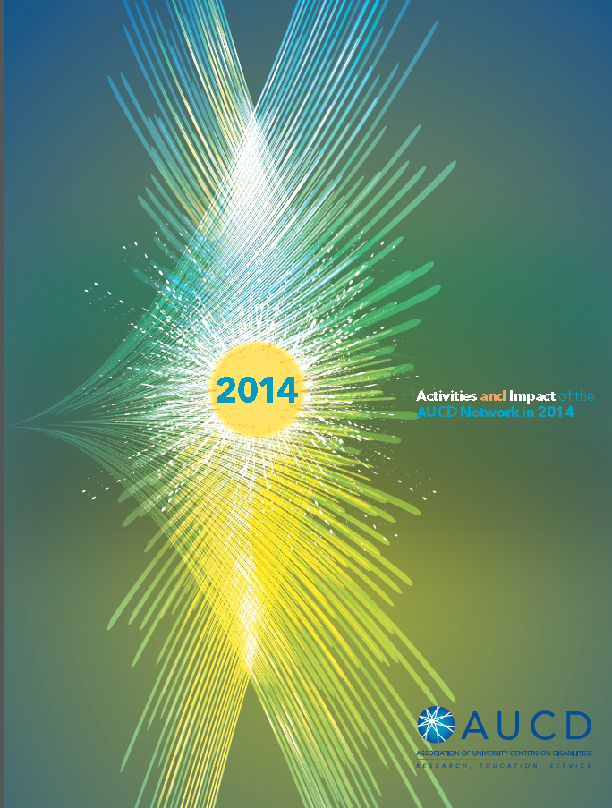
Publication:

AUCD 2014 Network Report

Item | Rate | # Copies | Cost
This publication | Network Members: $1.00 each
Shipping | $5.00 for orders under 50  $10 for orders over 50
Total | Return this form to: AUCD, Attn Publications,  1100 Wayne Avenue, Suite 1000, Silver Spring MD 20910

Payment Information |  | Shipping Information
Check  Payable to AUCD | Credit card  __Visa __ Mastercard  __American Express | Name:  Address1:  Address2:  City/State:  Zip: Phone:
CC Number:  Card Holder:  Address1:  Address2:  City/State:  Zip: Phone: |  | Name:  Address1:  Address2:  City/State:  Zip: Phone:

AUCD Billing Code  875 | Date Received | Date Paid | Date Shipped

