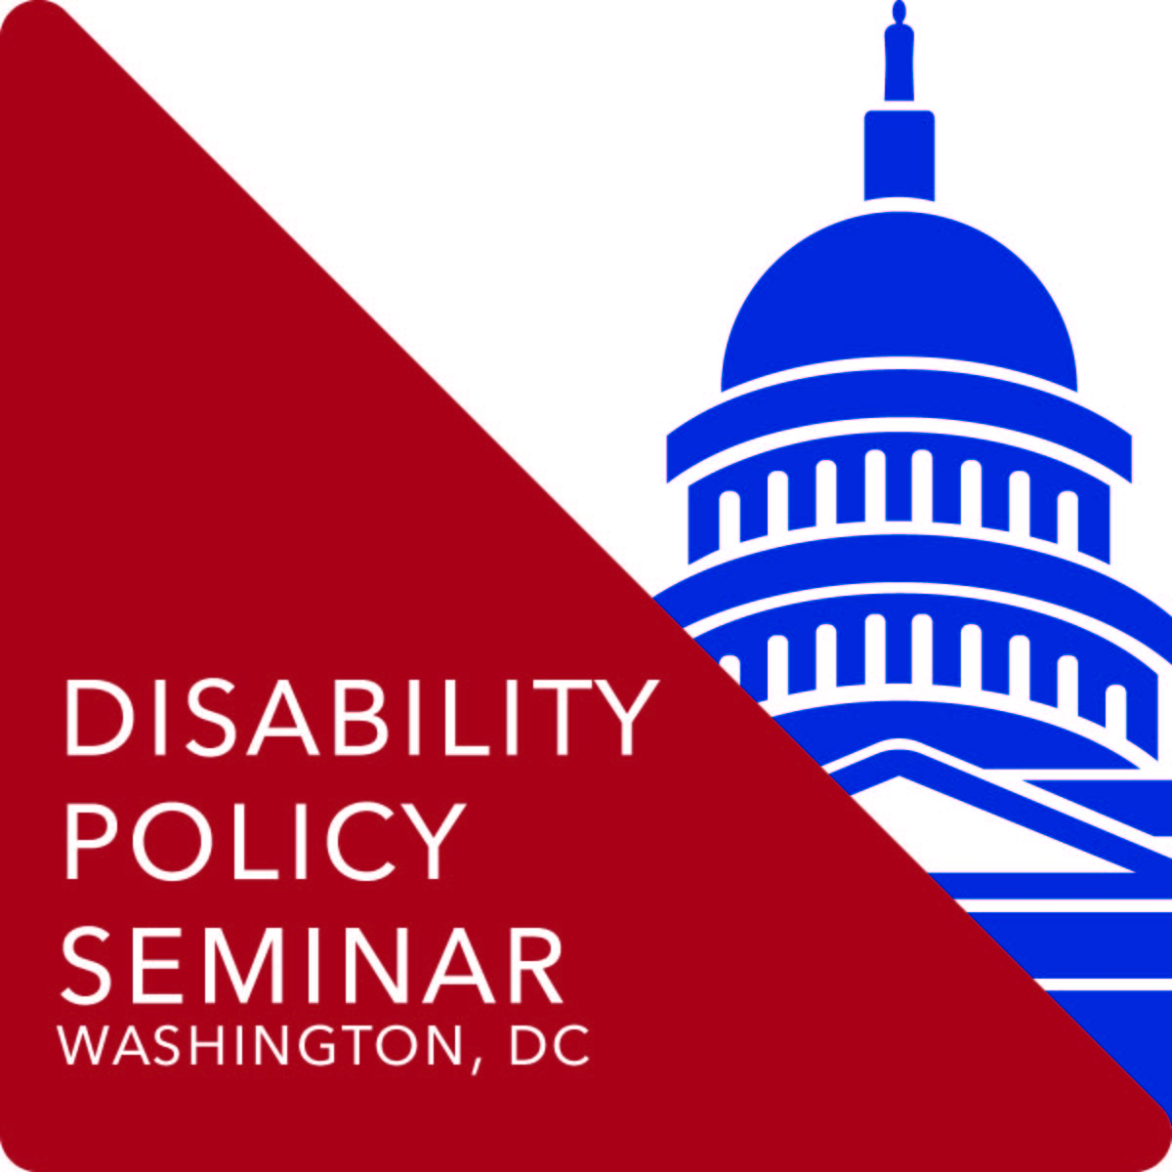
AUCD Trainee Policy Summit
Pre-Work
Before attending the AUCD Trainee Policy Summit and Disability Policy Seminar complete the following to prepare yourself for visiting Washington, DC and speaking with your legislator and/or their staff. These exercises are designed to help you plan your visit and frame your message for the greatest impact.

By April 2
- Attend the Policy Prep Session: A Webinar for AUCD Trainees attending DPS 2018 at 3:30pmET.

By April 16th
- Schedule your Hill visits and send visit information to AUCD (Christine: cgrosso@aucd.org or Rylin: rrodgers@aucd.org) including name of Member and staffer you are scheduled to visit, date and time of meeting and topics you intend to cover.
See How to Schedule Hill Visits for More Details

By April 20th
- Learn more about your Representative and Senators by completing the Getting to Know My Legislator Worksheet
- Prepare any material or supplementary data from your Center to give to your Legislator or their staffer during your visit

Be Sure to Pack
- Bring your business cards: you’ll want at least 50 for networking with trainees and professionals from around the country, and for disseminating on your Hill Visits
- Any Materials from your Center to share during your hill visits
- Bring table décor for your state. On Sunday afternoon of the AUCD Trainee Policy Summit, attendees will be sitting at tables designated by state. Bring a few (non-valuable) items that represent your state to display as a fun centerpiece: a blow-up lobster for Maine, a cheesehead for Wisconsin, etc.


