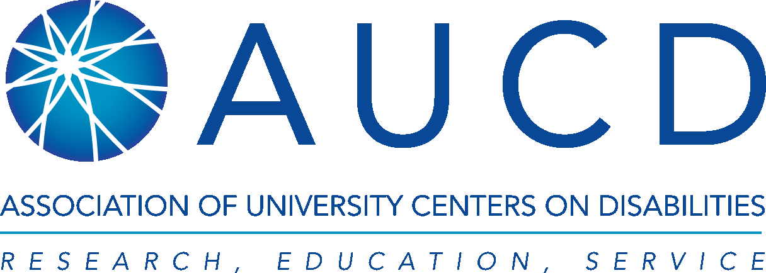
Autism CARES Act Funding Alert
June 12, 2017
SUMMARY:
The President’s FY 2018 Budget Request eliminates funding for the Health Resources Services Administration (HRSA) Autism CARES Act programs. This $47 million cut includes the $31.3 million appropriation for LEND programs. The national network of LEND programs would be eliminated. LEND directors, health professionals, trainees, families and allies must educate their Members of Congress about why this training program is important and why it must not be eliminated.

In millions | FY16 | FY17 | President’s FY18 Request | FY18 AUCD Recommendation
Autism and other DD | $47,000,000 | $47,000,000 | 0.0 | $52,000,000
LENDs | $29,042,255 | $31,317,485 | 0.0 | $31,317,485

BACKGROUND:
Leadership Education in Neurodevelopmental and Related Disabilities (LEND) programs have been funded for over 30 years to provide advanced training to students and fellows from a broad array of professional disciplines in the identification, assessment, and treatment of children and youth with a wide range of developmental disabilities. Disabilities include autism spectrum disorder (ASD), intellectual disability, fragile X syndrome, cerebral palsy, spina bifida, Down syndrome, epilepsy and many other genetic and metabolic disorders. Nationally, there continues to be tremendous shortages of personnel trained to screen, diagnose and treat individuals with DD. As a result, families often must wait months to get a comprehensive diagnosis. Delaying diagnosis also delays timely early intervention services that can reduce the impact of disability and therefore reduce long term service costs.

In 2006, Congress passed the Combating Autism Act to increase cross-agency collaboration and investments to address the rising numbers of those diagnosed with autism. Congress reauthorized this law in 2014 when it passed the Autism Collaboration, Accountability, Research, Education, and Support (CARES) Act (P.L. 113-157). The bipartisan bill was passed unanimously in the House and Senate.

The law increased the investment in the nationwide LEND network to address the severe shortage in adequately trained health professionals. Since 2006, the number of LEND programs has increased from 39 to 52 (in 44 states). LEND programs are administered by HRSA.

The Autism CARES Act also includes investments to: train developmental behavioral pediatricians, research to develop evidenced-based interventions, and state system change grants to promote innovation. AUCD is recommending that the same amount appropriated in FY 2017 be provided for FY 2018: $31 million to maintain Congress’ current commitment to the 52 LEND programs.
TAKE ACTION:
Call your Representative/Senator/Member of Congress:
- Dial the Capitol Switchboard at 202-224-3121 and ask for the office of your Representative/Senators
- Ask to speak to the person working on health and disability funding issues
- Email your members of Congress directly using AUCD’s Action Center.
Message: “I am calling Representative/Senator ___________ to urge full support of continued funding for the LEND interdisciplinary training program in our state. [use talking points below for more] Thank you.”

Additional Talking Points:
- There is a nationwide shortage of disability competent care providers in today’s health system to assess and meet the complex needs of children with autism spectrum disorders (ASD) and other developmental disabilities.
- ASD affects about 1 in 68; about 1 in 6 children has a developmental disability.
- It is difficult for families to obtain an appropriate diagnosis and much-need early intervention because of the lack of trained health and allied health care providers. Delaying diagnosis also delays timely early intervention services that can reduce the impact of disability and therefore reduce long term service costs.
- LEND programs are exceptionally qualified to address the shortage of professionals needed to address this issue of national significance.
- In FY 2017, additional LEND programs were established in states that did not have one to address this critical shortage.
- This funding will enable LENDs to assist in ongoing developmental monitoring, especially for children exposed to lead and other environmental toxins, and for infants exposed to the Zika virus with its resulting complications.
- LEND programs help reduce duplication and increase service system efficiency. Many operate clinics at universities or children’s hospitals that are interdisciplinary by nature.
- The training promotes collaboration among professionals from different disciplines that can help employers increase efficiency and reduce costs.
- For fiscal years 2011-2014, the LEND programs provided interdisciplinary diagnostic evaluations to more than 224,000 children, trained nearly 16,000 pediatricians and other health professionals, and initiated more than 3,000 continuing education events for practicing and pre-service professionals on screening, diagnosis, and intervention. Nevertheless, the shortage of appropriately trained professionals persists. Continued investment in training is imperative.

