WRITTEN By:

Oksana Klimova
Director of Web Services, AUCD

PROMISE TA Center
SharePoint Portal User Manual

https://promisetacenter.aucd.org/
____________________________________________________________

Table of Content
For Help Contact 3
Setting your browser to work with SharePoint 3
Accessing the PROMISE TA Center SharePoint Portal 8
Alerts 11
Creating Alerts: 11
Editing or Deleting an Alert: 13
How to Request account for PROMISE TA Center SharePoint Portal 13
PROMISE TA Center SharePoint Portal Areas 13
Homepage 13
Shared Documents 14
To Post a Document: 15
Add a new Microsoft Word Document: 15
To modify this file: 15
To view a file: 16
To delete a file: 16
To create document folder: 16
Links 17
Add a new Link: 17
Discussions and Ask Question 18
To create a discussion in Share Point: 18
To Reply to a discussion: 18
Calendar 19
Add a new Event: 19
To export one calendar event to Outlook: 19
To export the entire site calendar (all months) to Outlook: 20
Directory 20
Add a new Member: 20

The Grantee Portal SharePoint is a web-based system for accessing, editing, managing, and sharing collections of documents as well as holding discussions with grantees staff. This password-protected shared web space creates a place for the PROMISE Model Demonstration Project Teams to access draft materials, events, and share information and ideas. The PROMISE TA Center Grantee Portal uses SharePoint Foundation 2010 to provide a password-protected, secure, manageable, web-based collaborative environment. SharePoint is designed to function most fully with Microsoft Office tools including Word, Excel, and PowerPoint. The SharePoint portal works best with the latest combination of tools: Internet Explorer , Office 2007, and Windows Vista.
This manual includes the following topics:
- Setting your browser to work with SharePoint
- Accessing PROMISE TA Center Portal of the AUCD SharePoint server (https://promisetacenter.aucd.org/)
- Alerts
- Accessing the portal features and project

For Help Contact
If you need assistance or have questions about the Portal, please contact any of the following:
- D'Leon Barnett
dbarnett@AUCD.ORG
301-588-8252, ext. 216
- Oksana Klimova
oklimova@aucd.org
301-588-8252, ext. 210

Setting your browser to work with SharePoint
Saving a file locally requires a quick, one-time change of configuration to your browser's security setting. Since you will be saving files that may contain viruses, SharePoint insists that you change your security settings.
Solution: Make the SharePoint portal a Trusted Site:
Attention:
- Only perform the solution on your own computer.
- Only perform this action on a password-protected computer.
- Never perform this action on a publicly accessible computer, i.e. at a library or internet cafe.

- Open Internet Explorer (highly recommended to use IE)
- Log on to the portal home page (https://promisetacenter.aucd.org/)
- To adjust your security settings, locate the Tools menu in Internet Explorer and select ‘Internet Options’ from the drop down menu.

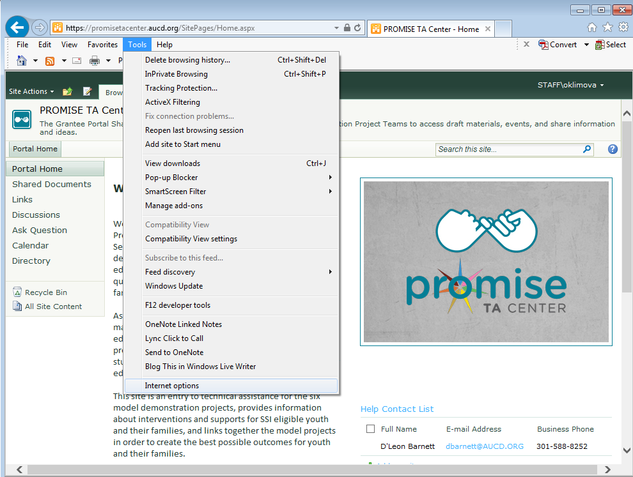

2. On the ‘Internet Options’ menu, follow these steps: 1) Click the "Security" tab in the upper left; 2) Click the "Trusted Sites" button in the upper middle, and 3) click the "Sites" button to add the “https://sharepoint.aucd.org” site.
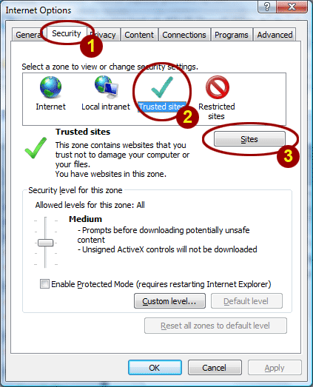

3. Type in “https://promisetacenter.aucd.org” to the Add Sites box. Click the "Add" button. You can require that server verification be used if you click to select the Require server verification (https:) for all sites in this zone check box.
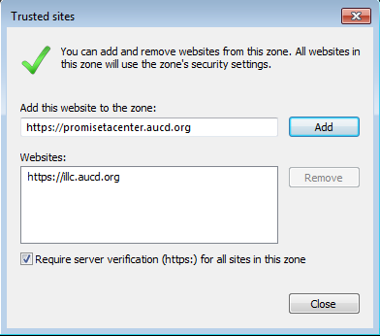
- Click on the "Custom Level" button.

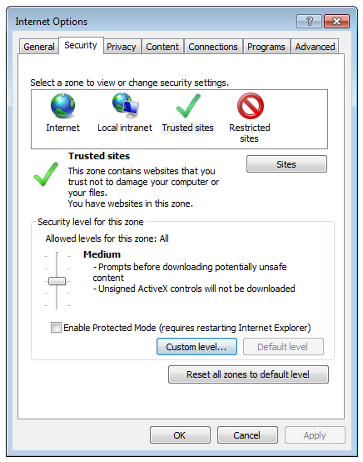

- Scroll down to the middle and enable "Display mixed content"
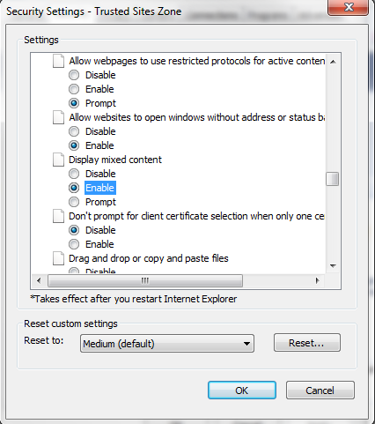

- Scroll down to the bottom
Under "User Authentication/Logon", select "Automatic logon with Current Username and Password" and click "OK"
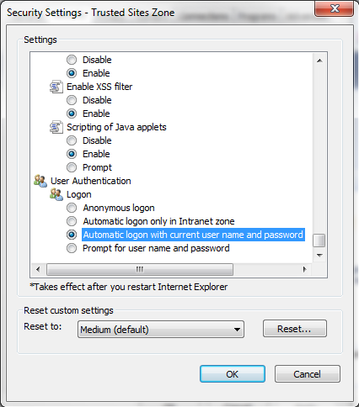

7. Click "OK" twice to close all dialog boxes
8. The next time you log on, be sure to select "Remember my password"

Accessing the PROMISE TA Center SharePoint Portal
1. To access the PROMISE TA Center SharePoint Portal, select section ‘Grantee Portal’ (http://www.promisetacenter.org) and click button ‘Login’ or enter https://promisetacenter.aucd.org in the address bar of your web browser.
2. The server requires authentication. Enter your username and your password provided by AUCD in the log-in box. You may find it convenient to click the "Save my password."
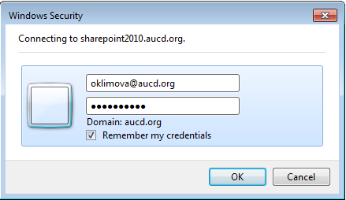

3. After you have logged in, you will see the SharePoint main portal. Depending on your computer's configuration, you may see the Internet Explorer Information Bar and a notice that you will need to install and 'Active X' control to allow you to fully access SharePoint.
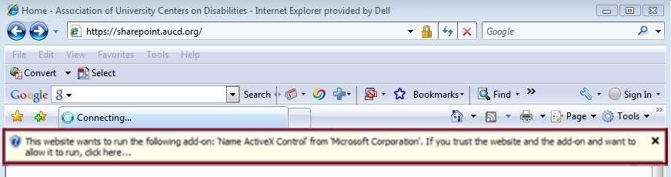
4. Close the alert message and then click on the yellow info bar to install the ActiveX control (ActiveX controls are mini-programs that expand or enhance your browser). Select "Run ActiveX Control" from the contextual drop-down menu.
5. Click "Run" on the alert message to install the ActiveX control.
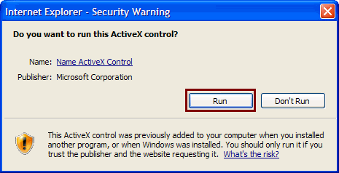

6. After you logged in you should be prompted to the homepage of “PROMISE TA Center Portal”.
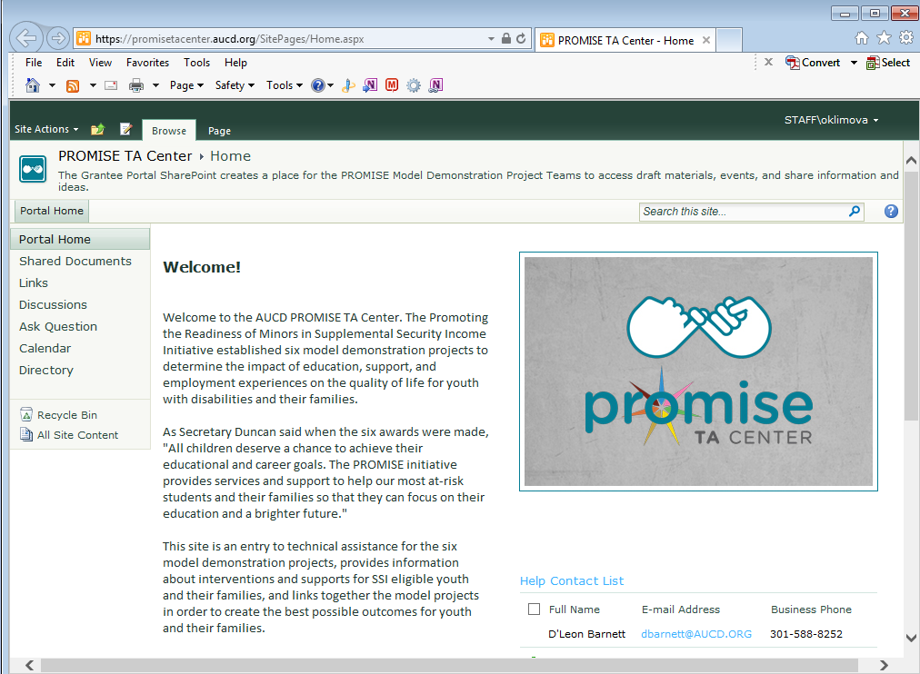

Alerts

Creating Alerts:
In order to participate fully in the collaborative features of SharePoint, members will have to create individual alerts for their preferences. To receive email alerts on posted documents, links, ongoing discussion boards, and announcements, a member will create an alert for these features.

Alerts can be created at anytime; however, it is recommended that they be created upon first access to the site.
- Login (see above)
- Under Welcome John Doe choose My Settings
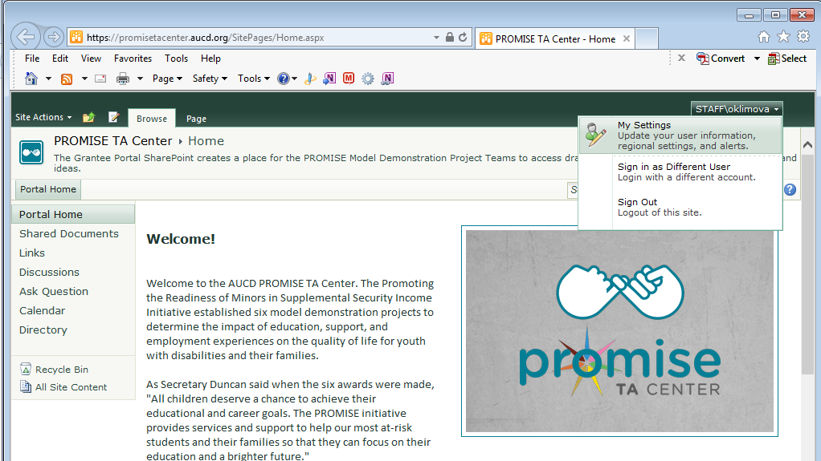

- On the User Information Page choose My Alerts
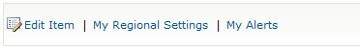
- Choose Add Alert
- From this page you can choose any of the lists or libraries for which you wish to receive emailed alerts. You can only choose one alert at a time. Recommended are Announcements, Shared Documents, any discussion boards you wish. Choose NEXT
- You will now create specific criteria under which you want the alert to be sent. For example, you may wish to receive daily alerts regarding document postings; however you want announcements and discussion board postings immediately. You can even set the time of day to have the emails sent. Choose OK
- You now see the Add Alert’s screen with your new alert created in a list. Repeat the creation of alerts for all desired lists and libraries in SharePoint following these steps.

Editing or Deleting an Alert:
You can edit the criteria on your alerts by going under My Settings, choose My Alerts, and select the alert you wish to edit or delete from the list displayed.

How to Request account for PROMISE TA Center SharePoint Portal
SharePoint is a collaborative workspace on the intranet however, it is password protected and only members to the site will have access. You will be supplied with a username and password to log in to the site.
To set up a member for PROMISE TA Center SharePoint Portal, a request must be sent to project coordinator with the person’s name, email address, and phone number. The email should be addressed to PROMISETACenter@aucd.org.
There are categories for membership on a Share Point site; Member and Administrator. These categories come with access restrictions and permissions that can be amended.

PROMISE TA Center SharePoint Portal Areas

Homepage
The PROMISE TA Center Portal homepage displays:
- Welcome introductory text.
- List of the announcements for the team.
- List of recently shared.
- Help Contact List.
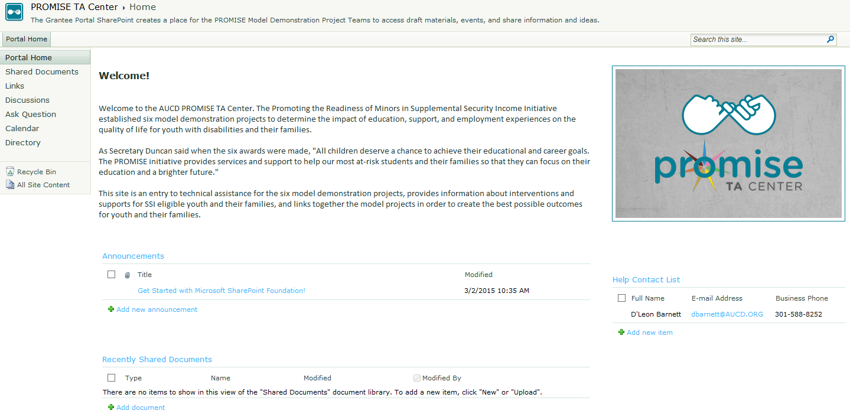

Shared Documents
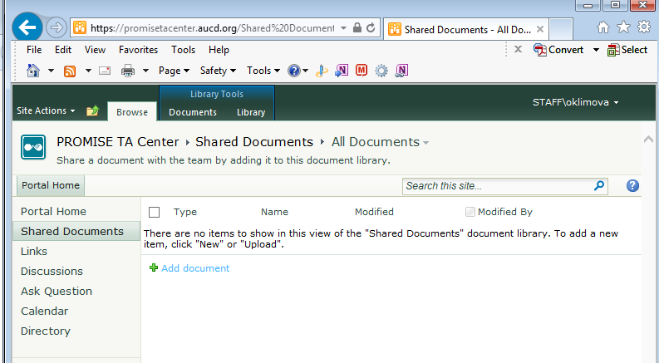

To Post a Document:
In the left hand menu, choose “Shared Documents”.
This opens the Document Library. Just like a real library, each entry is an exclusive item. Folders contain documents and other files that can be viewed, edited, copied, and downloaded to computers. Shared Document library will hold all types of files even media. Documents and files can be “checked out” in order to edit. Just like in a library, Checking Out a document prohibits others from editing or changing the file. Files must be “Checked In” in order for others to edit.

Add a new Microsoft Word Document:
1. Create your new document in Microsoft Word and save it somewhere on your local machine.
2. In your SharePoint document library, click add and use the Upload Document page to add the file you created in Word to the SharePoint document library.
3. The document is now available in the SharePoint document library. You may see your screen refresh to indicate that the file has uploaded. Files can now be viewed, edited or even deleted.
4. If the document is in final format and you do not want others to edit it, change it to a pdf file before uploading.

To modify this file:
Users should follow these steps to ensure that the file is locked while they work on it and is then updated properly on the SharePoint site.

PC Users:
1. Check out the file by mousing over the file name in SharePoint and click Check Out in the dropdown menu.
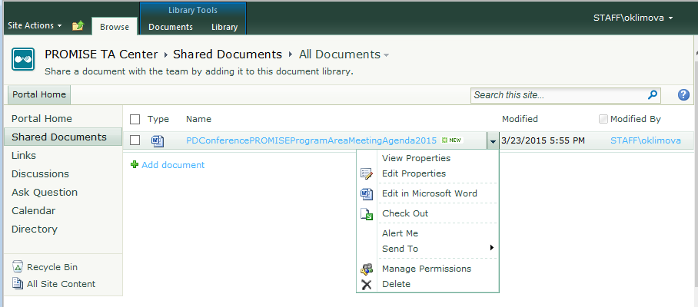
2. Click on the file name to open the file. You may be prompted to enter your username and password again.
3. Work on the file in Word and save your work.
4. Close the file.
5. At this point your document is uploaded, and you should see a page prompt to check in the document that you've uploaded so that others can work on it.

Mac Users:
1. Check out the file by mousing over the file name in SharePoint and click Check Out in the dropdown menu.
2. Click on the file name to download the file to the Mac.
3. Work on the file in Word and save your work.
4. Click Upload in the SharePoint document library to open the Upload Document page.
5. Use the browse button to add the document to the Name text box and make sure that the Add as a new version to exiting files checkbox is checked.
6. Click OK.
7. At this point your document is uploaded, and you should see a page prompt to check in the document that you've uploaded so that others can work on it
In the case of uploading a document to an existing folder, select the folder from the Shared Documents list then follow directions above.
If you do not see your name and date next to the file name select refresh in the browser bar.

To view a file:
Select file and it will open. You may be prompted to enter your username and password again. This is normal and does not indicate a problem with the system.
You may choose to download or copy a document to your computer for editing or filing. This is accomplished by selecting the arrow to the right of the file name. Choose “Send To” and another menu will appear. Choose Download copy and this will allow you to download a copy to your computer or an external drive.

To delete a file:
Select arrow to right of file and choose delete from the menu.

To create document folder:
Select tab “Documents” under the tab “Library Tools” from the horizontal menu.
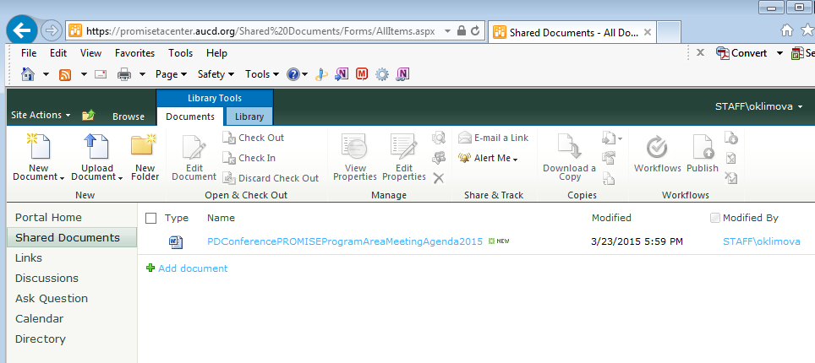
Click on “New Folder” icon and in “New Folder” form provide name for a folder, click Save.

Links
Click on “Links” to post link to external resources.

Add a new Link:
- In your SharePoint Resource Link library, click “Add new link”, add URL address of your resources and explanatory text into Notes text area. Click “save”.
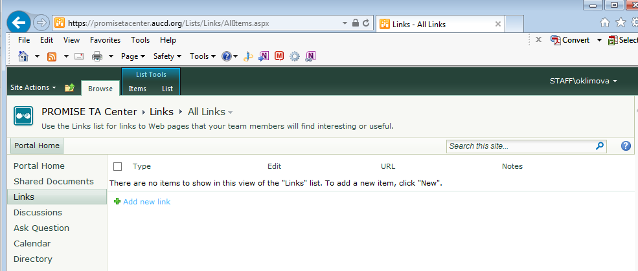

- The link is now available in the SharePoint Resource Links library. Links can now be viewed, edited or even deleted.

Discussions and Ask Question
Discussions is a Discussion Board and it is used to provide an ongoing conversation with multiple teams around one topic. Ask Question is a Discussion Board and it is used to provide an answer(s) from multiple members on asked question.
A Discussions and Ask Question has several components, subject, comment, and responses. The responses are grouped with the subject of the discussion and can be replied to directly or as a group.

To create a discussion in Share Point:
- Select “Add new discussion”.
- Create a Subject and type your discussion topic in the body. Select “save” when done.
- Optional – attach a file such as a draft or reference document for discussion

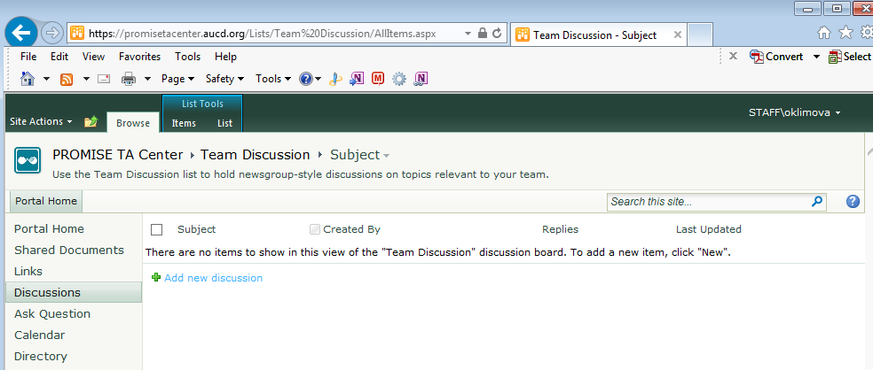

To Reply to a discussion:
- Select the Discussion Board you want to view
- Select the discussion you want to reply to by clicking on the name of the discussion
- Select Reply in the right hand corner of the screen
- Fill out your response and click “ok”
Discussion Boards and Ask Question Boards archive all responses to a particular discussion – all members can see responses. Abuse of discussion boards constitutes in the use of abusive or offensive language, and other matter is subject to review of the SharePoint Administrator. Report abuse of the discussion boards to Administrator at oklimova@aucd.org.

Calendar
All events related to PROMISE TA Center activities will be posted in the portal calendar.
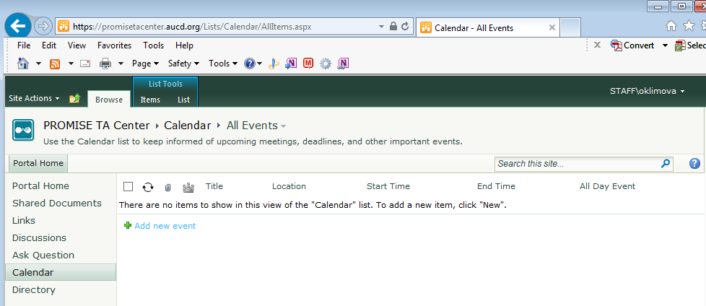

Add a new Event:

- In the left hand menu, choose “Calendar”. This opens the Calendar section.
- In your SharePoint Calendar section, click “Add new event”.
- Feel the form and click “OK” button.
- The Event is now available in the Calendar section. Events can now be viewed, edited or even deleted.

To export one calendar event to Outlook:
- Choose Calendar in the left side navigation pane.
- Select tab “List” under the tab “Library Tools” from the horizontal menu.
- Select event from the calendar that you would like to export to Outlook
- Choose Connect to Outlook from the tool bar.
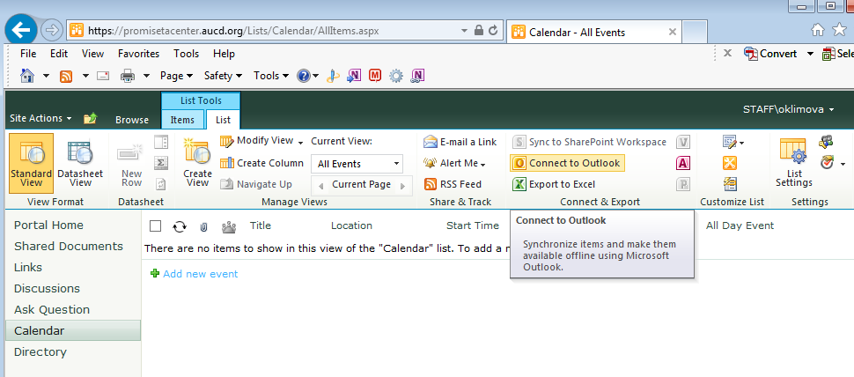

To export the entire site calendar (all months) to Outlook:
- Choose Calendar in the left side navigation pane.
- Select tab “List” under the tab “Library Tools” from the horizontal menu.
- You will have to allow the folder to be shared with Outlook. Click OK

Directory
Directory page lists all the people who are participating in PROMISE TA project. It is display users profile in a way that members can search for people, offices, departments, locations, skills or job titles.

Add a new Member:
- Choose Directory in the left side navigation pane.
- In your SharePoint Calendar section, click “Add new item”.
- Feel the form and click “OK” button.
- The Event is now available in the Calendar section. Events can now be viewed, edited or even deleted.
